Shakespeare’s
As You Like It:
A Portfolio


by Nicole Parker

Introduction

Overview of the play:
Rosalind, the heroine of the play, falls in love with Orlando but is banished from the court by her uncle, Duke Fredrick, who had earlier banished her father, Duke Senior. Rosalind disguises herself as a young boy named Ganymede and leaves for the forest of Arden with her cousin Celia. Orlando, in anger towards his brother, flees from the court and goes to Arden. It is here that he meets the disguised Rosalind and develops a relationship with him/her. Orlando’s brother, Oliver, is sent to the forest as well and falls in love with Celia. Rosalind reveals her true identity at the end of the play and marries Orlando, as do the other couples that met in the forest of Arden.

Mode of the play, formal features:
As You Like It, a comedy about people who were banished from court into urban community, is commonly known as a pastoral mode. Pastoral Mode is often comprised of people being excommunicated and banished from court to an urban area. The players often disguise themselves as shepherds to gain insight on the new life they have just moved into from their past life in court. The main point of a pastoral mode is the comparison that happens by way of the old life in court to the new life in the organic community. By using such comparisons, Shakespeare’s pastoral comedies were often used to teach the audience about social problems in society. For example, the speech made by Duke Senior in 2.1.1-16, brings the audience into the forest, which entices the audience to take a closer look at some of the pastoral modes and lessons being taught through the play.

Discussion of critical reception, popular reputation:
One of the most popular aspects of As You Like It is the Rosalind’s radical behavior which is brought on by her disguise of Ganymede. Critics such as Michael Shapiro (Shapiro 119), write on the opportunity that male actors had to authentically play a woman, playing a man. He discusses how this multi-layered acting would intrigue the audience in dynamic ways, more so then if the actor were simply playing a man in the play. Comparisons such as man versus woman, court versus rural forest, young versus old, strength versus weakness, are themes that come up throughout the play which critics have been discussing over the years. A general reaction to this Shakespearian play is that this is one of Shakespeare’s more basic plays, one that is not as much a play that Shakespeare wrote for people to be challenged by but one that he wrote for people as they would like it. Scholars that had this opinion were those such as George Bernard Shaw and Tolstoy.

Why I choose to teach this play/What I would focus on:
I really like the idea of teaching a high school class a comedy because students need to have fun and comedies bring a lot of fun. I am a strong believer that fun is important for learning and As You Like It, along with its many songs, fun lines, charismatic characters and fairytale setting, guides students into a land of fun. One of the other reasons I chose this specific play to teach to high school students is because this play has the potential to talk about important life lessons like ‘romantic love’ versus ‘real love’ and presence important topics in a light and friendly way. In our culture that has such a huge divorce rate, this is a topic that I believe needs to be talked about more, especially at such a confusing age as adolescence is.
Further aspects of the play I would highlight are: families and friendships and the reconciliation that comes through time in Arden; fools and jests and the particular use of fools; the use of song; and finally the green world and how Arden is used for transformation of each of the characters.

Resources

Editions

Shakespeare, William. As You Like It. The Complete Signet Classic Shakespeare. Ed. Sylvan Barnet. New York: Harcourt Brace Jovanovich, 1972. 845-75. Print.

It is always important to use the direct work of Shakespeare’s writing to demonstrate the teaching idea’s being made. The Complete Signet Classic Shakespeare Edition is a helpful resource to use for its intriguing introductions to the play, the informative guide to Shakespeare’s likely resources and other helpful resources for the reader. The introductions are done in a manner that is not necessarily biased to other editor’s opinions on the text; instead the introductions bring a diverse perspective to many controversial ideas in plays, especially in As You Like It.

SparksNotes. No Fear Shakespeare: As You Like It. New York: Barnes & Noble
Publication, 2004. Print.
The title of this book summarizes a key purpose of the use for this book. No Fear Shakespeare is a welcoming book for students to use alongside the original text of Shakespeare’s As You Like It to bring further understanding to the often-intimidating text. It does this by using common language to interpret the text. Along with interpreting the text into basic English, No Fear Shakespeare also gives side notes with further background information on the text being discussed and parallels the original text to the contemporary text. A cautionary with using this text is to be sure to highlight the initial text of Shakespeare’s As You Like It to encourage students to interpret it on their own without depending on the interpretation from No Fear Shakespeare.

Teaching Resources

Best, Michael. “As You Like It.” Internet Shakespeare Edition. University of Victoria, 2011.Web. 28 March 2011. <http://internetshakespeare.uvic.ca/Foyer/plays/AYL.html>.

The Internet Shakespeare Editions website is an excellent and easily accessible resource for students and teachers, both for specific works and for general cultural and contextual knowledge of Shakespeare and the Elizabethan era. The As You Like It home page includes introductory and critical essays, facsimiles, relevant cultural information, and a list of recent performances and performance artifacts. Helpful interlinking between key phrases and texts throughout the website allows users to further explore interesting concepts, and the website consistently provides a list of outside resources to further supplement students’ and teachers’ needs.

Clough, Sarah. "As You Like It." Sheffield Theaters Education Resource.
Sheffield Theatres, 2006. Web. 31 Mar. 2011.
<http://www.sheffieldtheatres.co.uk/creativedevelopmentprogramme/producti ons/asyoulikeit/index.shtml>.

The Sheffield Theaters Education Resource website is broken down into two sections; Context of what England would have been like in the time As You Like It was being written; and the text, specifically analyzing the themes, language, character analysis etc. If one were to want to know more about the context of Shakespeare’s writing they would receive an overview of the subject and links to various artifacts that bring evidence to these theories. Links included in a search like this would be, for example; The Elizabethan Theater – a brief background history; Boy Players – a review on who were the boy players and Cross Gender Casting etc.; and Women in Elizabethan Society. All of these links have further links attached to them with optional resources such as a link to The Globe.

Fischlin, Daniel. "Shakespeare Links." Canadian Adaptations of Shakespeare
Project. University of Guelph, 2004. Web. 31 Mar. 2011.
<http://internetshakespeare.uvic.ca/Foyer/plays/AYL.html>.

The Canadian Adaptations of Shakespeare website is a fantastic resource for teachers to have. Looking at only the websites specific page, “Shakespeare Links” invites teachers and students into a world of other resources such as ‘BBC’s 60 second Shakespeare’, ‘Records of Early English Drama (REED)’, and ‘Shakespeare’s Globe Theater’. This website has compiled many major resources for people looking to get to know the character, society and life of Shakespeare as well as what influenced him and guides to understanding Shakespearian language.
Primary Resources

The Tale of Gamelyn. N.p., 1450. Print.

One of Shakespeare’s major sources, Thomas Lodge’s Rosalynde, is based on the medieval narrative poem The Tale of Gamelyn and should be explored for its commonality to As You Like It. This poem, although the author is unknown, is dated near the middle of the fourteenth century and is linked to some of the same themes that the ballad of Robyn Hood comes from, and likened to that of As You Like It. Some of the common themes between As You Like It and The Tale of Gamelyn are the pastoral elements and the fleeing from ‘life’ at court to a forest. It might be useful to take The Tale of Gamelyn and compare its similar aspects to that of As You Like It to explore the differing influences that Shakespeare could have had as he wrote his plays.

Orlin, Lena. The Renaissance: A Sourcebook. Ed. Houndsmills, Basingstoke: Palgrave,
2009. 82. Print.

Orlin gives an account from April 19th 1575, called, “Magdalen Gawyn's Punishment for Cross-Dressing”. The account referred to a female “hic mulier” who cross-dressed in order to sell pamphlets to make money. The consequences for her actions were to be publicly “re-feminized” and later, sent to London’s house of correction. This resource would be an interesting source to bring to a class to not only question the possible reactions of the audience on watching Rosalind dress up as a man but also to question Shakespeare’s motifs in bringing in such a ‘forbidden’ concept.

Critical Articles

Brooke, Stopford A. On Ten Plays of Shakespeare. London: London Constable, 1905.
Print.

In his critique of As You Like It Brooke reminds his readers about the long road of misery and slaughter that Shakespeare has just finished writing about and the interesting transition he makes into writing about love by writing, Twelfth Night, Much Ado About Nothing, and As You Like It. Brooke highlights the obvious but important theme of love through As You Like It and talks about the various types of love seen throughout the play, that of sisterly love, romantic love, brotherly love and even a hint of father and daughter love. This resource would be helpful to parallel with the question of ‘what is love?’, an interesting topic for high school aged students.

Wurtzburg, C. A. Character in 'As You Like It': An Inductive Study. London:
Poet-Lore, 1892. Print.

Wurtzburg speaks to what he feels is the “leading motive” in As You like It, that being nature to fortune. He brings examples from the text about how the play alludes to its audience about the “adventitious” of things and the necessities of the realities of life, that being things like Orlando’s misfortune not stemming from his birth right but from the indignity of his nature on response to him being the youngest brother. This would be an interesting source to bring up because it would encourage students to inspect the actual characters and how their manners in response to their environment reflect who they are.

Performance Resource

As You Like It. Dir. Kenneth Branagh. Perf. Kevin Kline, Janet McTeer. HBO Films, 2007. DVD.

Branagh’s interpretation of As You Like It is set in the early nineteenth century Japan. At first reaction it is shocking for the viewer but a good reminder of the multifaceted ways Shakespeare’s plays can be interpreted. Branagh does not add lines but does cut some scenes and of course, he adds his own director’s notes. Other than the obvious changes to setting in the play (Japan vs. England’s stage), Orlando is played by an African American gentleman; the fight scene between Orlando and Charles is a sumo wrestle instead of a sword fight; the epilogue is done by Rosalind walking through the camera crew set up and into her trailer; and there is generally much more fighting in this rendition of the play. Although it is interesting to see another interpretation of the play, it would be more beneficial, I would think, for students to make their own interpretation and then contrast it with Branagh’s interpretation.

Teaching Ideas

Performance-related idea

60 Second Shakespeare:
Purpose is to, after students have read the play and discussed it’s themes, characters and plot, to have them make a 60 second video to recap what they understood about the play. This activity is useful because it challenges students to see the main points of the play and it is an opportunity for them to have fun by way of acting and sharing what they have made with their peers.

Activity:

Using BBC’s 60 second Shakespeare resource on the web as a guide( < http://www.bbc.co.uk/drama/shakespeare/60secondshakespeare/teachers_index.shtml>)
- Remind them of the main themes and plot of the play
- Explain what the students will be responsible for doing
- Writing 60 second Shakespeare (see example of lesson plan on web site)
- Making the movie
- Acting (These next three points could have specific day lessons attached to them, contrasting what acting, directing and editing – i.e. costume design, set etc. – would have been like in Shakespeare’s era.)
- Directing and lighting
- Editing

- Give them an example of what it will look like (Play example of 60 second Shakespeare clip)
- Break the class into groups of 7 or 8
(Have roles pre-assigned, i.e. actor, director, setting, lighting, editing)

This teaching idea can be used over many weeks or can be used over three of four classes and given as a formal homework assignment.

Language-related idea

Purpose of this assignment is to have student think about the plays language beyond verbal dialect and think about language in regards to body language, setting, and costume. In understanding these important features to Shakespeare’s As You Like It, the hope is that students would begin to read his scrip with an imaginative and thoughtful view of how Shakespeare and directors would have used setting, body language and costume to communicate beyond verbal language.

Class discussion:
Using a PowerPoint presentation so student can see examples of the following:

- Introduce Elizabethan dress in the late 15oo’s and early 16oo’s, as well, show different interpretations of costume over the years. Talk to the students about the use of royalties clothes in Shakespeare’s plays and how that may have influenced the audiences understanding of character and plot. Also talk to students about the use of props. Ask students to think about what props, i.e. hats, books, walking sticks etc., they would give to someone like Rosalind when she is in court and when she is in the forest. (Examples of typical dress in Appendix: Costume)

- Introduce popular theaters in Shakespeare’s era and the positive and negative attributes that they had (i.e. lighting, stage space etc.). Introduce students to differing stage designs over the years and ask students about why they feel these sets would have been beneficial or not in regards to what they feel Shakespeare was trying to depict through his play. (Examples in Appendix: Set Design)

Activity:

- Give students a scene (recommended: 3.2.382-428) and have them act it out with two people playing the parts, and two people speaking the parts off stage. This will encourage students to think of body language and how they think Shakespeare’s actors may have used body language as a way of conveying language. (Have students who are reading the lines, read slowly with small breaks in-between the lines so students acting can use their bodies to relay what they feel the text is saying.)

A cultural context teaching idea

Purpose:
To introduce William Shakespeare to the students in an interactive manner and to encourage critical thinking about the different lifestyle he lived and how his lifestyle could have affected his writing of As You Like It.

Activity and Materials Needed:
(Teacher would first teach on the life of Shakespeare so students would be prepared for the activity)

-Students will need a computer for the quiz. (Take class to the Library – this is a good opportunity for them to find out more information from the librarian on how to find resources on Shakespeare)
- Have web cite printed out on pieces of paper for the quiz: <http://shakespeare.palomar.edu/quiz/bioquiz.htm>
- Print off or put on projector, visuals of the life and times of William Shakespeare (See Appendix: Raw Data). These visuals would be helpful to have posted up on the wall for students to become familiar with so that, as the read Shakespeare’s works, they can be reminded of who he was as person.
*This source could also be used as a homework assignment in which students are to write down their score out of 22 questions and make ten new questions which they would bring to the following class. The students would then be broken into teams and would pool their questions to have a ‘get to know Shakespeare and times’ battle! The team who correctly answers the most questions given from the other team wins!
*Recommended variation of this is that the teacher can do this with the entire class on a projector in which the class could compete for prizes. This would be beneficial because it would keep the students focused and would encourage discussion surrounding the time, society and person of William Shakespeare. (Teacher would first teach on the life of Shakespeare so students would be prepared for the fun quiz)
* Questions would be asked of the students during or after the quiz (once the students seem to be understanding Shakespeare’s life well) that are based on culture and societal challenges and influences. Here are some examples of such questions:
1. Is there anything that stands out in Shakespeare’s life that makes you think that he wrote from personal experiences (in regards to As You Like It)?
2. How is the way he lives his life different from the way we live today? How might these differences influence his writing compared to writers today?

Formal Writing Assignment

The purpose of this assignment is to use music to help students better understand the characters, themes and plot of As You Like It. This assignment is particularly helpful for audible learners and students who enjoy analyzing interactions to discover buried meanings. First, the teacher will discuss with the class how they see media using music to influence the audience’s understanding of characters and plot in movies. Give an example of a famous influential song (i.e. the Jaws theme song: <http://www.youtube.com/watch?v=ZvCI-gNK_y4)> and ask students how this song contributes to character or plot in the movie. Then, introduce a song from the play (such as 2.7.181-201), and ask the class how they feel Shakespeare uses songs to shape his characters, relationships, or plot. Additionally, ask the class to think about what modern songs they would use to depict the character of a particular character, such as Duke Senior or Orlando. Students will then choose a song from the play and write about its influence in As You Like It. Give students the option of using a contemporary song to parallel the song in the play.

Class discussion and introduction to assignment:
-Discuss with the class how they see media using music to influence audience’s understanding of certain characters in movies.
Give an example of famous influential song. I.e., Jaws theme song: < http://www.youtube.com/watch?v=ZvCI-gNK_y4 >
- Ask students how they feel this sound contributes to characters and characters relationships in the movie.
-Introduce song from As You Like It i.e. 2.7.181-201
- Ask the class how they feel Shakespeare uses songs to shape his characters and their relationships with other characters?
- Ask the class to think about what modern songs they would use to depict the character of a particular player like Duke Senior or Orlando
(Option: Show Barenaked Ladies version of 2.7.181.201) Video: <http://www.youtube.com/watch?v=BAqCw1jD1vU>

Assignment:

-Choose from any of the songs in As You Like It: 2.5.1–60, 2.7.1–7 and 181–201, 4.2.1–19, 5.3.11–47, 5.4.202–208.
-Give handout to focus students as they analyze their passage.
(Handout borrowed from: < http://www.folger.edu/documents/Using%20MusicNEW.pdf) >
-From their research have students write a short essay on how songs influence the dynamics of relationships between characters, the characters themselves, and the plot of the play.
-Give students the option of using a contemporary song to parallel the similar meanings from the song in the play.

Appendix: Raw Data
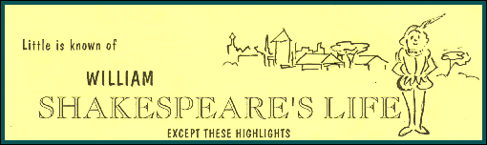

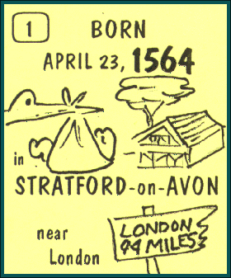

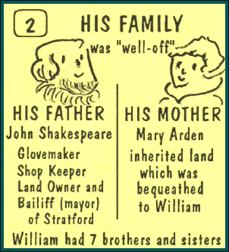

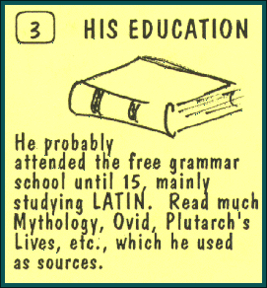

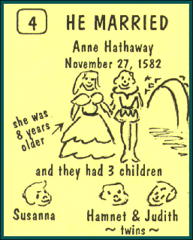



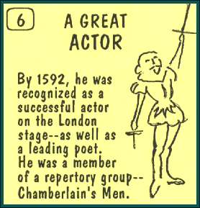

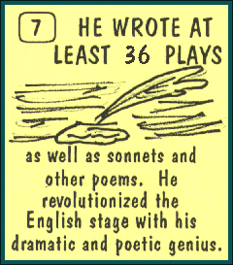

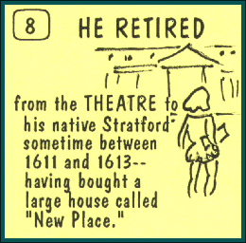

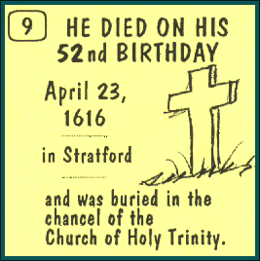

http://www.shakespearehigh.com/students/bio_handout.shtml

Appendix: Costume

Court Dress:

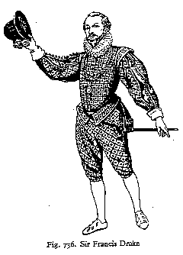
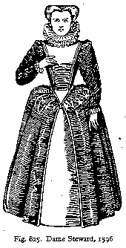

< http://www.lepg.org/clothing.htm>
Find out more detailed information women’s clothing and men’s clothing at: <http://www.lepg.org/women.htm> and, <http://www.lepg.org/men.htm>

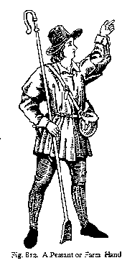
Dress in the Forest:

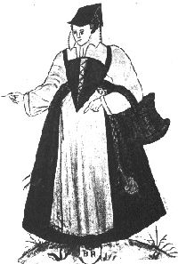

<http://www.lepg.org/men.htm>, <http://www.lepg.org/women.htm>

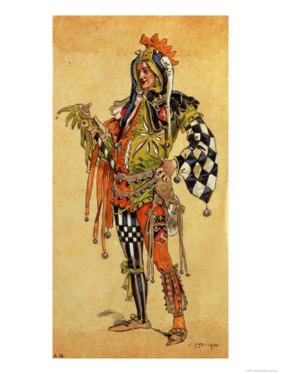
Touchstone:
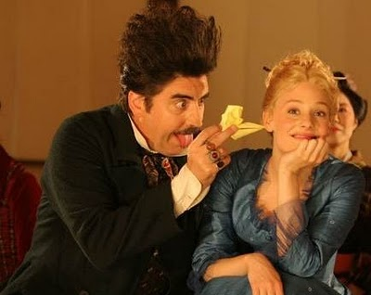

Left: Touchstone played in late 1500’s http://www.artchive.com/web_gallery/C/C.-Wilhelm/Touchstone-the-Clown,-costume-design-for-As-You-Like-It,-produced- by-R.-Courtneidge-at-the-Princes-Theatre,-Manchester.html

Right: Touchstone in Kenneth Branagh’s 2006 version of As You Like It

Appendix: Set Design
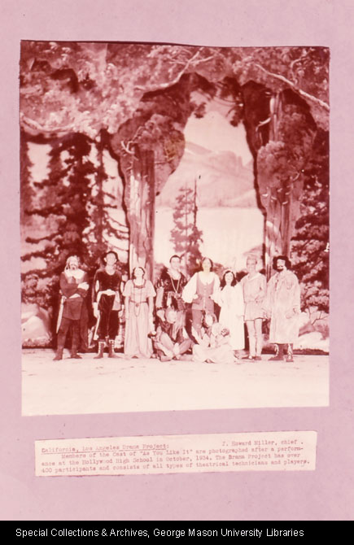


<http://dspace.wrlc.org/view/ImgViewer?url=http://dspace.wrlc.org/doc/manifest/2041/4770>

To the right is a picture
of a modern set for
As You Like It:

<http://www.flickr.com/photos/uistheatre/3502074152/sizes/z/in/set-72157618059004711/>
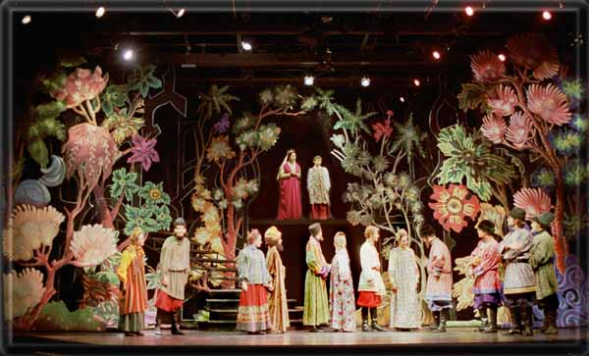

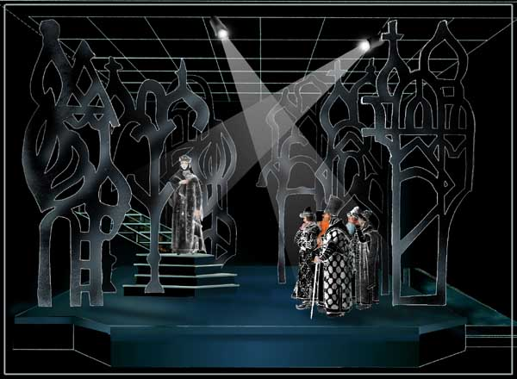

Above taken from < http://www.rfdesigns.org/ayli.htm >
A good contrast to what Shakespeare could be depicting between the court and the forest of Arden.

Good resources for further information on costumes and set:

<http://www.elizabethancostume.net/ > <http://www.costumes.org/classes/fashiondress/16thCent.htm>
< http://www.lepg.org/clothing.htm >
<http://www.costumes.org/history/100pages/timelinepages/1570to1600a.htm>
<http://www.marquise.de/en/1500/pics/1500c.shtml>
video: < http://www.facebook.com/video/video.php?v=554878237917 >
Forest clothes: < http://www.uvm.edu/~hag/sca/work/index.html >
Directing information: http://www.bbc.co.uk/drama/shakespeare/60secondshakespeare/directing_index.shtml
Virtual tour of The Globe: http://www.shakespearesglobe.com/

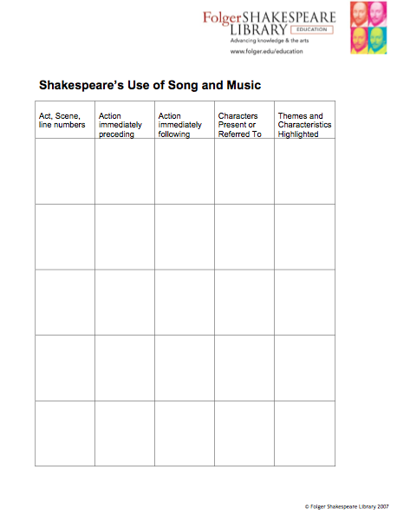
Appendix: Music Handout

<http://www.folger.edu/eduLesPlanDtl.cfm?lpid=713>

Work Cited

Shapiro, Michael. “Layers of Disguise: As You Like It.” In Gender in Play on the
Shakespearean Stage: Boy Heroines and Female Pages, pp. 119-42. Ann Arbor: University of Michigan Press, 1994.

Other useful sources:

Orgel, Stephen. “Why Did the English Stage Take Boys for Women?” Teaching Shakespeare Through Performance. New York: The Modern Language Association of America, 1999. 102 - 113. Print.

Gilbert, Miriam. “Writing about Performance.” Teaching Shakespeare Through Performance. New York: The Modern Language Association of America, 1999. 307-317. Print.

Potter, Lois. “Teaching Shakespeare: The Participatory Approach.” Teaching Shakespeare Through Performance. New York: The Modern Language Association of America, 1999. 235-243. Print.

