EPHE 452
Field Experience
Course
Assignment

2015
Part 2 - Planning

Instructor: Jeff Crane
jeffrcra@uvic.ca

Students Names | Teacher and School
Zoe Graham | Mr. Tom Turnbull
Amanda Mauro | Lambrick Park
Julie Williams | Grade 9/10

Part 2 - Planning Tasks

- Overview of planning
  - Content Analysis for Scope of 4 lessons
  - Sequence of lessons overview
  - Games and task progressions template
  - First lesson-plan.

- Data collection sheets
  - Time on Task
  - Teacher Feedback

- Self-evaluation form to be signed by teacher
Content Analysis

TACTICAL FRAMEWORK OF CONTENT FOR TEACHING

Consider:
What are the tactical problems in scoring/stop scoring and re-starting play?
What off-the-ball movements and on-the-ball skills are necessary to solve these problems?
 | Tactical Awareness
Tactical goals and problems | Movements (off-the-ball) | Skills (on-the-ball)
Offence and Scoring (scoring and restarting play)  Space: Where should you be in reaction to where the birdie is going? Where should you hit the birdie to in order to potentially win the point?  Time: When is the appropriate time to use a certain skill? When should you use a shot to give yourself more time?  Risk: When is it appropriate to play a risky shot? When is it appropriate to force your opponent to play a risky shot?  Force: How do you use force to win a shot? How do you use force to create an attack on your | - Be in a ready position  - Reading the shot  - Reacting to the shot and getting to birdie  - Getting back into a ready position being ready to move anywhere on the court  - Being aware of your opponents abilities in relation to yours | - Adjusting position to hit the birdie with split step footwork and athletic position  - Contacting the birdie at the appropriate time  - Choosing the appropriate shot  - Accurate hit the birdie to a correct location on opponents court  - Ensuring proper grip on racquet
Defence (Prevent Scoring, Starting and restarting play)  Space: Where should you position yourself after the shot to be able to return almost any shot?  Time: When is an appropriate time to reduce the time of your opponent?  Risk: In what ways is it the most useful to utilize time and space in different situations?  Force: What is the appropriate force in your return shot? | - Be in a ready position  - Anticipate your opponents shot  - Respond to your opponents shot  - Respond to opponents position on court  - Recover back to ready position in middle of court | - Adjust position to hit proper shot, to open space  - React with footwork to hit shot  - Contact the ball at the appropriate time  - Proper grip on racquet  - Choose the right force to get the birdie to the open space

Scope

What are students’ entry abilities? (The students will be able to= TSWBAT)
- TSWBAT know the proper grip for a forehand grip (cognitive)
- TSWBAT understand basic rules of badminton (cognitive)
- TSWBAT work as individuals and groups up to four of their peers (social, affective)
- TSWBAT hit a birdie over the net with their partner (psychomotor)

What do you expect to be students exit abilities?
- TSWBAT understand basic game tactics (cognitive)
- TSWBAT able to use and set up proper equipment (cognitive)
- TSWBAT able to play single and doubles (cognitive, social)
- TSWBAT listen to teachers instructions (social, affective)
- TSWBAT choose groups and work cooperatively with one another (social, affective)
- TSWBAT abide safety rules (social, affective)
- TSWBAT execute a proper serve (cross court and over service line) (psychomotor)
- TSWBAT demonstrate understanding and execution of the 4 R’s (psychomotor)
Overview and record of unit

Lesson 1 | Lesson 2
Game Aim  3 rules  Tactical Problem  Lesson focus  Introductory task/game  Skill/Concept development tasks/games  Culminating Game Activity: | Game Aim  3 rules  Tactical Problem  Lesson focus:  Introductory task/game  Skill/Concept development tasks/games  Game and culminating activity:
Lesson 3 | Lesson 4
Game Aim  3 rules  Tactical Problem  Lesson focus:  Introductory task/game  Skill/Concept development tasks/games  Game and culminating activity: | Game Aim  3 rules  Tactical Problem  Lesson focus:  Introductory task/game  Skill/Concept development tasks/games  Game and culminating activity:

Game

INSERT DIAGRAM HERE

How score : _____________________________________________________
_____________________________________________________

Rules:
How can you modify the game? (a) to make it flow, and (b) adapt it to make competition close?
What tactical problems does the game create?
What skills do you need to address these problems?
Off-the-ball Movements (Loco & Non-loco) | On-the-ball Skills (Manipulative)

Skill Phases for Key Skills (Sending, receiving or retaining)
Preparatory phase | Wind-up phase
Force phase | Recovery phase

Questions to help learner read tactical problems with and without the ball
Space

Time

Force

Risk

Outline Task Progression to follow to learn content for the Culminating Game

Task | Technique or Strategy | TASK/GAME instructions | Achievable goal of task or game to move on to next task/game | Cues or refinements for technique or strategy | Extensions/  Simplifications  S.T.E.P.

Create a map of your gym

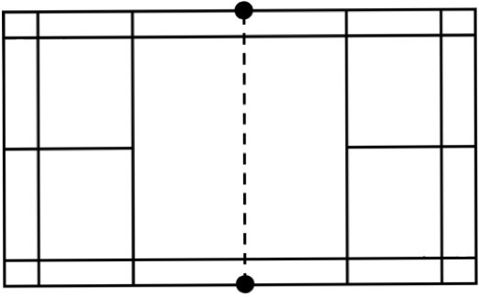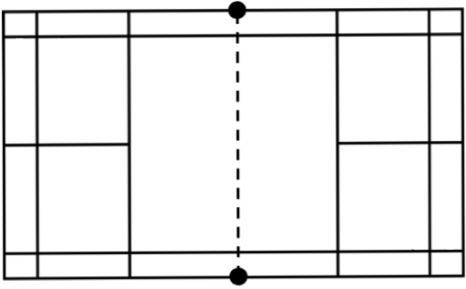


Teaching Feedback Sheet

Names of Teachers:____________________ Commenter:___________________

Hints | Hurrahs

Organization, use of space and Groupings
Task Progression
Refinements and feedback

Teacher Presence and Positioning

Pace, time on task and other thoughts
How were the learning domains challenged?
Additional comments:
Self-Evaluation: Signed and Returned to Instructor

Students’ Names: School:
Dates of Field Experience: Teacher/Coordinator:

Student Teachers Self-Assessments

What we have learned

Questions to pursue further

Assumptions we challengd

_________________________________________
Student Teachers’ Signatures

Co-operating-teacher’s comments

________________________________ _______________________________
Cooperating Teacher’s Signature University Instructor’s Signature

