8 spots and 4 paddle bats
3 bouncy balls
3 high bounce form balls
6 blue lines
Equipment Monitor

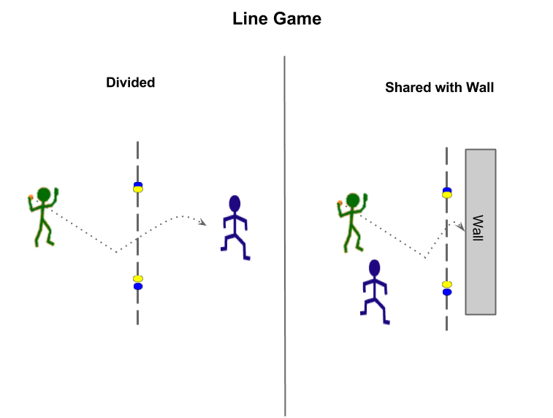
Aim of game: Bounce the ball on your side of the line between the spots to land in opponent’s area
- Ball must be sent from shoulder height and must bounce on sender’s side of the line.
- Ball must be sent between the two spots assigned to the sender (i.e. yellow or blue)
- Score point if ball is dropped or bounces on opponent’s side of the line before being caught
- Score point if sender fails to get the ball to bounce between assigned spots.
Official

Extensions to the game
Coach
- Catch and then strike ball with hand
- One-touch control then strike ball with hand or bat
- Strike ball with bat

How could a modification by adaptation rule be added to your game?
(Outcome of a game encounter changes the game for winner to make the game more challenging)
Strategies
Principles of Play
Consistency
Placement
Positioning
Spin
Power
Swap and play line game with wall if used just line and visa versa if started with the wall.
Analysis
What are the key strategies (ways of playing and movement off-the ball) to use to be successful at these games?
______________________________________________________________________________
______________________________________________________________________________
What body management (movement skills) do you need to play your game?
______________________________________________________________________________
What are the manipulative skills you need to play these games?
Choose a Sending Skill
Name Skill: ____________________________
- Preparation…………
- Wind-up…………….
- Force-Generation…
- Recovery…………..

What would be two tasks you could do to practice that would help your peers play your game?
Consider (1) Skill cues (2) Tactical prompts
Task | Word Suitable Tasks
1
2

