Active Health: Case Study with Ruby Scott

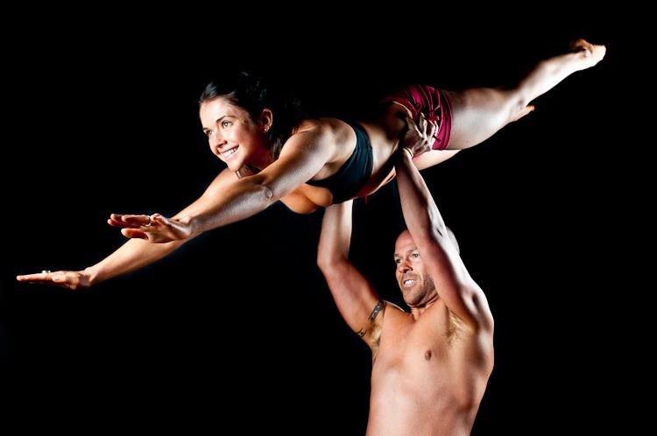

EPHE 246  
  
Prof. Kai Riecken   
  
Alex Howes

V00704201  
  
Feb 20th 2012

Title Page 1

Table of Contents 2  
  
Introduction 3  
  
Rationale for Choosing Ruby 4  
  
Personal Definition of Active Health 5  
  
Interview Questions & Responses/Analysis 6-14  
  
Conclusion 15  
  
References 16  
  
Appendix   
  
Recommended Resource by Ruby 17  
  
Additional reading 18

**Introduction:**

The current state of health of general population has been rapidly declining for some time now. In 2007, the Standing Committee on Health predicted that "today's children will be the first generation to have poorer heath outcomes and shorter life expectance than their parents". The entire report released in March of 2007 is full of shocking information concerning today's youth, their obesity rates and health issues we are facing if we continue our current lifestyles. It also estimates that obesity costs Canada 1.6 billion dollars annually in direct health care costs, and a whopping 2.7 billion dollars annually in indirect costs (lost productivity, disability insurance, reduced quality of life and mental health problems due to stigmatization and poor self-esteem). The effects of the society we are currently living in are not only having an effect on our physical health, but all other aspects of active health as well (social, environmental, spiritual, emotional). All nighters, hours of screen time, poor hygiene, and insufficient nutrient are all things we as a society have become guilty of lately. If we are going to stop our obesity and sedentary problems at their roots, we are going to need a massive social change. Today I have chosen to interview a health advocate and long time friend Ruby Scott to help explain what changes need to be made, and how we can begin to make them.

**Why I chose Ruby Scott**

Ruby was the perfect interviewee for this case study because she has insight into practically every aspect of active health. She is a personal trainer, a nurse, and most importantly a health nut! She was also a kind of mentor to me growing up. I was raised in an overweight sedentary family who liked nothing more than couple slices of cheesecake and some chocolate (they were all raised in Germany, go figure). It seemed I was the odd duck in the family because I never had much of a sweet tooth, and I preferred going out and playing sports rather than watching them on T.V.. Unfortunately I lacked any kind of guidance in the health department, and as a result didn't find many opportunities to get actively involved. Then I met Ruby, a health fanatic at 19 who opened my world to the possibilities of active health. She began teaching me about cardiovascular health, nutrition, and ways to release stress through exercise. She was a few years older than me, and studying nursing at the time so she always had juicy tidbits of information she had learned and wanted to share with anybody who would listen. I became her disciple and before long I had chosen to pursue physical activity and become a health advocate myself. Needless to say, Ruby was an easy choice for a case study interview.

**My Personal Definition of Active Health**

Active Health to me is about taking action and responsibility for your own personal health and well being. Its also knowing that although you may consider yourself healthy, there is always room for improvement in some aspect. Good health is made up of a variety of different features, including physical, social, emotional and environmental well being. To be actively healthy physically, an individual should take part in regular bouts of physical activity. According to the Canadian Society for Exercise Physiology that means 60 minutes per day of moderate-vigorous activity for adolescents, and 150 minutes per week for adults. This includes nutrition too! You are what you eat, so if you eat a lot of junk, you're going to feel like junk. Social well being to me means creating and maintaining positive relationships with the people around you; friends, family, peers, co-workers, teachers bosses etc.. Emotional health is more important than many people think. Being a student means I am subject to a lot of stress and heavy work loads. Good time management and planning allow me to control these things to the best of my abilities and not feel overly stressed or anxious. Active health encompasses a very broad spectrum, but many of these things overlap. For example, has been directly linked to help manage depression, anxiety, stress, and many other factors (Scully, 1998). The list of overlaps is long and complex, but the idea of active health is simple: take action in the fight for your personal well being.

**Interview Questions, Answers and Analysis:**

**Legend:**

**Alex's Questions**

*Ruby's Answers*

(Alex's brief analysis)

**So first things first, how about a quick bio of Ms. Ruby Scott?**

*Sure! I am a 25 year old female born and raised in Victoria. I am a personal trainer under my boyfriend's business "New You Fitness" certified with BCRPA as well as Health Fitness and Alliance. I have clients ranging in physical and mental constraints from a 30 year old male paraplegic, to a 300 lb woman, to your average girl on the elliptical at any gym. I like to think all of that changes when they decide to come work with me though! It is just not a workout, its diving deep into their current struggles and finding the center of the knot that allows them to unravel into the human being that is proud of being in their own skin. I also recently graduated from UVIC with my Bachelor of Sciences in Nursing, and work part time on the Surgical Relief Pool at the Royal Jubilee Hospital. I work on post-surgical wards such as orthopaedics, complex wounds, gastroenterology, burns, vascular, as well as the Emergency Ward. I am juggling to find the perfect balance with both work and my active life, but so far things could be worse.*

**Sounds busy! So tell me, what does the term “Active Health” mean to you?**

*To me it would mean going beyond acknowledging health risks and potential habits/risk factors and actively advocating for your own health. Whether that be a trip to the doctor that is long over due, a long walk, hiring a personal trainer, or going to the gym. It means you have to move, in a direction that is internally inspired to improve your health. Or at least that’s what I think of, but I’m sure you’re about to tell me it’s something else entirely aren’t you?*

**Haha, no I’m not everyone is entitled to their own views and opinions on health. Although, your definition of active health focuses strongly on the physical health, but don’t you consider mental health important too?**

*Absolutely! I guess for me the two go hand in hand but maybe not for everyone. When I go to the gym it’s not strictly to work out. The gym can be a very social place, which I consider very important for one’s health. In fact, that’s where I met my boyfriend! Now we’re both personal trainers under his business “New You Fitness”, and couldn’t be happier. Exercise gives me the opportunity to release a lot of tension too, whether it be from a hard days work, ridiculous amounts of school work, or something else that’s just rubbing me the wrong way. You’re never in a good mental state when you’re stressed out, or anxious and for me exercise was a key part of channelling my worries and getting me to a place I needed to be mentally. From a nurse's point of view, I can tell you that a positive attitude can do wonders for recovery too. I don’t know what it is or if there’s even medical reasoning behind it but patients that are in a positive mental state seem to recover quicker and better and those with a negative, anxious, or depressed point of view. They're overall demeanor is good, and even though they might be recovering from a physical injury, they never lose touch with their good mental health. Oh, and did I mention they're a pleasure to deal with?*

(Ruby has a good grasp on the ideas of active health. She looks at it in many different ways, like the physical and mental aspects of physical activity, as well as the emotional health of patients in the hospital. It was interesting to hear her talk about positive thinking to increase recovery time. After the interview I did some research on the reasoning behind this. Although interesting, I didn't fins anything definitive that I will be citing today.)

**Now we’re talking! Alright why don’t you tell me a little bit about how active health fits into your life?**

*Strictly for me, I do not fit active health into my life, but rather it is my life! It started when I was about 16 years old, up until which time I absolutely detested any form of exercise, running, sweating (making a grossed out face). At sixteen, I participated in a student exchange in Australia, and suffered from homesickness, and for whatever reason, turned to jogging as a coping mechanism. At first I couldn’t make one lap around the track, but after 3 months I ran the track 15 times everyday. When I arrived back home to Canada, I continued to run, mostly for psychological purposes, to reflect, feel a rush, and sweat out any fears or anxieties. After high school I decided that I needed to combine my work and fitness, in order to free up time to pursue school to become a nurse. Essentially I wanted to get paid to be active, and share my passion with others. Currently, I work part time as a nurse and part time as a personal trainer. When I’m in my nursing shoes, I wake up at 5:30am to clear my head and get in a neutral head space, and I use one of my dinner or lunch breaks to do my weights. Sometimes I will follow my day shift with a yoga class to rid my mind of the busy day and chaos I meet with over worked and understaffed nursing conditions. When I have my personal training shoes on, I strive to assess clients of their physical and psychological strengths and weaknesses, and start from the bottom up. Assessment is extremely important, as it dictates what a person can do to gain strength and confidence, as well as what they can absorb in terms of information. Then they can begin to incorporate that information into their own active health and perseverance to attain what is defined as "health" to them. As you can see, active health is my life, and I do it to both maintain a high functioning cardiovascular and functional strength conditioning, but just as importantly, it is to me, what valium is to others. It is my drug of choice, it calms me, it cleanses me, it flushes me, and it gives me a goal every day that I can conquer.*

(It's clear that Ruby is a health fanatic. She bases her entire day around not only the improvement of her own health, but the health of others as well. Her comments about assessment of her clients being incredibly important stood out to me. Ruby clearly takes the time to really understand both the physical and psychological strengths and weaknesses of the people around her, and uses that to advocate health to them in a way they can grasp. She also mentioned yoga as a good way to relieve herself of a stressful day. Yoga is both an emotional and spiritual booster.)

**Awesome, so what are some things you do to advocate active health to others?**

*To advocate for clients and patients, I need to assess their current understanding of health, and what they are initially willing to commit to. Only then can I begin to fertilize their internal seed of active health, and help it come to fruition. What I mean by that is that while daily physical activity, proper nutrition, and other health related concepts seem natural to you and me, doing these things is a real challenge to most people. So I really try and take the time to understand an individual’s needs, goals, and understanding of health related concepts before pushing them towards anything to fast. That being said, I also try to push everyone around me (clients, friends, family) to set goals for themselves, and offer them a helping hand when necessary. Last year I was helping some friends achieve some of their fitness goals when we decided that as a motivational tool we would enter ourselves into the Fitlive 2011 Fitness Show in the bikini category. It really inspired us to take health seriously, and at the show we met so many amazing people who all understood the value of making health a priority. So by advocating health to a few friends, suddenly they turned into health advocates too!*

(Her comments here really solidified that shat she knows what she's doing. She recognizes that although she may love fitness and health related concepts, not everybody shares her enthusiasm. It's nice to see that wasn't lost on her throughout her years of training, and she's still able to work with people at any level of fitness.)

**That sounds like a really positive experience, but let’s face it; it’s not always that easy. What are some of the challenges you face as a health advocate?**

*Well, in personal training clients often have psychological barriers. Many of them take the point of view that the workout and food regiment is controlling the way that they live. I try to show how they are actually controlling their life by taking control and having power over their overall health. Not everyone understands this though, and it can be a real challenge to keep people focused. Cost is another problem for a lot of people. Not everyone can afford personal trainers, and they feel as though that’s the only way they can stay healthy. The truth is that most people don’t need a personal trainer, they just need the motivation to do things themselves. Living in Victoria we are truly blessed with all the opportunities we have to improve our health both physically, nutritionally, and socially. That being said, although social involvement is a positive mental health characteristic, many people feel pressure to go out with their friends and eat fatty foods, and drink sugary/ alcoholic drinks. What I try and communicate to people around me is that I’m all for having a drink here, and a chicken wing there, but everything in moderation. If you went to wing Wednesday skip out on nacho Friday. Time is another problem. Not much to be said about it though, I wish there were more hours in a day. Unlike me not everyone is willing to give up their lunch break for a quick workout.*

*In Nursing we deal with a variety of challenges: depression, co-morbidities, overworked and understaffed nursing conditions, fear, anxiety, and lack of knowledge regarding illness/condition. These are issues that reflect directly on us as nurses, as well as on the patients. It’s an every day struggle to deal with these problems but those are challenges we are willing to face to improve the health conditions of everyone around us.*

(Ruby experiences all the barriers and challenges expected of your typical health advocate. She provided me with some really great ideas about how to get around some of those barriers with future students though.)

**What are some ways you hope to further enhance the Active Health concept?**

*Well every day I get the opportunity to pass my knowledge onto others, and everyday I urge others to pass on what they know now. “New You Fitness” is gaining more clients every week, and unfortunately people will never stop needing the hospital. Between clients, friends, patients, family, and anybody else that gives me the opportunity I try really hard to share my positive experiences, and knowledge in hopes that they will pass that onto others.*

(Sharing her knowledge with everyone she can, and encouraging them to pass on that information was the same way Ruby changed me into the health advocate I am today.)

**In an ever advancing technology based world, children and adults are becoming more sedentary every day. Any useful strategies you’ve found to use technology and promote health at the same time?**

*Well I think some of the virtual reality video game systems are on the right track. I would never go as far as to suggest this instead of regular exercise, but its better that sitting with a controller in your hand for hours on end. It didn’t take me long to figure out that I didn’t really need to use my whole body for a lot of the Wii games like boxing or tennis though, I simply had to flick my wrist. Dance dance revolution on the other hand left me sweating like a pig! I think these are a good start, especially to maybe get kids who are not physically active to take a sudden interest in a sport.*

(V.R. video games are a step in the right direction but are still not a substitute for actual exercise. Especially when only 10% of Canada's youth meet the quota of under 2 hours of screen time a day, and the average Canadian youth spends 6 hours a day outside of school time, and 7 hours a day on weekends (Active Healthy Kids Canada, 2011)).

**What percentage of Canadian youth do you think is inactive?**

*I want to have faith and say maybe half? But that sheepish grin on your face tells me I’m way off the mark*

**87%**

.........................................................................................................................(shaking head)

**Who is responsible for providing children with a healthy lifestyle?**

*Everybody! I think as a community we have a responsibility to share our knowledge with children and provide them with as many opportunities as possible to get active. Teachers, parents, peers, doctors, neighbours….we’re all in this together. Until the age of 5, family is the main source of contact a child has, and that contact will continue all throughout their lives. Raising a child in an active environment at home is a great way for parents to guide their kids towards a more active lifestyle in the future. School is a great way for kids to get active, especially younger ones. Teachers and peers should provide opportunities for absolutely everyone to get active everyday. We could say these things about anybody, and if everyone encouraged the people around them to get active in some way, we wouldn’t have a problem at all.*

(Interesting to hear the value Ruby places on family participation at an early age. I imagine had I been raised in that type of environment I would have been active much sooner.)

**What about the government, are they responsible?**

*Absolutely! We’re lucky to live in a place where lakes, trails, and fields are in no short supply but not everyone is so fortunate. The government needs to be involved in supporting organizations and events that promote the Active Health concept, like rec centers and public community sporting events. They also need to be actively involved within the schools. I love that becoming a P.E. teacher doesn’t just mean tossing a ball around all day, but rather becoming a true advocate of health. But where are these concepts in elementary and high school? That’s why were at 87%!!*

(I strongly agree. The Active Healthy Kids Report Card on Physical Activity for Children and Youth 2011 stated that "93% of parents reported that public facilities for P.A. and sports are available locally, and 95% say parks and outdoor spaces for P.A. and sports are nearby and available". So the problem is not in the lack of availability but more so in the lack of education. The same report card stated that 22% of parents reported their children have absolutely no daily P.E.)

**How important is nutrition to you?**

*Obviously nutrition is a huge part of a person’s overall health, but I believe we are constantly being misinformed about it. Maybe misinformed isn’t the right word, more like uninformed. There are no regulations that state that nutritional values must be posted in any restaurants, why not? Without the proper information, how is an individual supposed to make an informed choice about their meals? A deluxe pizza for Dominos isn’t healthy just because it has 5 types of vegetables on it, and lettuce and tomato don’t help out the Big Mac much either. That being said, live a little, haha. I’m a firm believer in everything in moderation, just make sure you know what the definition of moderation is! On a side note, I urge anybody who's looking for great recipes or nutritional ideas to check out http://www.facebook.com/newyoufitnesspt. It offers amazing cooking ideas, as well as training tips, motivational quotes, and photos of me, my boyfriend and lots of our clients doing different workouts.*

(Ruby seems a little lax on the nutrition stand, although I've seen what she eats on a daily basis and I can tell you it's not a Big Mac. Having a regulation that forces restaurants to provide diners with caloric costs and nutritional values would give people the information needed to make healthier choices. It would be up to them to partake in active health.)

**Well Ruby, I’m sure we could talk about this all day, but before we go, any words of wisdom?**

*My words of wisdom are to strive towards balance in life! Have a few nachos and a beer with your friends on Friday, but maybe hit the trails Saturday morning to flush out your circulatory system, sweat it out. Be good 90% of the time - clean food and sweat - set personal goals - and with that in mind, I hope to never have to be your nurse because I don't want any of you to have to step foot in the hospital. And if you do, well start back at square one…*



**Conclusion**

This case study was an amazing opportunity to learn from someone who is so actively involved in multiple aspects of health and health education. Hearing tips from Ruby is always far more inspirational and personal than reading a long list of facts out of any book or website. Ruby explained how important it is to become fully involved and committed to understanding the personal needs, goals, and barriers of each individual, as well as techniques to overcome those barriers. She understands that not all individuals embrace active health as a core value of their life. Her goal is to change that, and help people around her understand that health is not only related to ones physical capabilities, but to their mental strength as well. As a physical education teacher, I am going to face many of the barriers Ruby mentioned. I took some good ideas about how to get around these though, such as positively reframing the aspects of health that people tend to look at negatively. It will be important to remember to not only discuss health, but to advocate the active participation in it too. Participation at an early age can help youth understand the benefits and carry those lessons with them into adulthood. As a teacher I will have the chance to develop many young minds into active health advocates, and hopefully prevent avoidable health issues such as cardiac disease and obesity. Someone somewhere once said, "an ounce of prevention is worth a pound of cure".

**References**

House of Commons Canada. (2007). *Healthy Weights for Healthy Kids*. Retrieved February 20, 2012 from http://www.ccfn.ca/pdfs/healthyweightsforhealthykids.pdf.

Canadian Society for Exercise Physiology. (2011). *Canadian Physical Activity Guidelines.* Retrieved February 20, 2012 from http://www.csep.ca/CMFiles/Guidelines/CSEP- InfoSheets-youth-ENG.pdf.

Scully, D., Kremer, J., Meade, M. M., Graham, R., & Dudgeon, K. (1998). Physical exercise and psychological well being: a critical review. *British Journal of Sports Medicine, 32, 111-120.* Retrieved from http://bjsm.bmj.com/content/32/2/111.full.pdf+html.

Active Healthy Kids Canada. (2011). *Report Card on Physical Activity of Children and Youth.* Retrieved February 21, 2012 from http://dvqdas9jty7g6.cloudfront.net/reportcard2011/ahkc2011_shortform_eng_final.pdf

**Appendix**

**Source suggested by Ruby:**

http://www.facebook.com/newyoufitnesspt

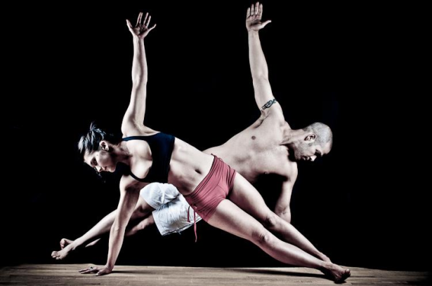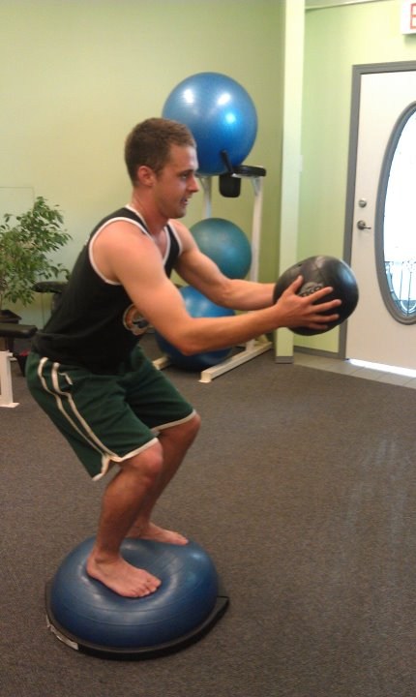

<<< Seared Tuna Soba Salad

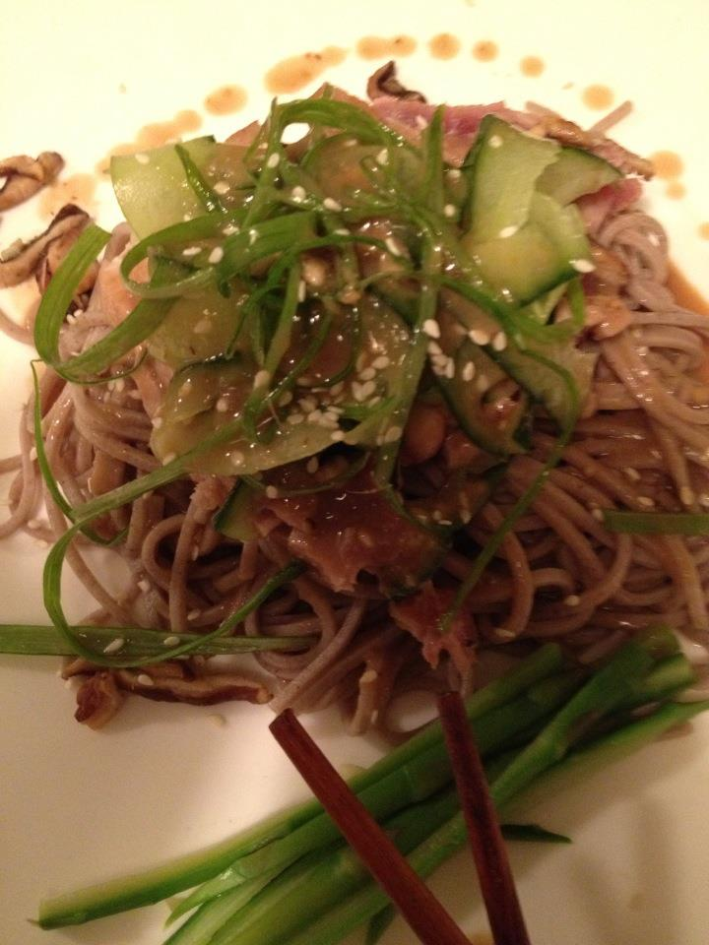

**Additional Resources worth reading:**

Katzmarzyk, P. T. (2002). *The Canadian Obesity Epidemic.* Retrieved February 15, 2011, from   
 http://www.cmaj.ca/cgi/content/full/166/8/1039

Maziak, W., Ward, K. (2009). From Health as a Rational Choice to Health as an Affordable  
 Choice. *American Journal* *of Public Health,* 99 (12), 2134-2139. Retrieved from: http://www.ncbi.nlm.nih.gov/pmc/articles/PMC2775783/pdf/2134.pdf