**Active Health Seminar Package:**

Helping Students Overcome Barriers to Physical Activity & Post-Workout Nutrition

Alanna Macdonald, Cole Dagg, Ryan Davidson, Kim Robertson and Megan Hedican

EPHE 246

Presentation Date: March 17, 2014

Table of Contents

Introduction and Rationale for the Lesson Plan_______________________________________3

Our Workout_________________________________________________________________4

Post-Workout Nutrition_________________________________________________________6

Post-Workout Nutrition Rationale___________________________________________6

Smoothie Recipe________________________________________________________7

Nutritional Information___________________________________________________7

Other Possible Smoothie Ingredients________________________________________7

Make Your Own Workouts______________________________________________________8

Presenting the Workouts__________________________________________________8

Incorporating Curricula Goals___________________________________________________9

References__________________________________________________________________10

Appendix A: Student-Made Workouts____________________________________________11

Introduction and Rationale

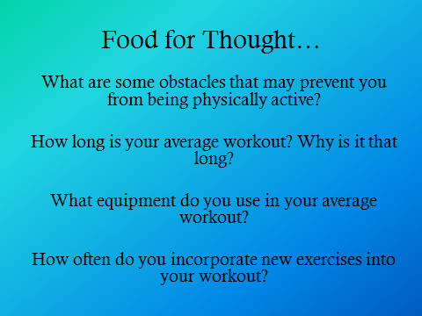 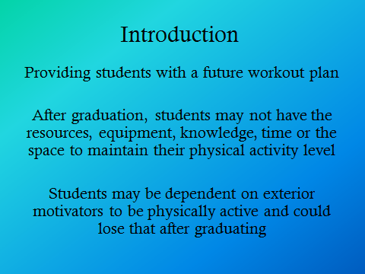

We have designed a lesson based around providing students with the tools to overcome barriers to physical fitness. We incorporated post-workout nutrition into our presentation as a way to portray the importance of replenishing the body, but also to portray that a healthy post-workout snack does not have to be costly. The workout we have designed is a cost effective program that requires minimal space and equipment. The exercises included are all based on fundamental movement skills and are scalable to facilitate all levels of participants. In a school setting, this program can be part of any physical education program or even in the planning 10 curriculum, as it gives students the chance to learn new and effective workout movements while also equipping them with the knowledge to perform the routine once they graduate. After graduation, students often lose many of the social constructs that kept them active in high school. Physical education classes, coaches, teachers, and team activities all fade as it becomes up to the individual to sign up and participate in activities and sports on their own in a post-secondary setting. This loss of external motivation can often result in decreased amounts of physical activity, and may eventually lead to some very serious health complications. By illustrating to students how quickly a workout can be performed alone or with friends through high intensity interval training, they are more likely to continue to be active throughout their post-secondary life. Furthermore, another benefit of high intensity interval training is that it can be performed anywhere. Students who are not used to a gym atmosphere and may feel uncomfortable in such an environment can utilize high intensity interval training to remain active and maintain an active lifestyle. In conclusion, our program is cost efficient and can be performed anywhere and by a wide-range of abilities. By introducing students in high school to this kind of training we can, as educators, increase the chances that these students will leave high school with the knowledge and confidence to maintain an active healthy lifestyle in their post-secondary lives and beyond. As explained by Gibala, Little, MacDonald & Hawley (2012):

Exercise training is a clinically proven, cost-effective, primary intervention that delays and in many cases prevents health burdens associated with many chronic diseases. Particularly in post-secondary education, health becomes a recurring struggle for many individuals, regardless if they are immediately immersed in a career or post-secondary education. These years can be highly associated with high stress levels as well as unhealthy diet due to lack of knowledge of healthy foods, financial reasons, and time restraints. Precise type and dose of exercise needed to accrue health benefits is a contentious issue with no clear consensus. HIIT (high intensity interval training) is an effective alternative to traditional endurance-based training. “Lack of time” remains the most commonly cited barrier to regular exercise participation.

Our Workout

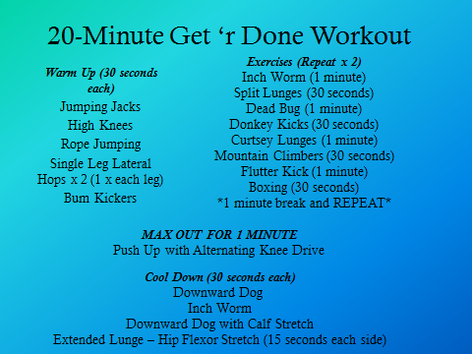 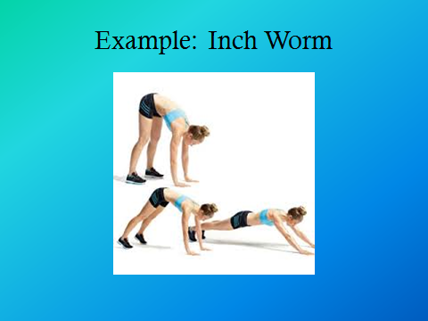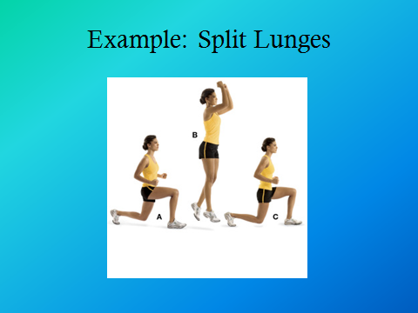 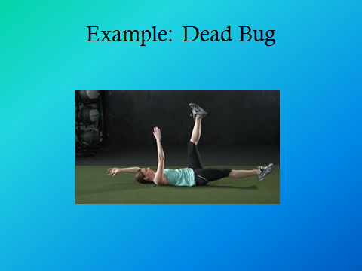 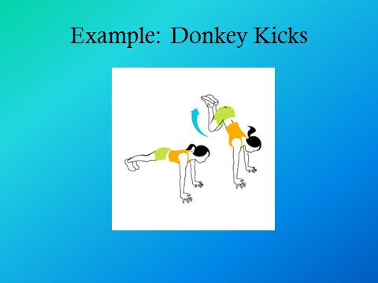 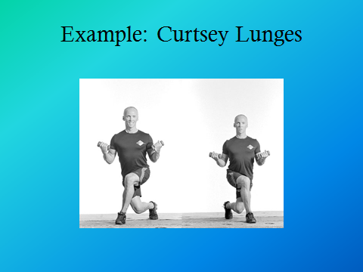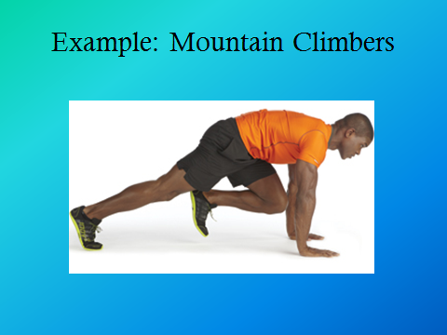 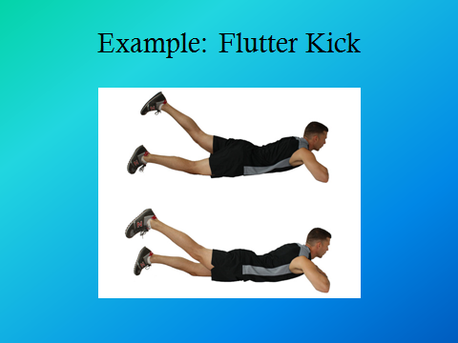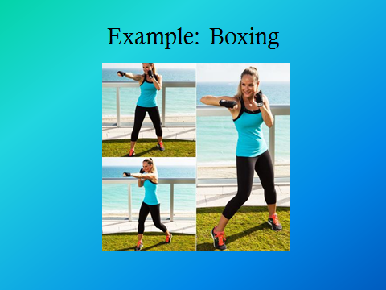 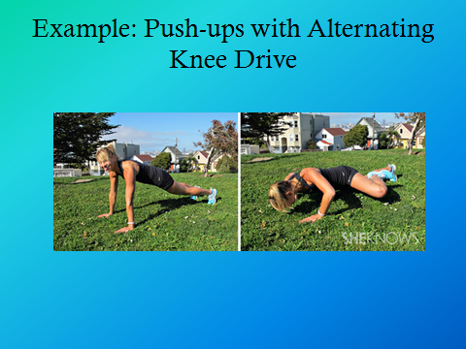Note: All images were found by searching “Example [insert exercise name] exercise” on Google Images.

|  |  |  |  |
| --- | --- | --- | --- |
| **Warm Up**  (30 seconds each) | **Exercises**  (Repeat x2 with a 1 minute break between) | **Max Out**  (1 minute – as many as you can) | **Cool Down**  (30 seconds each) |
| Jumping Jacks | Inch Worm (1 minute) | Push Ups with Alternating Knee Drive | Downward Dog |
| High Knees | Split Lunges (30 seconds) |  | Inch Worm |
| “Rope” Jumping | Dead Bug (1 minute) |  | Downward Dog with Calf Stretch |
| Single Leg Lateral Hops (15 seconds x each leg) | Donkey Kicks (30 seconds) |  | Extended Lunge – Hip Flexor Stretch  (15 seconds each leg) |
| Bum Kickers | Curtsey Lunges (1 minute) |  |  |
|  | Mountain Climbers (30 seconds) |  |  |
|  | Flutter Kick (1 minute) |  |  |
|  | Boxing (30 seconds) |  |  |

Post-Workout Nutrition

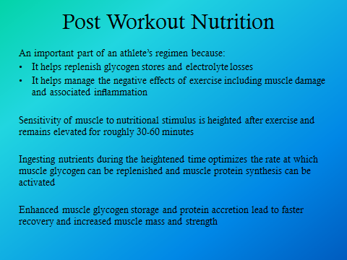 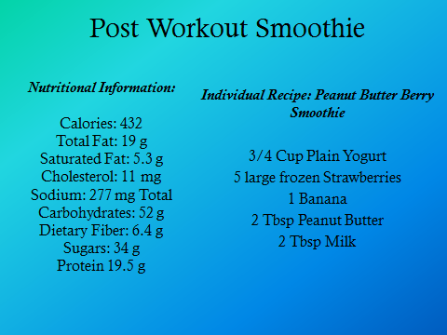

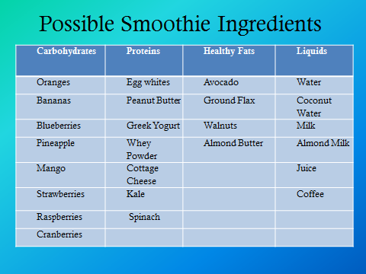

Post-Workout Nutrition Rationale

* After exercise, key fuel stores such as muscle glycogen are low or even depleted (Ivy, 2010).
* We need to replenish these stores to balance energy expenditure and intake.
* Post-exercise nutrition is an important part of an athlete’s regime to replenish glycogen stores, ﬂuid and electrolyte losses and, to manage the negative effects of exercise including muscle damage and associated inﬂammation. Protein ingestion post-exercise increases the rate of muscle protein synthesis and suppresses muscle protein break-down, allowing net muscle protein gain (Reid, 2013).
* Sensitivity of muscles to nutritional stimulus is heightened after exercise and remains so for approximately 30-60 minutes (Ivy, 2010).
* Ingesting the proper nutrients during this heightened time optimizes the rate at which muscle glycogen can be replenished and muscle protein synthesis can be activated (Ivy, 2010).
* Recent research has demonstrated the effectiveness of carbohydrate-protein supplementation in restoring muscle glycogen, repairing muscle damage, diminishing protein loss, and initiating protein synthesis (Ivy, 2010).
* Enhanced muscle glycogen stores and protein accretion lead to faster recovery and increased muscle mass and strength (Ivy, 2010).
* Appropriate nutrient supplementation during and following exercise can also prevent exercise-induced immune system suppression (Ivy, 2010).

Smoothie Recipe: Individual Serving Size (Fitness Blender, n.d.)

Strawberry Peanut Butter Banana Smoothie: ¾ cup plain yogurt, 1 banana, 5 large strawberries, 2 tbsp. peanut butter, and 2 tbsp. milk

Nutritional Information: Individual Serving Size (Fitness Blender, n.d.)

|  |  |
| --- | --- |
| **Calories** | 432 |
| **Total Fat** | 19 g |
| **Saturated Fat** | 5.3 g |
| **Cholesterol** | 11 mg |
| **Sodium** | 277 mg |
| **Carbohydrates** | 52 g |
| **Dietary Fibers** | 6.4 g |
| **Sugar** | 34 g |
| **Protein** | 19.5 g |

Other Possible Smoothie Ingredients

|  |  |  |  |
| --- | --- | --- | --- |
| **Carbohydrates** | **Protein** | **Healthy Fats** | **Liquids** |
| Oranges | Egg whites | Avocado | Water |
| Bananas | Peanut Butter | Ground Flax | Coconut Water |
| Blueberries | Greek Yogurt | Walnuts | Milk |
| Pineapple | Whey Powder | Almond Butter | Almond Milk |
| Mango | Cottage Cheese |  | Juice |
| Strawberries | Kale |  | Coffee |
| Raspberries | Spinach |  |  |
| Cranberries |  |  |  |

Make Your Own Workouts

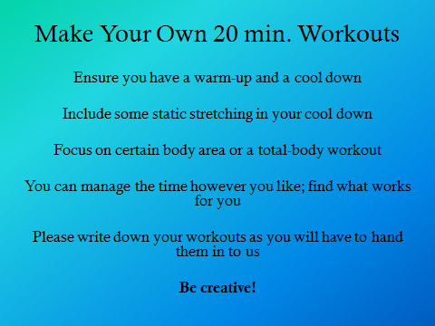 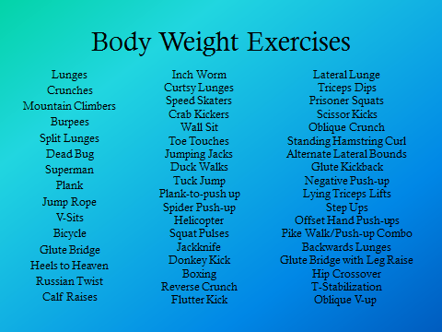

Students will be paired up and provided with the following criteria:

* Ensure you have a warm-up and a cool down
* Include some static stretching in your cool down
* Focus on certain body area or a total-body workout
* You can manage the time however you like; find what works for you
* Please write down your workouts as you will have to hand them in to us
* Be creative!

Presenting the Workouts

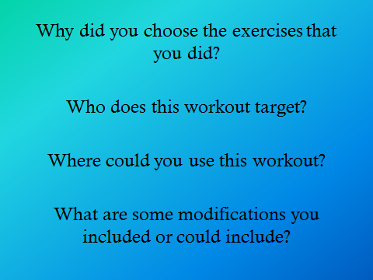

Students will be given the following questions as discussion prompts:

* Why did you choose exercises that you did?
* Who does this workout target?
* Where could you use this workout?
* What are some modifications you included or could include?

Incorporating Curricula Goals

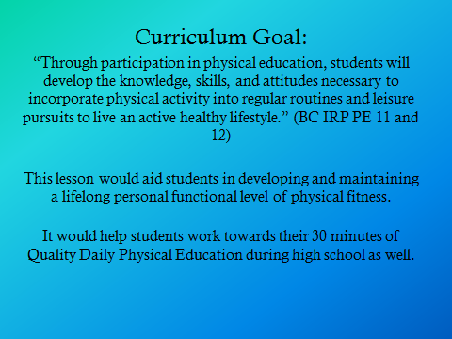

Designing and implementing individual exercise programs is one aspect of the grade 11 and 12 Physical Education integrated resource package. The curriculum goal is to aid students in developing and maintaining a lifelong personal functional level of physical fitness. A critical focus in physical education is to help students develop the “knowledge, skills, and attitudes necessary to incorporate physical activity into regular routines and leisure pursuits to live an active healthy lifestyle” (British Columbia Ministry of Education, 1997). As physical educators, we wanted to give our students the tools to take part in pursuing a healthy and active lifestyle on their own. Our active health lesson plan consisted of a 20 minute HIIT work out followed by the students taking part in the student-centered learning process where they were asked to design their own 20 minute workout. As stated in the Physical Education 11 and 12 integrated resource package: “programs are structured so that the duration, intensity, and frequency of activities motivates students to meet their individual goals” (British Columbia Ministry of Education, 1997). The function of the 20 minute exercise program recognizes the importance of duration, intensity, and frequency and as such, can help students achieve the ‘daily physical activity’ requirement of 30 minutes a day.

This exercise program can also be a useful resource in a Planning 10 course. The general aim of Planning 10 in the curriculum is to “enable students to develop the skills they need to become self-directed individuals who set goals…and take responsibility for pursuing their goals throughout life” (British Columbia Ministry of Education, 2007). By designing their own programs and implementing the knowledge from previous lessons, students will be participating in self-directed learning. This is a critical component to the rationale of the Planning 10. This active health lesson plan gives students the tools to further their knowledge on fitness and exercise for future implementation, and therefore they will be able to “pursue their goals throughout life” (British Columbia Ministry of Education, 2007).

References

British Columbia Ministry of Education. (1997). Physical education 11 and 12 integrated resource package. Retrieved from <https://www.bced.gov.bc.ca/irp/pdfs/physical_education/1997pe1112.pdf>

British Columbia Ministry of Education. (2007). Planning 10 integrated resource package. Retrieved from <http://www.bced.gov.bc.ca/irp/pdfs/health_career_education/2007planning10.pdf>

Fitness Blender. (n.d.). Post workout protein smoothie: Strawberry peanut butter banana smoothie. Retrieved from <http://www.fitnessblender.com/v/article-detail/Post-Workout-Protein-Smoothie-Strawberry-Peanut-Butter-Banana-Smoothie/4d/>

Gibala, M. J., Little, J. P., MacDonald, M. J., & Hawley, J. A. (2012). Physiological adaptations to low‐volume, high‐intensity interval training in health and disease. The Journal of physiology, 590(5), 1077-1084.

Ivy, J. (2010). Optimizing resistance exercise adaptations through the timing of post-exercise carbohydrate-protein supplementation. *Strength and Conditioning Journal, 32*(1), 30-36.

Reid, K. K. (2013). Performance Food: Promoting foods with a functional benefit in sports performance. Nutrition Bulletin, 38(4), 429-437. doi:10.1111/nbu.12065

Appendix A: Student-Made Workouts

Workout One: Targeting Middle/High School Age Youth

|  |  |  |
| --- | --- | --- |
| **Warm Up**  (30 seconds each) | **Exercises**  (Repeat x2-4 – 30 seconds each) | **Cool Down** |
| Jog on Spot | Pulse Squats  (20 seconds in full range, 10 seconds pulsing) | Light Jog on Spot  (30 seconds) |
| Squat Jumps | Calf Raises | Lateral Toe Touches  (30 seconds) |
| Jumping Jacks | Walking Plank | Hip Flexor Stretch |
| Lateral Toe Touches | Knee Drives | Quadriceps Stretch |
| Shoulder Rotations | Triceps Dips | Calf Stretch |
| Squat Jumps | Side Plank | Chest Stretch |
| Jog on Spot | Superman | Back Stretch |
|  |  | Biceps/Triceps Stretch |

Workout Two: Targeting Middle/High School Age Youth

|  |  |
| --- | --- |
| **Exercises**  (Repeat x3) | **Cool Down** |
| Burpees x 5 | Static Stretching – all major muscle groups |
| Space Squats x 10 |  |
| Split Leg Lunge x 20 |  |
| Double Crunch x 10 |  |
| Dead Bug x 20 |  |
| Skipping x 10 |  |
| Plank (or variations) x 30 seconds |  |
| Push-ups x 10 |  |
| Inch Worm x 5 |  |
| Wall Sit x 30 seconds |  |

Workout Three: Targeting 55+ Years of Age

|  |  |  |
| --- | --- | --- |
| **Warm Up**  (5 minutes) | **Exercises**  (Repeat x2 – 30 sec. break between each exercise) | **Cool Down**  (5 minutes) |
| Brisk Walk | Bicep Curls with 3lbs. weights (1 minute) | Breathing Techniques – inhale through nose while extending arms outward and downward |
| High Knees | Stretches – right arm to left foot then vice versa (1 minute) | Basic Static Stretching – all major muscle groups |
| Side Steps | Step Ups (2 minutes) |  |

Workout Four: Targeting Middle/High School Age Youth

|  |  |  |
| --- | --- | --- |
| Warm Up  (30 seconds each) | Exercises  (Repeat x 2) | Cool Down  (30 seconds each) |
| Downward Dog with Leg Extensions (30 sec. each leg) | Burpees (1 minute) | Open the Gates |
| Jumping Jacks | Squat Pulses (30 seconds) | Close the Gates |
| High Knees | Glute Bridge with Leg Extensions (1 minute) | Deep Warrior Pose |
| Speed Skaters | V Crunches (30 seconds) | Cobra Pose |
|  | Split Lunges (1 minute) |  |
|  | Squat Jumps (30 seconds) |  |