Unit Resource Package

Squash

By Charlotte Dickinson (2013)

1. Task analysis………………………...………………………………………2
2. Cognitive and affective domains…………………………………………….7
3. Collection of learning activities………………...………………………….10
4. Sample Lesson Plan………………………………...……………………...21
5. Handout……………………………...……………………………………..23
6. Recommended Websites………………...…………………………………24
7. References………………...………………………………………………..25
8. **Task Analysis**

Skill #1 – the grip

|  |  |
| --- | --- |
| C:\Users\Char\Pictures\2013-09-30\grip 1.jpg | 1. Hold the racket like you are ***shaking hands with it*** 2. The thumb and index finger should ***form a V*** on the inside edge 3. ***Choke up on the handle*** to begin with, for control |
| C:\Users\Char\Pictures\2013-09-30\grip 2.jpg | 1. Spread your fingers out, ***curl the index finger*** around the handle 2. ***Leave a gap*** between the index and middle fingers 3. Keep the ***racket face open***   Adapted from Yarrow (1997) |

Skill #2 – Forehand swing

|  |  |
| --- | --- |
| C:\Users\Char\Pictures\2013-09-30\Forehand Swing 1.jpg | 1. Keep racket high, ***elbow bent*** 2. Keep your ***eye on the ball*** 3. Step ***toward ball*** with front foot |
| C:\Users\Char\Pictures\2013-09-30\forehand swing 2.jpg | 1. ***Weight transfer*** to front foot 2. Lean into ball, ***turn hips*** 3. Bring racket down to ***meet ball*** as it starts to rise, ***open faced*** |
| C:\Users\Char\Pictures\2013-09-30\forehand swing 3.jpg | 1. Keep ***hips and feet stationary*** 2. ***Bring head up*** to watch the ball, ***bend elbow*** 3. Racket comes ***across the body,*** open faced, to ***opposite shoulder***   Adapted from Yarrow (1997) |

Skill #3 – Backhand swing

|  |  |
| --- | --- |
| C:\Users\Char\Pictures\2013-09-30\backhand swing 1.jpg | 1. Start with the ***racket high,*** behind neck 2. Face side wall, ***feet pointed toward target*** 3. Move ***front foot toward ball*** |
| C:\Users\Char\Pictures\2013-09-30\backhand swing 2.jpg | 1. ***Drop shoulder*** towards ball 2. Bring ***racket around body***, arm straight, wrist strong 3. Racket face open, ***contact ahead of front foot*** |
| C:\Users\Char\Pictures\2013-09-30\backhand swing 3.jpg | 1. Keep ***hips and feet stationary*** 2. ***Open shoulders***, ***bringing racket up*** and around to above the head 3. Turn to ***watch the ball***   Adapted from Yarrow (1997) |

Skill #4 – Forehand shot (straight)

|  |  |
| --- | --- |
| C:\Users\Char\Pictures\2013-09-30\forehand straight 1.jpg | 1. Get racket ***high***, do it ***early*** 2. Move ***front foot toward ball*** 3. Keep ***eye on the ball*** |
| C:\Users\Char\Pictures\2013-09-30\forehand straight 2.jpg | 1. Keep ***back foot stationary*** 2. Make ***contact*** with ball ***level with front foot*** 3. Get and ***maintain a low position*** (shoulder low, knee bent) |
| C:\Users\Char\Pictures\2013-09-30\forehand straight 3.jpg | 1. ***Follow through*** until racket is in front of the body 2. ***Transfer weight*** to back foot 3. ***Move back*** toward centre court   Adapted from Yarrow (1997) |

Skill #5 – Basic serve (left box)

|  |  |
| --- | --- |
| C:\Users\Char\Pictures\2013-09-30\left serve 1.jpg | 1. ***Back foot*** must stay in the ***service box*** 2. ***Face side wall*** opposite (right) 3. Hold ***racket high,*** ball in hand |
| C:\Users\Char\Pictures\2013-09-30\left serve 2.jpg | 1. ***Throw ball up and out*** toward centre court 2. ***Step toward the ball*** with front foot 3. ***Contact ball at waist height***, racket open faced |
| C:\Users\Char\Pictures\2013-09-30\left serve 3.jpg | 1. ***Move toward centre court*** with both feet 2. ***Follow through,*** end with racket on opposite shoulder 3. ***Watch the ball***   Adapted from Yarrow (1997) |

1. **Cognitive and affective domains**

Rules (World Squash Federation [2013] & Squash Canada [2011])

Squash Canada (2011) define squash as a racket sport that is played by two or four player in a single or double style format.

The ***objective*** of the game is to hit the ball against the front wall, above the tin and below the *red* *out line* in a manner in which the opponent is not able to ‘play’ or return the ball in the same fashion.

The ***ball*** may strike any of the four walls as long as it hits below the *red* *out line*, and it may hit any combination of the walls on the way to, and away from the front wall. The ball may only bounce off the floor once (and the side and back walls any number of times) before being returned to the front wall.

Each game is played to 11 ***points***. The first player to reach 11 wins the game, unless the score is tied 10-10. In this case the game continues until one player wins by two clear points. A point is awarded on every serve (PAR – point-a-rally). If the server wins the rally they retain the serve and gain a point; if the receiver wins the rally, they gain the point and the service.

A point is awarded in the following circumstances:

* The ball bounces more than once before the receiver strikes it
* The receiver strikes the ball and it either hits on or above the red out line, hits the tin, or does not hit the front wall
* If the receiver is obstructed, and the interference prevents them from making a shot that, in fair judgement would have successfully hit the front wall

The ***rules*** for squash can be complicated and difficult to understand. The World Squash Federation prepares and maintains the official world rules. These can be accessed online at: <http://www.worldsquash.org/ws/wp-content/uploads/2013/01/110920_Singles-Rules-V6.pdf>

They also offer an abbreviated version to help players understand the basics. This can be found online at: <http://www.worldsquash.org/ws/wp-content/uploads/2010/05/RulesAbbreviated.pdf>

The standard ***squash court*** measures 9750mm (l) by 6400mm (w).

There are rules and regulations pertaining to the height from the floor to the lower edge of the front wall line, the back wall line and the service line on the front wall, as well as height of the tin and the size and distance to the short/service lines and boxes. All of these are overseen by the National Governing Body of Squash; however, the players will not be responsible for evaluating lines or distances as all wall markings and floor markings will be in place in a set environment.

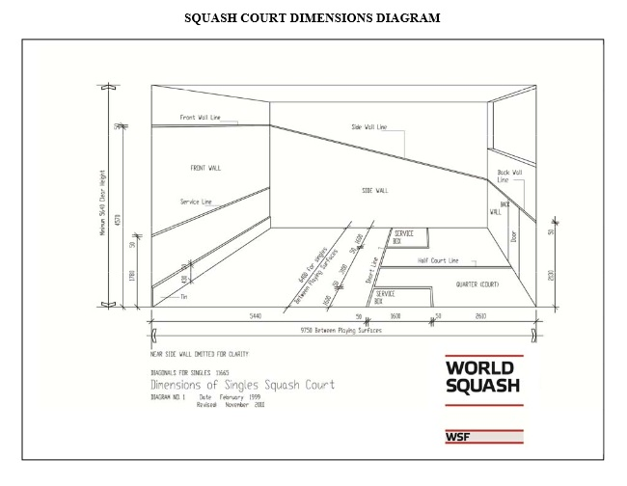 As squash is a fast paced game, where balls can sometimes reach 100+ mph, ***safety*** is an important component of the game. It is recommended that all players wear *eye protection* whenever they are within the four walls of the court, as well as take regular *water breaks*. As with any physical activity it is wise to conduct an *appropriate warm up* and *stretch*, as well as a *cool down*. A squash player who is not well prepared may find themselves as greater risk for muscle and bone injuries such as ankle and wrist sprains, muscle strains, bruises and bone fractures from frequent and heavy impact with the walls.

**Figure 1.** Squash court dimensions. World Squash Federation, <http://www.worldsquash.org/ws/wp-content/uploads/2013/01/110920_Singles-Rules-V6.pdf>

In the game of squash ***etiquette*** is important. Most squash organizations list their key points regarding etiquette of players on and off the court. For example, Strachan Sport Services (2011), Mt Maunganui Squash Club (2013), and the Seattle Squash Racquets Association (2006).

There are lets and strokes which are designed to prevent dangerous situations. A let restarts the point and can be awarded for a variety of reasons including the opponent impeding access to the ball; whereas, a stroke (point given) would be awarded if they interfered with your swing. Many times a let is called (“let please”) if there appears to be any infringement, and if there is any doubt a let should be called to prevent dangerous play occurring.

Due to the fact that most squash games are refereed by the players themselves it is imperative that player ***etiquette*** is maintained at all times. If at all possible a shot should not be played that may strike the opponent on the way to the front wall, any disagreements should be dealt with calmly, and will often end in a replaying of the point. It is also important for players to self-regulate and call their own *double bounces* as often times the person with the best view is the person closest to the ball.

Squash is a very tactical game and there are many ***tactics*** that players use to out run and outsmart their opponent. It is good form to control the centre of the court. This is referred to as the ***“T”*** because the intersection of the lines form the letter. Whenever a player is in the “T” zone they should be able to reach all 4 corners; therefore, players should try to get back to this area after every shot.

Players should keep their opponents moving in order to tire them out. This is most effectively done by *playing to open spaces*, using *deep and drop shots*, and *varying the speed* and *direction* of the ball when you hit it.

Tactically, playing to the opponent’s weaker side is also advantageous and this is normally, especially in beginners, the backhand side. Furthermore, keeping the ball close to the wall will make it more difficult to hit the ball clearly and with power. Flynn (1999) describes the 3 situations that require training in order for the player to have the tactical advantage, or be an “expert player”. These are: *shot selection*, *anticipation* and *deception*. Having an understanding of these 3 basic principles will allow even a novice player to improve and succeed.

*An excellent example of a ***safety***, ***etiquette*** and ***tactical*** issue, especially in younger students, is enforcing the rule that the ball should ***never be aimed at or hit at the head*** of an opponent. This should include when making use of an acceptable tactic known as the *body serve.*

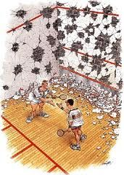

**Figure 2.** Etiquette at the end of a game, even in light of prior events. Mt Maunganui Squash Club, <http://www.sportsground.co.nz/mtsquash/70676/>

1. **Collection of learning activities**

Activities designed to be used as portions of a full lesson – to help a beginner student develop their individual skills.

#1. Ball roll [racket & ball handling]

|  |  |
| --- | --- |
| http://i2.cdn.turner.com/cnn/dam/assets/130709173733-h2h-maria-01-story-top.jpg | * ***Grip the racket*** correctly, hold it out ***in front*** of the body * Hold the racket with the ***knuckles down*** * Racket head is ***parallel*** to the ground * Place the ball on the racket and ***roll it around*** on the face of the racket for as long as you can without the ball falling off the racket.   IMPROVEMENT:   * Hold the racket with the ***knuckles up*** * ***Repeat*** the procedure |
| Notes:  Keep the ball moving at a controlled pace  Make sure the racket face remains parallel to the ground  To **increase** difficulty   * Walk around the court while rolling the ball around the racket head * Close your eyes during the exercise and keep them closed   To **decrease** difficulty   * Hold the handle of the racket closer to the head – “choke up” * Slow down the movement of the ball * Use a bigger ball   Next step: Bounce the ball on the racket face  Adapted from Yarrow (1997) | |

#2. Catch with the racket [ball handling]

|  |  |
| --- | --- |
| Swot Forehand - starting off hits | |
| * Stand about two arms lengths from the wall * Throw the ball against the wall * Catch the ball on the racket face   Note:  Try to cradle the ball with the racket face  Pull the racket down to prevent bouncing | **Increase** difficulty:   * Have a partner hit the ball against the wall   **Decrease** difficulty:   * Throw the ball in the air * *high + low = most difficult*   Adapted from Yarrow (1997) & Francis (1995) |

#3. Tag [warm up]

|  |  |
| --- | --- |
| http://www.alphasprite.com/coachpad/squash.png | Requires:  3 dodge or soft balls  Pinnies (x4-7)  Purpose:  Evasion movement within the court area  5 – 8 students per court space  5 – 10 minutes, broken into multiple games |
| * One student (tagger) has a ball and must throw the ball at the other players in order to tag them (no head shots/above shoulder height) * When a player is hit with a ball they become a tagger as well * When a player holds the ball they may not move, but can pass and tag   To **increase** difficulty for the players add more balls | |

#4. Solo lob drill

|  |
| --- |
| C:\Users\Char\Pictures\2013-10-01\Top.jpg  note: the performer in the  diagram is performing the  skill left handed |
| * Face the left wall and throw the ball off the wall towards yourself * Hit a forehand lob (high shot) that strikes the wall in front of you, loops over your head and strikes the wall on the other side * Pivot on the left foot, move the right foot across the front of the body and strike the ball with a backhand lob * Keep the rally going from side to side, judging the correct stroke power to create an upward arch   To **increase** difficulty: Increase the speed of the ball, don’t create as much of an arch (more flat)  To **decrease** difficulty: Increase the arch to give more time to turn |
| Time: 5 – 10 minutes  Purpose: To judge the power and angles needed to perform the lob shot successfully on both forehand and backhand shots  Equipment: One ball, one racket, one court (two people can perform this task in one court with considerations for space)  Adapted from Francis (1995) |

|  |  |
| --- | --- |
|  | * Two students stand in the court, one has a racket, one does not (is the assessor) * The assessor calls out a number, associated with a position on the court (1-6) as the player returns to the T * The player must move to that position using good form (J movements, side steps etc – see below) * The player makes a playable swing at an imaginary ball * The assessor uses the criteria below to assess the movement |
| 1. Does the player move smoothly to the correct area? 2. Does the player push off from the back foot? 3. Does the player move back in to the T quickly? 4. Does the player use a proper swing at the appropriate time?   **Increase** difficulty:   * Add a timer (30 shots in 2 minutes etc) | |

#5. Movement on the court [Peer teaching/assessing]

The assessor should use a checklist such as this:

The player should:

1. Use a J shaped movement in the front 2 corners (from the T to the corner)
2. Side step to the sides
3. Pivot toward the back corners and side step

They should **ALWAYS:**

1. Hold the racket high and prepare early for the shot
2. Push off of the back foot when moving in either direction
3. Use an appropriate swing (forehand or backhand)

If the player you are observing does these skills at **all** of the points of the star, award them 5 points.

If the player you are observing does these skills **some** of the time, award them 3 points

If the player you are observing does these skills **rarely**, award them one point.

*at the end of the round tell them their score and **identify** what they did right and **identify** what they missed or could do better*

Switch positions and repeat the procedure!

Or this:

Court movement peer assessment

Observer:______________________ Performer:______________________ Date:__________

**Instructions:** In pairs, one student (partner A) will prepare themselves at the T zone while one student (partner B) will call out positions as previously determined. Partner A must move to the areas, make a ghost swing and return to the ready position (T zone).

|  |  |  |  |  |  |  |  |  |  |  |  |  |  |  |  |  |  |  |  |  |  |  |  |  |  |  |  |  |  |  |  |  |  |  |  |  |  |
| --- | --- | --- | --- | --- | --- | --- | --- | --- | --- | --- | --- | --- | --- | --- | --- | --- | --- | --- | --- | --- | --- | --- | --- | --- | --- | --- | --- | --- | --- | --- | --- | --- | --- | --- | --- | --- | --- |
| (1) Mark the box with a **Y** if each cue is met in the course of the full movement sequence:   1. Move in a ***J shape*** toward the ***front corners*** 2. ***Side step*** to the side walls 3. ***Pivot*** and ***back step*** to the back wall   C:\Users\Char\Pictures\2013-10-01\Top-003.bmp.jpg   |  |  |  |  |  |  |  |  |  | | --- | --- | --- | --- | --- | --- | --- | --- | --- | | Cue 1 | | | Cue 2 | | | Cue 3 | | | |  |  |  |  |  |  |  |  |  | | (2) Mark the box with a **Y** if each cue is met in the course of the full movement sequence:   1. Hold the ***racket high*** in preparation 2. Push off the ***back foot*** 3. Use an ***appropriate swing*** for position on the court 4. C:\Users\Char\Pictures\2013-09-30\forehand straight 3.jpg (2)     C:\Users\Char\Pictures\2013-09-30\forehand straight 2.jpg  (3)   |  |  |  |  |  |  |  |  |  | | --- | --- | --- | --- | --- | --- | --- | --- | --- | | Cue 1 | | | Cue 2 | | | Cue 3 | | | |  |  |  |  |  |  |  |  |  | |

Partner B will watch partner A to determine if they meet the criteria for correct movement patterns (1) and if they use appropriate ready positions and action movements (2). Make 3 full attempts.

What did they do well? What do they need to work on?

Adapted from Langlois and Johnson (2012)

#6. Cross-court volley [skill development]

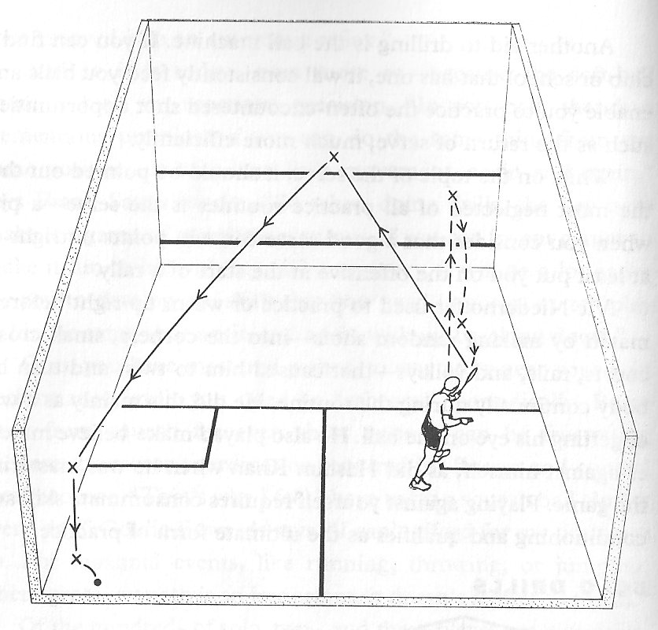

1. Hit the ball to yourself using a straight shot (approximately at the service box)
2. After a bounce on the return hit a cross court shot off the front wall
3. Aim for the side wall, behind the service box, preferably tight in the corner

**Decrease** difficulty –

* Stand closer to the wall for the feed
* Aim for a more general area
* Use a lob over a power shot

**Increase** difficulty

* Make a target and aim for it consecutively
* Have a partner try to return the shot (to determine the most likely spot for a point winner)
* Include a partner and try to rally using the same procedure
  + Straight drive (R), cross court (R), straight drive (L), cross court (L) etc
* Vary the height and speed of the ball

**Cognitively:**

Take the opportunity to assess the role of the positioning of a shot for the likelihood that the shot will be returned. If the shot is returned, where is it likely to go? **Anticipate your opponent.**

Adapted from Francis (1995)

#7. Volley on the run [skill development]

|  |
| --- |
| Who? Partner A and Partner B What? Returning forehand and backhand volleys  Where? Squash court When? 5 – 7 minutes per partner (15min/max)  Why? To improve timing when striking the ball, ensure footwork is correct, practice moving around the court, practice volleying the return from an opponent |
| 1. Partner A starts at the T (centre court) and partner B, standing in the back corner, should feed high, soft shots against the back wall. 2. Partner A should move across the space to intercept the ball and play a straight volley 3. If possible player B should return a high, soft shot to continue the rally 4. After hitting the ball player A should run across to the opposite side wall 5. Then run back to the T to prepare for the next shot |
| To be successful:  Player A should time their movement so their last step is just before making contact  Player A should backpedal to the T as smoothly as possible  Player A should be able to hit a volley that lobs over their head to the back corner (to B)  Player A should be able to reach the side wall and be back in time to strike the ball again  Player B should play a fair shot for player A to intercept  Player B should be able to return the ball in a similar fashion each time |
| To **increase** difficulty:  Have player B feed the ball faster and lower to decrease time to react  Instead of running to the side wall, run backwards to the back wall and return to the T  Play an imaginary shot when you reach the wall before returning to the T  To **decrease** difficulty:  Partner B waits until partner A is back in the ready position at the T  Partner B (the target) moves further forward in the court  Adapted from Yarrow (1997) |

#8. Serve practice [skill development] – adapted from Yarrow (1997)

Practice serving from the right box, then switch to the left box.

Practice a range of different serves:

* + Basic serve – ball slightly ahead of you, step toward ball, contact at waist height
  + Advanced serve – ball to the side of the body, step towards T, drag ball across body, transfer weight from back to front foot
  + Lob serve – ball ahead of body, short backswing, hit underneath ball, with less pace
  + Hard hit serve – start with racket high, throw ball above head height, contact ball high, step into the serve, swing quickly, aim for the centre of the court
  + Backhand serve – racket starts behind head, throw ball underneath right elbow, step across on front foot and turn front shoulder toward front wall, swing through

Key points:

ALWAYS try to move straight to the T zone after a serve

ALWAYS keep one foot in the service box

From right box aim for front wall 2/3rds way up, so hits side wall toward back of service box

From left box aim slightly to the left of centre on front wall, so it hits the wall behind the service box

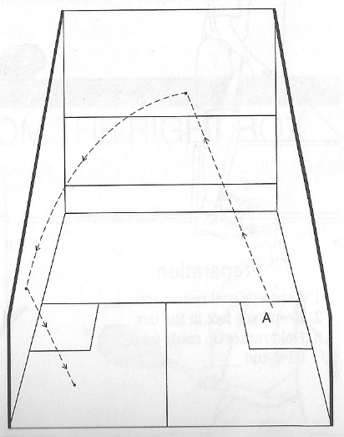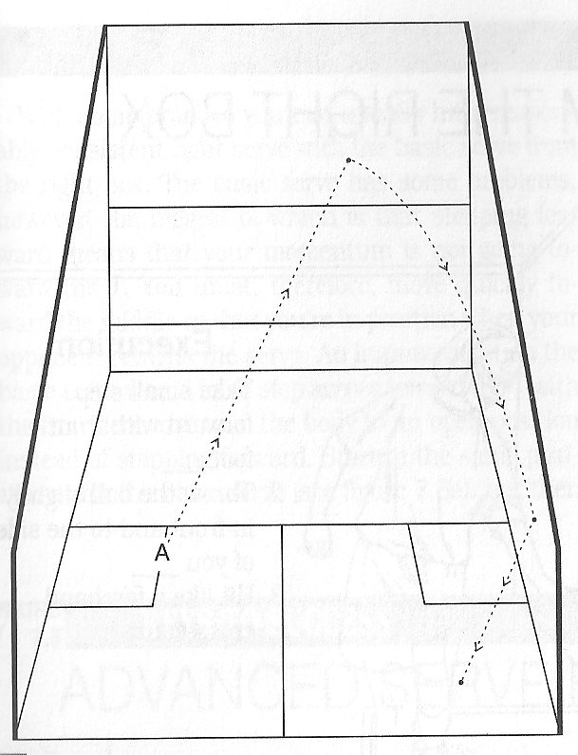

**Figure 3.** Approximation of location for serve **Figure 4.** Approximation of location for serve

from left service box from right service box

#9. SWOT [modified game]

|  |  |
| --- | --- |
| SWOT is a lower progression of squash  Games played to 10 | It is played using:  Wider faced bats (like paddles)  Larger, softer ball (spongy) |
| Rules:  One foot must remain in the service box  Throw the ball up to serve (similar to overhand/hard hit serve)  Must hit front wall above red serve line  Must land in opposite half court  Must not bounce more than once (can be volleyed)  Point-a-rally  First to 10 points wins | Concept:  The game is played the same as squash, however it is played with different equipment.  The choice of equipment is meant to both slow down the play, giving the player more time to make choices and to emphasise the key parts of the game while still maintain a game environment |
| This game is one of a three part progression…  SWOT (3) is the highest level (closest to squash); to play at a simpler progression consider:   * MINI SWOT (1): played on only one wall, with a ball that does not bounce as far (beyond the short line is out), and the serve is made from waist height. The ball can be hit on any bounce * MOD SWOT (2): played using a ball that bounces further into the playing area and is only played on three walls. Service is made out of the hand, or from a bounce.   Adapted from Strachan Sport Services (2011) | |

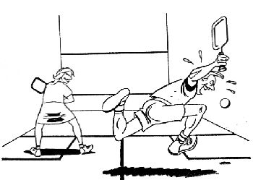

#10. 4 corners [modified game]

Time: 15 minutes

Equipment: 2 rackets & 1 squash ball

Players: 2 opponents

Players attempt to hit the ball into one of the four corners

Can either come off the front, side or back walls

Ball must die in the marked corner area – die means bounce twice

Opponents take turns serving and game play is normal

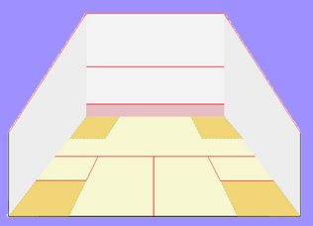

The point is awarded if the ball dies in the square. If the ball dies elsewhere the service changes but no point is awarded.

Game is played to 15 points.

To **increase** difficulty: Make the corners smaller

To **decrease** difficulty: Make the corners bigger

Adapted from inside squash (n.d.)

#11. Short court squash [modified game]

Ideally this game would be played within the short line and the front wall

However, one court could be modified to handle two games if the back wall is marked the same as the front wall

All it requires are 2 squash rackets and a squash ball per pair

Game rules:

* Play the ball off the front wall in a manner that is unreturnable by the opponent
* The play area is restricted to the front of the court in which a normal game is played

Objective:

* To play short shots that are deceptive
* To increase and improve physical fitness levels
* To improve reaction times and decision making
* To out think and out play your opponent (just like full court squash)

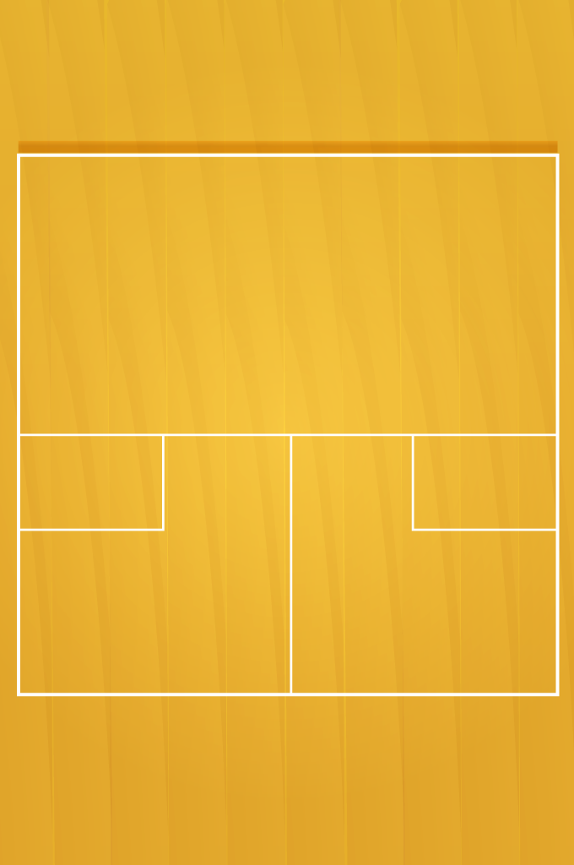

**Figure 5.** Short court set up

#12. Kings court [modified game]

Players are broken into group of 3 – 5 students on a court

1 racket per player, one ball per court

This game is the closest approximation to 1v1 squash, however it is modified to allow frequent player changes

The first pair play the first point, which includes spinning the racket to determine the server.

The game is played with conventional squash rules, including play areas and point scoring rules.

The first round is played until the ball is unplayable (2 bounces) or until it goes out of bounds.

The winner stays on and the loser is replaced by another opponent from the group.

This is repeated for the length of time assigned to the game. Students keep track of how many kings court points they win.

Advantages:

Close approximation of the game of squash

Keeps all players active as opponents switch out regularly

Increases reflection time after each round, for each player

Disadvantages:

Cannot be adapted if players are not at the same playing ability

Can mean that one player maintains Kings Court throughout

Leaves lag time between point ending, reflection and opportunity to play again

1. **Sample Lesson Plan**

|  |  |  |  |
| --- | --- | --- | --- |
| **Lesson 1:** Introduction  **Grade:** 9/10  **Equipment:**  **Space:** 4 squash courts  **Time:** 80 minutes (90 – 10 change time)  **Students:** 15 - 16 co-ed | **Students will be able to:**   * Explain the correct grip and its importance * Identify the major lines and markings on the court * Demonstrate basic ball handling proficiency * Hit the ball against the front wall using forehand and backhand swing * Work co-operatively with a partner to develop skills | | |
| **Parts of the lesson** | | **Teaching points** | **Progressions** |
| **Introduction (10 mins)**  **Show video** (5 mins):  <http://www.youtube.com/watch?v=6_IQDnmZ0QQ>  Question students on the basic rules and shots ID in the video – check for understanding (2 mins)  **Game #1** (3 mins)  Ball roll – keep the ball on the face of the racket | | Meet in regular gym  Prepare laptop screen/ projector  Check each individual for grip   * V shape * Fingers spread | Inc. difficulty – movement, close your eyes  Dec. difficulty – bigger ball, choke up on handle |
| **Body (40 mins)**  **Game #2**  Racket bounce (4 mins)  Students bounce the ball up in a continuous fashion  **Area worksheet** (5 mins)  Using prepared worksheets students move from station to station, ID names of areas or lines, and important rules  **Tag** (10 minutes)  Tag game with spongy balls  **Demo** (5 mins)  Teacher demo of forehand and backhand swing  **Patting the ball** (8 mins)  In partners, one player tosses ball to other, other returns ball with racket  **Self feed** (8 mins)  Pick a spot on the wall, throw the ball against the wall and swing on the rebound | | Move to squash courts   * Keep racket face open * Maintain constant pace * Don’t hit too high * Don’t hit too low   All points are important to the playing of the game   * Chaser throws ball * If hit, become chaser * Cannot move with the ball * Forehand – racket high, step into shot, drop shoulder, cross body with arm, follow through * Backhand – racket high behind opposite shoulder, step in, drop front shoulder, open shoulders, follow through * Use appropriate strength to reach partner * Hit ball as it is falling * Switch when comfortable * 4 – 5 students per court * Throw with enough force to bounce back * Choose swing based on location ball returns * Step into shot | Inc. difficulty – add movement, add pattern  Dec. difficulty – certain height  Set up req’d before class – each station has different info – all important for game  More difficult: less people in space  Less difficult: More people, move with the ball  Ask questions for understanding – use student to demo  Have students break down movement from observation  Inc. – move further away, move side to side as target  Dec – come closer, choke up on handle  Inc. – Throw ball up and hit, keep hits continuous  Dec. – Use only forehand, catch ball after every hit |
| **Conclusion (30 mins)**  **Game #3** (15 minutes)  MINI SWOT – Using one wall pairs play for points using squash or modified ball  **Cool down** (7 mins)  Slower movement version of tag – those who are chasers cannot move, must turn and tag  **Stretching** (7 mins)  Stretch muscles, hold for 30 seconds, include all major muscle groups | | * Ball can be hit on any bounce * Short line and beyond is “out” * Play to 15 points * All students in one space to decrease movement room * No movement with the ball * No throwing the ball * Include calf, thigh, back, shoulder, biceps and triceps * Use walls for dynamic stretch | 2 pairs can play in one court using front and back walls  Inc. – use fore and backhand  Dec. – Focus on continuous hits at a single target  Slower paced to reduce heart rate  Ask questions for understanding as stretches are being held |

1. **Handout**

|  |
| --- |
| http://www.alphasprite.com/coachpad/squash.pngIntroduction to squash 2013  Answer the following questions from information you learned playing squash today.  Mark on the diagram and label the location of the following things:   1. Front wall b. Short line   c. Left service box d. Half court  Identify which swing is being described: (if you are stuck try acting it out)   * Racket begins high, behind neck - Racket begins high, above head * Face left wall (if right handed) - Face right wall (if right handed) * Step into shot with front foot - Step into shot with front foot * Swing racket, open shoulders - Swing racket across body * Follow through, end low - Follow through, end high   I think this describes the _________________. I think this describes the ________________.  Three things that I did today that I enjoyed were 1.___________________________________,  2._____________________________________, 3.__________________________________.  Two things that I learned today that I did not know before are 1.____________________________________, 2.___________________________________.  One thing that I want to learn more about in future classes is ___________________________ ____________________________________________________________________________ |

**(f) Recommended Websites**

<http://www.worldsquash.org/> - The World Squash Federation. Find information about rules, major events from around the squash world, and resources for players, coaches and referees.

<http://www.squashgame.info/> - This website supplies lots of information about drills and tactics for a novice player, including progressions and videos.

<http://www.insidesquash.com/> - Online resource for lesson ideas, drills and tips for a better squash game. This website includes lessons grouped by task.

<http://www.seattlesquash.com/etiquette101.htm> - This web page is useful for its analysis of what to do and what not to do in reference to squash etiquette.

<http://squashtip.blogspot.ca/2013/05> - This webpage is created by players for player and has a very user friendly set up for presenting tips, drills and tactics. It also includes self-made YouTube videos.

**(g) References**

Flynn, Roger. (1999). *Tactics and strategy in squash.* Unpublished manuscript.

Francis, Austin. M. (1995). *Smart squash.* New York, NY: Lyons & Burford.

Inside squash. (n.d.). *Inside squash.* Retrieved from http://www.insidesquash.com.

Mt Maunganui Squash Club. (2013). *Squash rules and etiquette.* Retrieved from http://www.sportsground.co.nz/mtsquash/70676.

Seattle Squash Rackets Association. (2006). *101 things not to do in the game of squash.* Retrieved from http://www.seattlesquash.com/etiquette101.htm.

Squash Canada. (2011). *Rules of the game.* Retrieved from http://squash.ca/en/rules-game#

Squash Canada. (2010). *World squash singles rules 2010.* Retrieved from http://squash.ca/sites/default/files/files/Singles%20Rules%20Dec%202011%281%29.pdf

Strachan Sport Services. (2011). *Squash coaching and advice.* Retrieved from http://www.insidesquash.com.

Valerani, Alessandro. (2013). *Squash tips!.* Retrieved from http://squashtip.blogspot.ca/2013/05.

World Squash Federation. (2010). *World squash singles rules 2010.* Retrieved from http://www.worldsquash.org/ws/wp-content/uploads/2013/01/110920_Singles-Rules-V6.pdf

World Squash Federation. (2013). *Official website of the world squash federation.* Retrieved from http://www.worldsquash.org.

Yarrow, Philip. (1997). *Squash: Steps to success.* Champaign, IL: Human Kinetics.