***Lesson Plans and Resource Package***

EPHE 246 – Active Health

Kim Robertson

April 3, 2014

Table of Contents

Teaching Philosophy_________________________________________________________3

Lesson Plan One_____________________________________________________________4

Introduction__________________________________________________________5

Learning Objectives____________________________________________________7

Lesson Plan Outline____________________________________________________8

Handouts____________________________________________________________9

Workout Record Sheet___________________________________________9

Upper Body Exercises___________________________________________10

Upper Body Exercises Quiz______________________________________14

Upper Body Exercises Quiz: Answer Key___________________________15

Lesson Plan Two__________________________________________________________16

Introduction________________________________________________________17

Learning Objectives__________________________________________________19

Lesson Plan Outline__________________________________________________20

Handouts__________________________________________________________22

Deep Breathing Exercise________________________________________22

Power Point Presentation______________________________________________23

Conclusion_________________________________________________________28

References_________________________________________________________29

Appendix__________________________________________________________31

Teaching Philosophy

Physical and health education classes should help students find balance in all aspects of health – physical, mental, emotional, spiritual and social. My aim as a physical educator is to provide students with the knowledge and the tools to achieve and maintain a balanced, healthy lifestyle. I aim to lead by example and to pass on my experiences to students, hopefully enabling them to make informed choices when it comes to their health. By sharing my passion for health and fitness with my students, I hope to instill a passion in them, encouraging them to continue their practice of a healthy and active lifestyle even after they leave my classroom.

High school is an insecure time for all students, and too many students feel those insecurities in physical and health education. No matter what those insecurities stem from, I believe that educators should be doing all that is possible to try to eliminate them. I aspire to bring enthusiasm into all aspects of my teaching to make my classroom a place where students want to be. I believe in building a relationship of respect with all students, because that has the potential to make all the difference in motivating an unengaged student. I strive to create a safe space for all students, as I believe that physical and health education should be an enjoyable and engaging experience for all students. Too often, the world caters to the “norm” and the “elite,” but I believe that the classroom should be an inclusive space for all. I strive to establish a classroom climate that all students feel comfortable in, as I focus on success for everyone. I aspire for my students to know that they have someone in their corner, rooting for them to succeed; I hope they feel support in my classroom so they can feel free to go after their goals.

My hope for my students is that they become healthy, confident, well-rounded individuals, and I hope to help them get there. I strive to encourage my students to set goals for themselves and I hope to ignite an excitement within them to pursue and conquer their goals and then continue to set more goals. I want to allow students to experience individual growth through student-centered learning, giving them various chances to expand their learning both in class and on their own time. My intention is to give my students opportunities to find something they love and to pursue that. Through my teaching, I believe I can give students the knowledge to safely maintain a balanced, healthy lifestyle, and I hope that students can carry what they learn in my classes with them for the rest of their lives.

***Lesson Plan One:***

***An Introduction to the Weight Room – Upper Body Exercises***

Introduction

“Participation in physical activity promotes the development of gross motor skills, school performance, [weight management], and social engagement and fosters physical and mental health” (LeBoeuf, 2014, p. 100), and this only scrapes the surface of the benefits of physical activity in youth. “Leadership skills, socialization skills, and overall self-perceptions can be improved [through resistance training programs]” (Piper & Tiechelman, 2003, p. 35) as well, which are all incredibly important psychological benefits for adolescents. This is why I have created a lesson plan surrounding physical activity in the weight room: to help give students the tools to use utilize the benefits of strength training in their everyday lives.

The following lesson plan (An Introduction to the Weight Room – Upper Body Exercises) is for a Grade 11 Weight Training class with the duration of 80 minutes, and I have designed this class to be given over an entire term (twice a week for 5 months). The lesson plan I created would be lesson 6 out of 40 and the preceding lessons would go by the following sequence: Safety in the Weight Room, Spotting Techniques, Sets and Repetitions, Calculating 1 Repetition Maximum (RM), An Introduction to the Weight Room – Lower Body Exercises. The subsequent lesson would be An Introduction to the Weight Room – Core Exercises, and from there the class would break off into more student-centered learning, focusing on individual goals. During this lesson, students will complete an upper body workout that includes a warm-up, six exercise stations, and a cool down. The six stations will consist of the bench press, lat pull downs, bicep curls, should press, chest flies and seated rows, permitting students to work their upper bodies and get a feel for the exercise equipment involved. At the end of this lesson, students will be required to complete a short quiz, hopefully enabling them to better remember what they have learned throughout the lesson.

I chose this lesson plan because I believe that it is imperative to allow students to build confidence in strength training and weight room settings. As stated in the Physical Education 11 and 12 Integrated Resource Package (IRP), “the aim of physical education is to enable all students to enhance their quality of life through active living” (BC Ministry of Education, 1997, p. 9). By providing students with an opportunity to gain the necessary knowledge of strength training and how it can benefit their lifestyle, we allow them a greater chance of achieving and maintaining a healthy, active lifestyle (Davis, 2003). It is important to orient students so they can feel comfortable with exercise equipment because unfamiliarity to the weight room can be a large barrier to physical activity for many, even in adult life (Jacobsen & Jenkins, 2006). Too often do students feel the need to compare themselves to others, causing negative self-perceptions, and that is something I strive to steer away from in this Weight Training class through student-centered learning (Piper & Tiechelman, 2003).

During this class, student-centered learning approaches will be employed throughout the term. In this particular lesson plan, student-centered learning will be utilized during the stations. Students will be moving through the stations in their groups of three without constant teacher supervision. Students will have a handout, which will explain the proper form and safety considerations for each station, and it will be each group member’s responsibility to help the other members execute the exercises safely and properly. Where student-centered learning really comes into play is in the “upcoming homework assignment” I have devised for this Weight Training 11 class (See Appendix A). This assignment is described in detail in Appendix A, and it is focused on individuality. It gives students the opportunity to create a personal strength training program, assisting them in setting and achieving their goals in a safe and supportive environment.

Learning Objectives

**Class:** Weight Training 11 (80 minute class) **Unit:** Introduction to the Weight Room

**Lesson Focus:** Introduction to Weight Room Equipment Part 2 – Upper Body Exercises

**Lesson Number:** 6 of 40 **Facilitator:** Ms. Kim Robertson

**Equipment:** Need access to gym and weight room

|  |  |
| --- | --- |
| Learning Outcomes: The Students Will Be Able To… (Original Work) | |
| Psychomotor | * Demonstrate the proper form for each exercise * Choose an appropriate amount of weight for them to use during each exercise * Detect if they are lifting too much weight or doing something unsafely * Spot their fellow group members effectively while they are executing the exercises * Stretch the appropriate muscles during the cool down |
| Affective | * Compare their group’s execution of each exercise to the criteria on the handout and provide feedback consistent with the criteria and performance * Cooperate within their group of three during the stations exercise * Assist their group members when they need or ask for help * Participate enthusiastically throughout the lesson |
| Cognitive | * Continuously follow the teacher’s movements and verbal directions during the five minute warm-up * Describe each exercise station to their fellow group members * Identify the safety considerations associated with each of the six exercise stations * Apply the knowledge learned during this lesson to the short quiz at the end of class |

Lesson Plan Outline

|  |  |
| --- | --- |
| **Warm-Up (~5 minutes)** Teacher Led Warm-Up: Students will spread out and follow the teacher through the following five minute dynamic warm-up sequence:   * Jumping Jacks (1 minute) * High Knees (30 seconds) * Bum Kickers (30 seconds) * Shoulder Shrugs (30 seconds) * Arm Circles (30 seconds) * Torso Twists (30 seconds) * Neck Rolls (30 seconds) * Walking Lunges (30 seconds) * Skipping (30 seconds) | **Teaching Cues**  Follow teacher’s lead  Complete warm-up to the best of your ability |
| **Body of Lesson (~50 minutes)** Teacher Demonstrations (10 minutes): As a class we will go over each of the upcoming stations; students will receive a handout with descriptions of each station (See Handouts); teacher will demonstrate proper form  Upper Body Workout (40 minutes):  Students will need a group of 3; two students will act as spotters while one student completes an exercise; they will continuously switch roles. Station 1: Bench Press  Station 2: Lat Pull Downs Station 3: Biceps Curl Station 4: Should Press Station 5: Chest Fly  Station 6: Seated Row | Choose a station to start at  Read handout carefully before trying exercise  Complete 2 sets of 8-15 repetitions of each exercise at approximately 50% effort (Council on Sports Medicine and Fitness, 2008)  Focus on proper form |
| **Culminating Phase (~20 minutes)** Cool Down (10 minutes): Head to toe stretching, focusing majorly on the muscles workedShort quiz covering upper body equipment (See Handouts) (10 minutes) | Closed book quiz; papers should be put away |
| **Closure (~5 minutes)** Discuss upcoming project: 8 week workout program (See Appendix A) |  |

Note: Lesson plan is original work; outline is a modified version of Dr. Temple’s outline from EPHE 352

Handouts

***Workout Recording Sheet (Original Work)***

Name:

Date:

|  |  |  |  |  |
| --- | --- | --- | --- | --- |
| Station # | Exercise | # of Sets | # of Repetitions | Weight Used (lbs.) |
| 1 | Bench Press |  |  |  |
| 2 | Lat Pull Downs |  |  |  |
| 3 | Biceps Curl |  |  |  |
| 4 | Shoulder Press |  |  |  |
| 5 | Chest Fly |  |  |  |
| 6 | Seated Row |  |  |  |

Mount Stewart High School Weight Training 11 Ms. Robertson ©

***Upper Body Exercises Handout (Original Work)***

**Station 1: Bench Press**

1. Lay down on your back on the bench, lining your chest up with the bar
2. Plant feet firmly on the ground
3. Grip the bar slightly wider than shoulder width, with arms directly perpendicular to your chest
4. Inhale and slowly lift the bar off the rack and lower the bar down to chest level
5. Exhale and push the bar back up
6. Elbows should be straight but not locked
7. Do not lift your back off the bench, maintain your natural spine arch throughout the exercise

**Safety Considerations:**

1. **Do not overestimate your strength** – start with a lower weight and **slowly** increase the weight
2. Utilize a spotter for this exercise
3. Ensure good grip on the bar so it does not slip

**What Muscles Are You Working?**

Pectoralis Major, Pectoralis Minor, Anterior Deltoid, Triceps

**Station 2: Lat Pull Downs**

1. While standing grab the bar’s handles with a wide grip, palms facing forwards
2. Once you have a steady grip, inhale and sit down and pull the bar down with you
3. Exhale and pull the bar down to chest height
4. You should be leaning back slightly (initiate the lean from your hips)
5. Slowly let the bar up to starting position and repeat

**Safety Considerations:**

1. **Do not overestimate your strength** -- start with a lower weight and **slowly** increase the weight
2. Ensure you have a good grip on the bar
3. When finishing a set, stand up to put the bar back in place – do not just let go of the bar while sitting
4. Try to utilize your latissimus dorsi muscle, not just your arms

**What Muscles Are You Working?**

Latissimus Dorsi, Rhomboids, Posterior Deltoid

**Station 3: Biceps Curl**

1. Sit on seat with bent knees, feet planted on the floor and your chest against the pad
2. Place arms over the angled part of the bench so the upper arms rest on the pad
3. Grasp the handles with upward facing palms
4. Exhale and bend the elbows to pull handles up towards the chin
5. Slowly return the handles to the starting position

**Safety Considerations:**

1. **Do not overestimate your strength** – start with a lower weight and **slowly** increase the weight
2. Keep a straight line across the hand and wrist to avoid wrist injury
3. Do not fully straighten your elbows when returning the handles back to starting position – this puts too much pressure on your elbow joint

**What Muscles Are You Working?**

Biceps Brachii, Brachialis

**Station 4: Shoulder Press**

1. Sit on the seat with back and neck resting against the back rest
2. Grip each handle with palms facing forward and elbows bent
3. Exhale and push the handles straight above your head – straighten arms but do not lock elbows
4. Slowly lower handles back to starting position

**Safety Considerations:**

1. **Do not overestimate your strength** – start with a lower weight and **slowly** increase the weight
2. Ensure the handles are level with your shoulders before you start
3. Maintain fluid motion

**What Muscles Are You Working?**

Deltoids, Pectoralis Major, Triceps Brachii, Trapezius

**Station 5: Seated Row**

1. Sit on the seat and place feet in the foot holds, knees should be slightly bent
2. Keep back upright with a slight backward lean
3. Grip handle with palms facing each other, arms should be straight but do not lock elbows
4. Exhale and pull handles toward your chest with elbows driving backwards
5. Slowly return handles to starting position

**Safety Considerations:**

1. **Do not overestimate your strength** – start with a lower weight and **slowly** increase the weight
2. Do not hunch your shoulders

**What Muscles Are You Working?**

Trapezius, Rhomboids, Latissimus Dorsi

**Station 6: Chest Fly**

1. Sit on the seat with back and neck resting against the back rest
2. Grip one handle first and pull it towards the middle of your body, then grip the second handle and bring it towards the middle of your body as well
3. Arms should be parallel to the floor
4. Allow arms to part to a comfortable position
5. Exhale and squeeze the handles together in front of your chest
6. Slowly move arms back out to starting position and repeat

**Safety Considerations:**

1. **Do not overestimate your strength** – start with a lower weight and **slowly** increase the weight
2. Do not try to grip both handles at once – they will be too far back

**What Muscles Are You Working?**

Pectoralis Major, Pectoralis Minor, Anterior Deltoid

Mount Stewart High School Weight Training 11 Ms. Robertson ©

***Upper Body Exercises Quiz (Original Work)***

Name:

Date:

1. Name the most common safety consideration in the weight room:
2. What **3** muscles are you working when executing the seated row?
3. Explain the proper form of the lat pull down (point form is fine):
4. What are the safety considerations when using the biceps curl machine?
5. What are the **4** muscles you are working when executing the bench press?

Mount Stewart High School Weight Training 11 Ms. Robertson©

***Answer Key: Upper Body Exercises Quiz (Original Work)***

1. Do not overestimate your strength
2. Trapezius, Rhomboids, Latissimus Dorsi
3. I) While standing grab the bar’s handles with a wide grip, palms facing forwards  
   II) Once you have a steady grip, inhale and sit down and pull the bar down with you  
   III) Exhale and pull the bar down to chest height  
   IV) You should be leaning back slightly (initiate the lean from your hips)  
   V) Slowly let the bar up to starting position and repeat
4. I) **Do not overestimate your strength** – start with a lower weight and **slowly** increase the weight  
   II) Keep a straight line across the hand and wrist to avoid wrist injury  
   III) Do not fully straighten your elbows when returning the handles back to starting position – this puts too much pressure on your elbow joint
5. Pectoralis Major, Pectoralis Minor, Anterior Deltoid, Triceps

Mount Stewart High School Weight Training 11 Ms. Robertson©

***Lesson Plan Two:   
What is Stress and How Can Students Deal with it?***

Introduction

Students often deal with the negative side effects of stress on their own, feeling like they cannot handle the pressure, and unfortunately a lot of that pressure stems from inside schools (Hardy, 2003). Teaching stress management in schools is becoming increasingly important as students are faced with increasing amounts of both external and perceived stresses. The surrounding world forces students to try to grow up more quickly nowadays; however, that often means that students are not yet mature or developed enough to deal with the issues presented to them (Hardy, 2003). Discussing student stress and stress management techniques is paramount because, despite its relevance in schools, student stress is often overlooked or skirted over in class discussion (Center for Adolescent Health, 2006).

The following lesson plan (What is Stress and How Can Students Deal with it?) is designed for a Grade 11 or 12 Physical Education class focusing on active lifestyles. This type of class would focus on finding balance in all aspects of health, not just through physical activity. I created this lesson plan for an 80 minute class, and it is designed to be a part of a unit on stress management for students. Students are meant to learn how to “describe strategies for stress management and relaxation” (BC Ministry of Education, 1997, p. 48) in Physical Education 11 and 12 and this lesson is meant to introduce students to the topic. This lesson acts as an introduction to stress, how it can affect students, and how students can deal with it; so, this lesson could be the first in a three or four-lesson unit on stress management.

This lesson will be a mix of teacher presentation and group discussion and activity as described in the outline; however, I would like this lesson to be more focused on student interaction through discussion and activities. The lesson will start with a question posed to the students, asking them to brainstorm their definition of stress and what stress means to them as individuals. Another question that will be posed to the students is asking them to think of where their stress comes from and if it is the same for everyone. This discussion will lead into the first class activity: the sticky note activity (described in detail in the lesson plan outline). Later on, another interactive group drawing activity (described in the lesson plan outline) will be completed, allowing for creativity and collaboration between students. At the end of class, students will participate in a deep breathing exercise as well (See Handouts). A student-centered learning approach is utilized through all of these questions, discussions, activities and exercises. By giving students the opportunities to voice their thoughts and views, we can make their ideas an important part of the classroom. Student-centered learning is valuable to utilize in the classroom because including the student voice in the classroom contributes to increased engagement and achievement among students (Phillips, 2011). During the sticky note activity the stressful situations are coming directly from students, providing students with the chance to guide discussion topics. This ensures that the topics discussed will be important and relevant to students, meaning that students will be able to gain more from the class discussions.

This lesson complies with the IRPs Suggested Instructional techniques as well, as it “investigate[s] the physiological effects of stress… [and] indentif[ies] relaxation techniques and stress management strategies to alleviate these effects” (BC Ministry of Education, 1997, p.28). I chose this type of lesson because I believe that it is very important for students to learn how to cope with stress, because unresolved stress can have serious, long-lasting effects on all aspects of a person’s well-being.

Learning Objectives

**Class:** Active Lifestyles 11 (80 minute class) **Unit:** Stress Management

**Lesson Focus:** What is Stress and How Can Students Deal with it?

**Lesson Number:** 1 of 3 **Facilitator:** Ms. Kim Robertson

**Supplies:** 20 sticky notes, 5 pieces of poster paper, markers

|  |  |
| --- | --- |
| Learning Outcomes: The Students Will Be Able To… (Original Work) | |
| Psychomotor | * Draw their own versions of stress-free and stressed out students * Breathe deeply through their lower abdomen during the deep breathing exercise |
| Affective | * Participate in group discussions throughout the class * Offer suggestions on different ways to deal with stress in the varying situations brought up in the sticky note activity * Cooperate with their group members during the drawing activity * Evaluate their own stress management skills in everyday life |
| Cognitive | * Define stress and identify what it means to them * Compare and contrast the differences between good stress and bad stress * Describe where typical student stress comes from * Analyse a stressful situation and contribute to finding a stress management solution * Describe the physical and mental effects that stress can have on the body * Analyse factors that can influence health both negatively and positively * Describe strategies for stress management and relaxation |

Lesson Plan Outline

|  |  |
| --- | --- |
| **Introduction (~10 minutes)**  Defining Stress (~5 minutes):   * Pose question to students “How do you define stress?” * Give the dictionary definition of stress   Is all Stress Bad? (~5 minutes)   * Explain the types of good stress (notes on power point slides) | **Teaching Cues**  Try to maintain a comfortable and safe classroom environment for this discussion |
| **Body of Lesson (~60 minutes)**  Where Does Student Stress Come From? (~5 minutes)   * Pose question to students “As high school students, where does the majority of your stress come from? Is it the same for everyone?” * Where does the literature say student stress comes from (notes on power point slides)   Sticky Note Activity (Original Work) (~20 minutes):   * Each student is given one sticky note * Give students ~5 minutes to anonymously write down a specific stressful situation * Collect the sticky notes and put them in a bucket, then pick ten sticky notes out of the bucket and read them to the class * Group discussion: as you read out each situation, ask students how someone could deal with each situation   Stress Adds Up (~10 minutes):   * Discuss how excessive stress can affect a person * Discuss physiological and mental effects (notes on power point slides)   Drawing Activity (Original Work) (~20 minutes):   * Divide students into five groups of four and give each group a piece of poster paper and four markers * On one side of the paper, students will draw their version of a happy, stress-free students * On the opposite side, students will draw a stressed out student, showing the effects of stress on the body * Each group will share and explain their drawings with the class when everyone is done   Dealing with Stress (~5 minutes):   * Give some helpful hints for dealing with stress (notes on power point slides) | Why is stress different for everyone?  Be specific  Do not write your name on your sticky note – these are meant to be anonymous situations  Your drawing skills are not the important aspect here  Keep it classroom appropriate and be prepared to share |
| **Culminating Phase (~5 minutes)**  Deep Breathing Exercise (~5 minutes):   * Give students a handout so they can do this exercise on their own | Please remain silent |
| **Closure (~5 minutes)**  Discuss next class: looking at mental illnesses related to stress |  |

Note: Lesson plan is original work; outline is a modified version of Dr. Temple’s outline from EPHE 352

Handouts

***Deep Breathing Exercise***

(This exercise was borrowed from the School Health Programs Department: Stress Reduction Activities <http://www.healthiersf.org/resources/pubs/stressRed/StressReductionActivities.pdf>)

**Purpose:**

Students practice deep breathing techniques as part of stress reduction

**Materials:**

No materials needed

**Content:**

Teacher/facilitator introduces and demonstrates the concept of deep breathing as a stress reduction strategy that can be used in the present moment as well as an excellent skill to master to more effectively cope with future stressors. Teacher/facilitator has all students stand with comfortable space between each other or seated in a chair.

Provide students with the following directions:

1. Stand straight up with feet shoulder-width apart

2. Arms and hands are relaxed downward

3. Body is relaxed

4. Eyes closed

5. Focus on lower abdomen (belly) and imagine a small balloon in that space

6. Breath in slowly and deeply through nostrils, imagining the balloon inflating *(getting bigger/larger/growing)* slowly, hold a few seconds

7. Slowly exhale through the mouth, imagining the balloon gently deflating *(getting smaller, shrinking)*; blow out of the mouth as if blowing out a candle

8. **Tip**: Place a hand over the lower abdomen to feel it go up and down, and make sure you’re not breathing with the chest

9. Repeat at least 10 times

Power Point Presentation

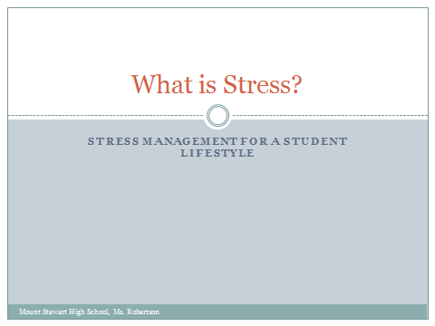 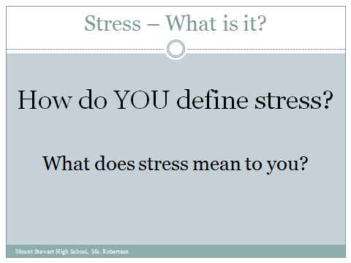

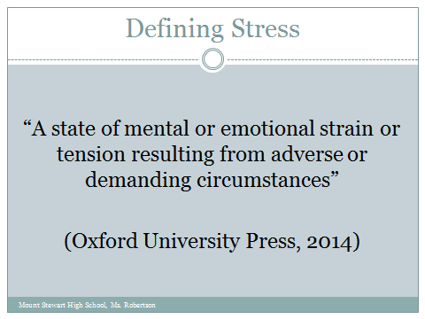 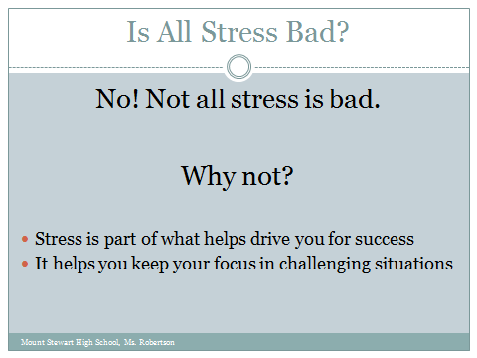

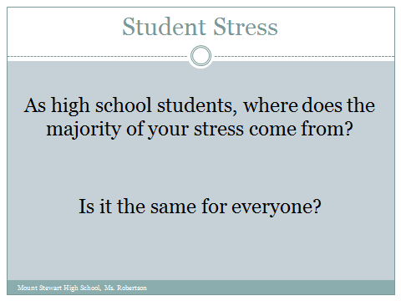 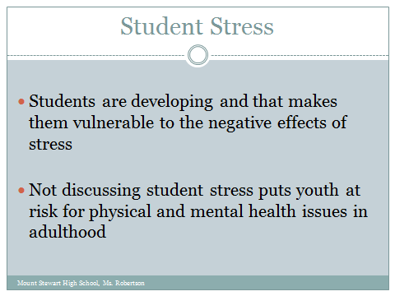

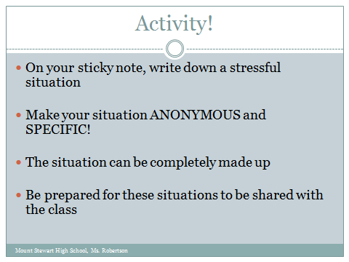 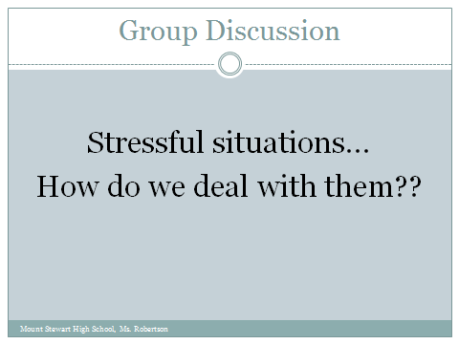

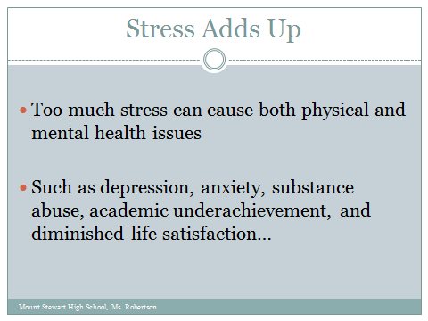 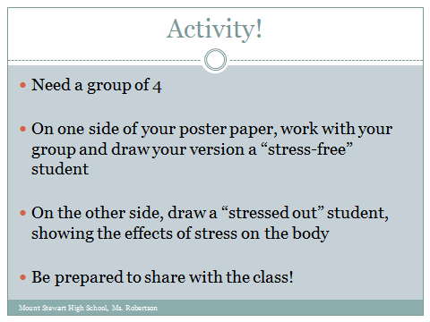

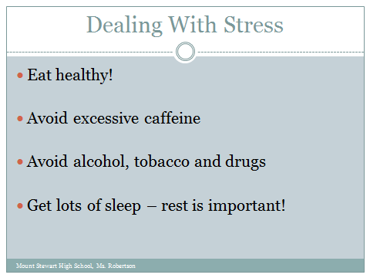 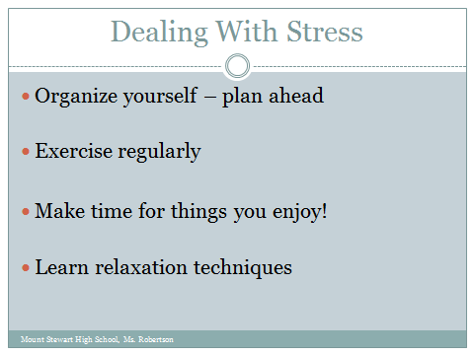

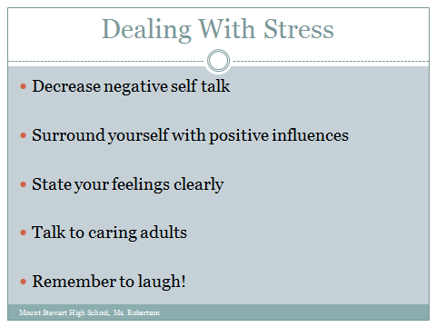 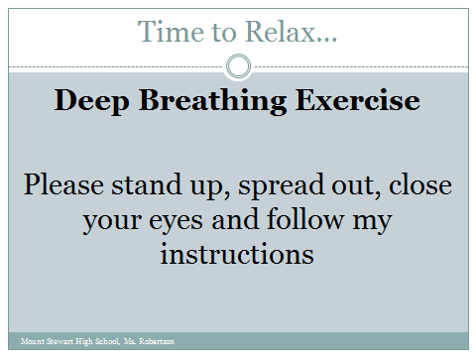

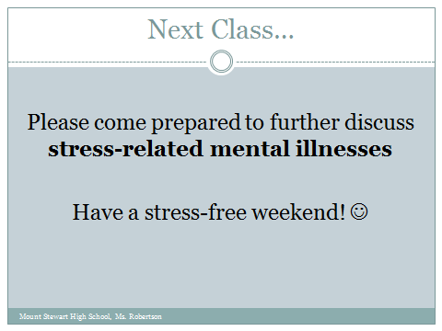

Talking Points for Power Point Presentation

Student Stress:

* Teen stress is an important, yet often overlooked, health issue (Center for Adolescent Health, 2006).
* Sources of external stress in adolescents include normative stressors (i.e., developmental challenges inherent to adolescence, such as puberty, school transitions, increased academic demands), non-normative stressful life events (e.g., divorce, deaths), and daily hassles (e.g., chronic stressors such as parent–child conflict and academic pressure) (Suldo, Shaunessy & Hardesty, 2008)
* Students’ stress is usually related to everyday experiences, worries and challenges at school, home, in the community and within their peer group. For example, young people may experience stress resulting from bullying, name calling, social isolation, not getting what they want, body image, academic difficulties, and unsafe neighbourhoods (School Health Programs Department, n.d.).

Stress Adds Up:

* The impact of ongoing and/or unresolved stress can lead to feelings of anxiety, depression, irritability, poor concentration, aggression, physical illness, fatigue, sleep disturbance and poor coping skills such as tobacco, drug and/or alcohol use (School Health Programs Department, n.d.).
* Children and adolescents who report high levels of perceived stress are at high risk for negative outcomes, such as depression, substance abuse, academic underachievement and diminished life satisfaction (Suldo, Shaunessy & Hardesty, 2008).
* So, what effects could these negative outcomes have on your body?

Dealing with Stress:

* Boys and girls differ in coping techniques: boys tend to solve problems individually instead of asking for someone’s help compared with girls (Wang, 2013).
* Students can benefit from learning and practicing stress management skills; students who develop stress reduction skills learn how to feel and cope better without hurting themselves or others; identifying and acknowledging the causes of stress and expressing feelings about them are usually the most effective tools students have to reduce stress (School Health Programs Department, n.d.).
* Eat healthy: lots of healthy foods like fruits and vegetables, use food as fuel for your body, treat your body right
* Avoid caffeine: caffeine can increase feelings of anxiety and agitation
* Avoid alcohol, tobacco and drugs: self-explanatory!!
* Get lots of sleep: students often view sleep as something they can get by without
* Organize yourself: get into the habit of making a schedule or a routine for homework
* Exercise regularly: reap the health benefits of physical activity, a healthy body helps build a healthy mind
* Make time for things you enjoy: never forget to have fun and enjoy yourself, life should not always be serious
* Learn relaxation techniques: deep breathing, meditation, yoga, etc.
* Decrease negative self-talk: focus on improvement, do not talk down to yourself
* Surround yourself with positive influences: your friends should have a positive impact on your life, help to make you the best you can be
* State your feelings clearly: make yourself heard, do not let others disregard you
* Talk to caring adults: seek out those who support you
* Laugh: laughter is the best medicine after all

Time to Relax:

* Refer to Deep Breathing Exercise handout

Conclusion

The classroom climate influences the abilities for students to learn, so by creating a classroom environment that caters to student-centered learning we can make the classroom experience gratifying and positive for students (Phillips, 2011). Both of these lesson plans focus on equipping students with the tools to maintain balanced health throughout their lives using student-centered learning. Through each of these lesson plans, students experience “activities that promote lifelong, healthy living” (BC Ministry Education, 1997, p. 9) through both physical activity and other social mediums. In each lesson, there is also a focus on growing student self-confidence, a very important aspect in the physical and overall education of youth (BC Ministry of Education, 1997). The Weight Training lesson influences students’ self-confidence by providing them with the ability to participate in another popular form of physical activity. The Active Lifestyles lesson tries to build students self-confidence by giving students more control over what is discussed in class; a majority of this lesson is based around group discussion, which enables students to build confidence for speaking in public about what is important to them. Students are more likely to speak up in discussions when the topic holds personal meaning for them. Through each of these lessons, I strive for students to develop an understanding and an appreciation of the value of active living, because “through active living, students have opportunities to understand physiological changes, make appropriate choices, and set personal goals that enhance their quality of life” (BC Ministry of Education, 1997, p. 13).

References: Lesson Plan One

BC Ministry of Education. (1997). Physical education 11 and 12: Integrated resource package. Retrieved from <https://www.bced.gov.bc.ca/irp/pdfs/physical_education/1997pe1112.pdf>

Council on Sports Medicine and Fitness. (2008). Strength training by children and adolescents. *Pediatrics, 121*(4), 835-840.

Davis, R. (2003). Adolescent strength training in physical education. *Strategies: A Journal for Physical and Sport Educators, 16*(3), 27-28.

LeBoeuf, R. (2014). Barriers to physical activity in children. *Journal of Pediatric Nursing, 29*(1), 100-101.

Jacobsen, T. & Jenkins, J. (2006). Assessment in the weight room. *Strategies: A Journal for Physical and Sport Educators, 19*(3), 11-18.

Piper, T. & Tiechelman, T. (2003). Strength training for pre-adolescent students. *Strategies: A Journal for Physical and Sport Educators, 17*(2), 35-38.

Teach PE. (2014). Resistance machine exercises. Retrieved from <http://www.teachpe.com/strengthening/machines.php>

References: Lesson Plan Two

BC Ministry of Education. (1997). Physical education 11 and 12: Integrated resource package. Retrieved from <https://www.bced.gov.bc.ca/irp/pdfs/physical_education/1997pe1112.pdf>

Center for Adolescent Health. (2006). Confronting teen stress: Meeting the challenges in Baltimore City. Retrieved from <http://www.jhsph.edu/research/centers-and-institutes/center-for-adolescent-health/_includes/Teen_Stress_Guide.pdf>

Hardy, L. (2003). Helping students de-stress. *Education Digest, 68*(9), 10-17.

Phillips, R. (2011). Toward authentic student-centered practices: Voices of alternative school students. *Education and Urban Society, 45*(6), 668-699.

Suldo, S., Shaunessy, E. & Hardesty, R. (2008). Relationships among stress, coping, and mental health in high-achieving high school students. *Psychology in the Schools, 45*(4), 273-290.

School Health Programs Department. (n.d.). Stress reduction activities for students. Retrieved from <http://www.healthiersf.org/resources/pubs/stressRed/StressReductionActivities.pdf>

Wang, Z. (2013). Coping style and mental health on high school students. *Health, 5*(2), 170-174.

Appendix

Lesson One’s “Upcoming Homework Assignment”

This is a homework option that I have designed for students to complete during the Weight Training 11 class. I have devised this assignment, due October 15th, so students can follow it throughout the term, making their experience in Weight Training 11 more personal. It directly correlates with the IRPs for Physical Education 11 and 12, as it allows students to “develop programs to meet [their] needs and interests…and to meet their individual goals” (BC Ministry of Education, 1997, p. 9). I chose for its duration to be 8 weeks because it takes at least 8 weeks to see improvements in strength even if a person is only training once a week (Council on Sports Medicine and Fitness, 2008). Through this assignment, I hope to introduce students to program planning while maintaining student-centered learning by allowing them to work towards personal goals. This approach contributes to the elimination of comparison between students, as they will all be working towards different goals with diverse approaches and on varying timelines. I believe this allows for more wide-ranging success in the classroom, leading to an enjoyable experience with physical activity.

***Eight Week Individual Workout Plan (20%) (Original Work)***

*Due Wednesday, October 15th Total Marks /20*

The objective of this assignment is for students to design their own strength training program, **which they will follow over an eight week period**. Students will be given the freedom to create personal goals for themselves and to design the program as they see fit to meet said goals.

**CONTENT /15**

* Create an eight week strength training program (you may extend the program longer than eight weeks if you desire to, however, only you are only required to hand in the first eight weeks).
* You must have **at least one overall goal** for their strength training plan; goals must be relevant, specific, and measureable.
* Provide brief descriptions of each exercise you chose (pictures can be used to supplement written descriptions, but not to replace them).
* Specify the frequency, intensity, and duration for each exercise.
* Provide the number of sets and repetitions you chose for each exercise.
* You must provide **rationale** for why you designed your program the way you did (i.e., why you set up your program the way you did, why you chose the number of sets and repetitions you did, why the exercises and the number of exercises you chose are appropriate for you goals, etc.); use references!
* Include progressions over the eight weeks (i.e., variations of exercises, weight increases, set and repetitions changes, etc.).
* **Be creative! Make your program enjoyable – this is for you!**

**FORMAT & STYLE /5**

* Include a cover page, page numbers, and a reference page (APA style format)
* Writing should be clear and concise; program should be well organized

Mount Stewart High School Weight Training 11 Ms. Robertson©