Yoga Peer Assessment

Beginners Pose  Childs Pose  3 Cues  - Arms are straight and stretched out  - Hips are to heals  - Back is flat and forehead resting  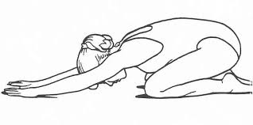 | Intermediate Pose  Tree Pose  3 Cues  - Straight posture and stable base  - Bottom foot is rested on upper thigh or calf (not on knee!)  - Arms are together and reaching to the sky  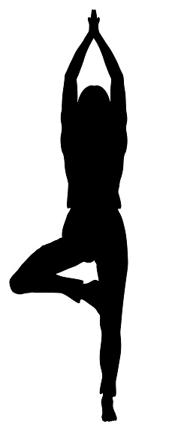 | Advanced Pose  Triangle Pose  3 Cues  - Heel to arch alignment  - Knee pushes against elbow  - Both arms in one straight line (this is perpendicular to the floor)  