ED-D 401

# Matthew Collins V00698046

Presented to Lindsay Mccardle

April 14th 2013

As a future educator I found it appropriate and relevant to cover the topic of expert teaching. Expert teachers are not defined as those who hold years of experience but rather can be defined as someone who allows for all types of learning in their classroom. “An expert is one who knows more and more about less and less” (Enti, 1997). This quote from Nicholas Murray Benner suggests that it is ones passion to the specificity of teaching that promotes their eventual expertise. This paper will examine multiple connections to expert teaching as learned throughout the semester in ED-D 401. The topics that relate to expert teaching that will be discussed in this paper are group work, constructivism, social development, self-regulated learning, motivation, goals, memory and finally self-efficacy. All these concepts relate to expert teaching in many ways. The concept map seen in the appendix as item number one shows visual connections while this paper discusses technical connections.

The first concept I will discuss is expert teaching and how one would master a skill so complex. It is important to note that experience in teaching does not always equate to the mastery of teaching (Tsui, 2009). An educator with the kind of expertise this paper examines would have an automaticity, effortlessness and fluidity to their style of teaching (Tsui, 2009). As taken from the article, “distinctive qualities of expert teachers,” experience is usually an indicator for expert teachers however it is not the sole contributor by any stretch of the imagination. An example they used is Bereiter and Scardamalia’s research of expert and less competent writers. They say that thousands of hours of practice does not compute to an automatic expert writer but rather that they may just become bad fluent writers (Tsui, 2009). However they do state that expert writer’s end up spending longer hours and more time on their work but that is merely because of the high standards they have set for themselves and are constantly challenging themselves. They state that expert writers tend to, “work at the edge of their competence,” and that is what differentiates them as expert writers and not experienced non-expert writers (Tsui, 2009).

The research on expert teaching suggests that the most effective educators are the ones who manage their classroom the best (Tsui, 2009). This is a key concept in developing your teaching style in to an expertise. Teachers that were able to prevent disruption in the classroom by implementing routines and norms had better attention from the students in the classroom and were able to spend more facilitating the learning of the students rather than disciplining one or two students during class (Tsui, 2009).

An example that the article on expert teaching uses is during their research on expert teachers they had two different teachers introduce the same lesson plan to different classes but they were allowed to adjust the lesson plan beforehand. The two first time teachers to the class were examined by two monitors who recorded how they taught and any changes to the lesson plan. The first thing the two teachers both did was introduce themselves using only three adjectives. These adjectives varied from the two but what stood out in their research was the activity that ensued. The first teacher Eva asked the students to do the same, write down three adjectives about themselves and keep it to themselves. She created an information gap between the students as an ice breaker and asked everyone to turn to the person on their left and say why they chose these adjectives (Tsui, 2009). This created a communicative environment in which all students had to participate. Where the second teacher Marina went wrong is that during her activity she asked the class to do the same in writing down the three adjectives but then instead of communicating these with a partner she called a name from an attendance list and asked that that individual to say their three adjectives and proceeded to ask the fellow class mates if the adjectives accurately described that individual. The students in the class were not all participating and talking because they all didn’t know if the adjectives resembled the qualities of that person because they maybe didn’t know the individual also Marina only called upon a few students not enabling the whole class to share (Tsui, 2009). Taking that activity one step further would be to do what Eva did in the first place and share with a partner but then after that use what Marina did and communicate what you’re partner said in discussion to the class. It seems that Marina missed a crucial step in her modified lesson plan.

The second, third and fourth concept that I related to expert teaching was group work, constructivism and social development. I think these three concepts really are the backbone of becoming an expert teacher. Some educators are under the miss-conception that they always need to be throwing information at the students and the more the students can regurgitate is the measure of what they’ve learned. Most students would not agree with this method and furthermore, from personal experience I find that more is learned through hands on learning and self-discovery based learning. This is not to say that all people will learn the way I will but I can guarantee standing and talking at the front of the class for an hour and a half won’t get the information through to the majority of the students and what they learn won’t be remembered as accurately. Group work promotes guided discovery and brainstorming, the only hindrance can be too large of groups in which all the members don’t get to be heard. I think letting the class learn for themselves is undervalued and is a necessity at times to reach mastery in the field of teaching. Social development is gained through group work and more than just learning the material for the test, they can develop social experiences that will help them for the rest of their lives. Being able to work with any kind of personality is a strongly valued life skill. Group work helps so much in social development of students and has so many positive side effects. Some benefits from group work that can lead to positive social development are improved self-esteem, better language skills, the strengthening of learning skills, building of friendships and finally becoming your own identity ("Social development in," 2012). As an educator if you are able to enable students to thrive from these benefits while having them simultaneously learn valuable knowledge I truly consider that a main contributor to teaching excellence.

Constructivism is also a very important as it relates to group work, social development and expert teaching. Constructivism has an interesting premise that people construct their knowledge based on their life experiences (Callison, 2001). This approach is very important in the classroom and is very important for educators to adopt some form of constructivism in their classroom. Learning from experiences is part of maturing and it is important for an educator to acknowledge this as they look to better the quality chances of their students successes. Constructivists believe that knowledge is constructed and not transmitted by the teacher and that knowledge is embedded in all activity (Callison, 2001). As an educator this is a very important point and the constructivist point of view should be explored. However, it is not the only teaching style that works, it tailors to many students but not all.

The next concept that I related to expert teaching, group work and social development was self-regulated learning which I then related to motivation, goal setting and memory. Self-regulated learning is one’s ability to asses and control their own learning. Research has shown that most people have a faulty mental model of how they learn and remember (Bjork, Dunlosky & Kornell, 2012). As a future educator it is my responsibility to be able to help the students gain a more realistic sense of their own self-regulated learning which will help them with comprehension, test scores and future learning. It is important to inform the students that although they believe that information can just write itself in their memories after hours of studying, if it’s done in a passive way, they are wrong (Bjork, Dunlosky & Kornell, 2012). Having a firm understanding of what self-regulated learning is and the problems that surround it as a teacher will only benefit the students and make you a better teacher.

Students may ask many questions to themselves about studying techniques and among those is how much time should I spend studying? The answer is not as simple as it seems because sometimes studying for a long time isn’t always the key to doing well on tests. Students need to remain focused and productive while studying and inexperienced students can waste a lot of time on areas that will not benefit them as much as they believe (Bjork, Dunlosky & Kornell, 2012). Students still need to spend a considerable time studying however that is not the only indicator for succeeding on tests. Students may exaggerate the amount of time they spent studying as well because although they were at their computer “studying” for three hours bouts of ten minutes on Facebook and YouTube can easily cut that time in half (Bjork, Dunlosky & Kornell, 2012). It’s a problem with the modern era of studying on a computer and even though some may not admit it I know I have been a victim to the temptations of the internet while studying for finals.

Another question students may ask in studying is how should I study in order to receive good grades? The answer to this question is also very situational. There are many strategies that will help any student in studying but they must be done effectively and the strategy must benefit the learning style of the student (Bjork, Dunlosky & Kornell, 2012). Students may engage in practice questions, group studying and summarizing but all pose potential risks to following the wrong path and failing exams. Group study sessions, if focused are very solid ways of studying but they can also turn in to social events (Bjork, Dunlosky & Kornell, 2012). Furthermore the idea of summarizing material for a test seems in practice to be effective but if the student lacks the general ability to summarize the appropriate information they have the possibility of struggling.

The final concepts that I linked to motivation, memory and goals is self-efficacy. Self-efficacy is the idea that a person is only as good as they think they can be. This idea is very important for an expert teacher to follow because without the proper attitude towards rewarding students with feedback, they may in turn have a poor self-confidence in relation to academic based activities. Self-efficacy must be recognized as valid in order to become an expert teacher. Students who are motivated tend to have positive self-efficacy because if they believe they can succeed at the task the likelihood is that they will and be motivated to challenge themselves and get even better at the given task. Setting goals is another indicator of positive self-efficacy but it is the teacher’s job to make sure they are attainable and realistic so the student does not feel discouraged if they do not meet these expectations. An expert teacher can promote positive self-efficacy by making short and long term goals for each student based on their current skill level. Short term goals will help them attain that motivation to continue trying and eventually meet their long term goal(s).

To conclude, the concept map shown as figure one in the appendix outlines the route of which all these ideas, concepts and theories connect with one another. Teachers do not simply get better with age, they also need the core values and ideologies going in to the field to be able to master education. Expert teachers are willing to adapt their lesson plan and have an open room in which all the students feel comfortable in expressing their ideas and questions without being judged. If an environment of collaboration, communication and respect can be established expert teaching and learning can occur. Understanding the ideas, concepts and theories discussed in this paper are essential in becoming an expert teacher and should be researched and valued by future educators.

**References**

Bjork, R., Dunlosky, J., & Kornell, N. (n.d.). Self-regulated learning: Beliefs, techniques and illusions. (2012). *Annualreviews*, *64*, 417-44. Retrieved from http://www.annualreviews.org.ezproxy.library.uvic.ca/doi/pdf/10.1146/annurev-psych-113011-143823

Callison, D. (n.d.). Constructivism. (2001). *EBSCOhost*, *18*(4), 35-8. Retrieved from http://web.ebscohost.com.ezproxy.library.uvic.ca/ehost/detail?sid=774b90d5-8197-4600-94f4-afc2979e95cc@sessionmgr15&vid=1&hid=28&bdata=JnNpdGU9ZWhvc3QtbGl2ZSZzY29wZT1zaXRl

Enti, D. (1997). *Education - quotes*. Retrieved from http://www.etni.org.il/quotes/education.htm

*Social development in children*. (2012). Retrieved from <http://www.scanva.org/prc-social-> development-in-children.htm

Tsui, A. B. (n.d.). Distinctive qualities of expert teachers. (2009). *Taylor and francis online*, *15*(4), 421-439. Retrieved from <http://www.tandfonline.com.ezproxy.library.uvic.ca/doi/full/10.1080/13540600903057179>

Appendix

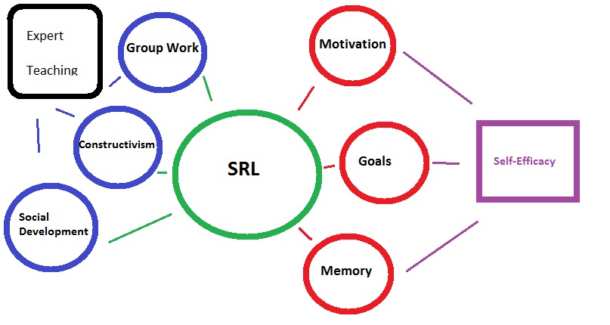

**Figure 1.** *Concept map of Ed Psych connections*