Endball and Benchball (with Goal-Taker)
2 x 3 pinnies. 1 playground ball. 1 soccer ball. 8 yellow corners.
2 benches.
Equipment
Monitor

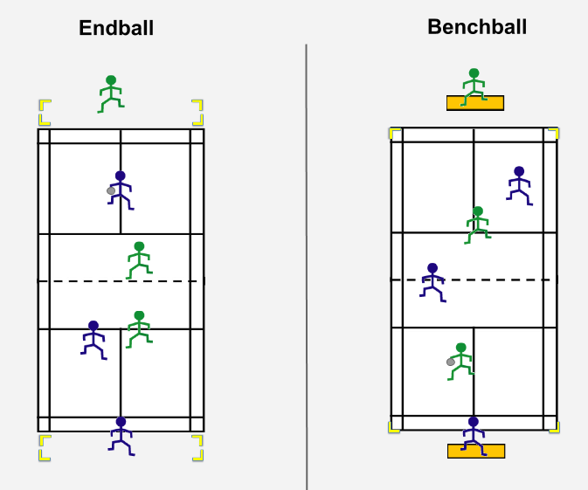
Official
Goal Taker
Goal Taker
Goal Taker
Goal Taker

Aim of the games: Score by invading opponents’ area to pass the ball to the goal-taker.
Rules
- Score by passing to goal-taker who catches the ball in space marked by yellow corners or when on the bench.
- Players cannot move with the ball
- If score is made the defending team starts with the ball, scorer swaps places with the goal taker and rest of the team retreats to their half.
- Throw-in from side to defending team if ball or player with ball goes out of play.
- One defender must go to player with the ball, rest of the defenders try to intercept the ball.
Extension rules:
- Can only score with a pass from below head height or a bounce pass.
- No defender allowed in end zone.
- 3 second rule with ball
- No goal taker, score by passing to person in end-zone
Coach
- Allowed to run with ball, turnover if tagged.

How could a modification by adaptation rule be added to your game? (Outcome of a game encounter changes the game for winner to make the game more challenging)
Principles of Play
Team with the Ball | Team without ball
Score | Stop scoring
Keep possession | Get possession
Invade territory | Prevent Invasion

Analysis

What are the key strategies (ways of playing and movement off-the ball) to use to be successful at these games?

_________________________________________________________________

What are the manipulative skills do you need to play these games?
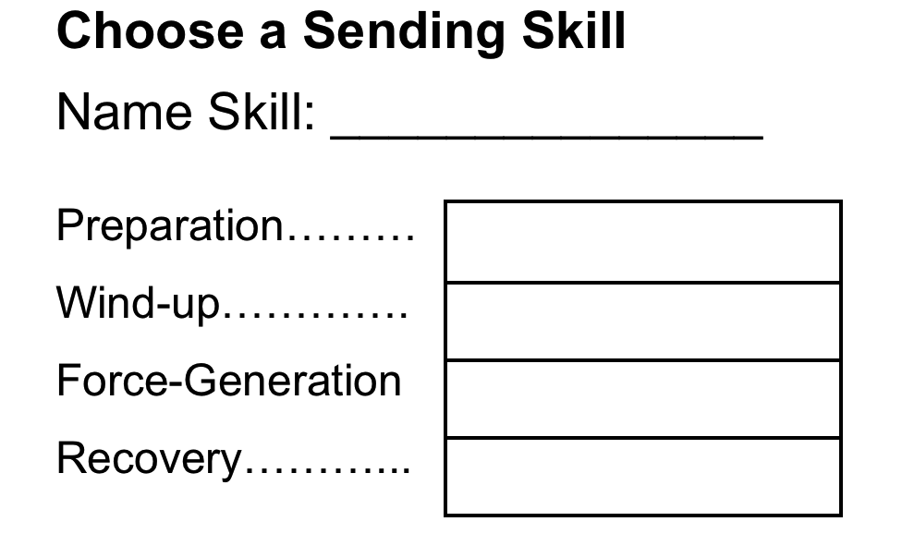 | 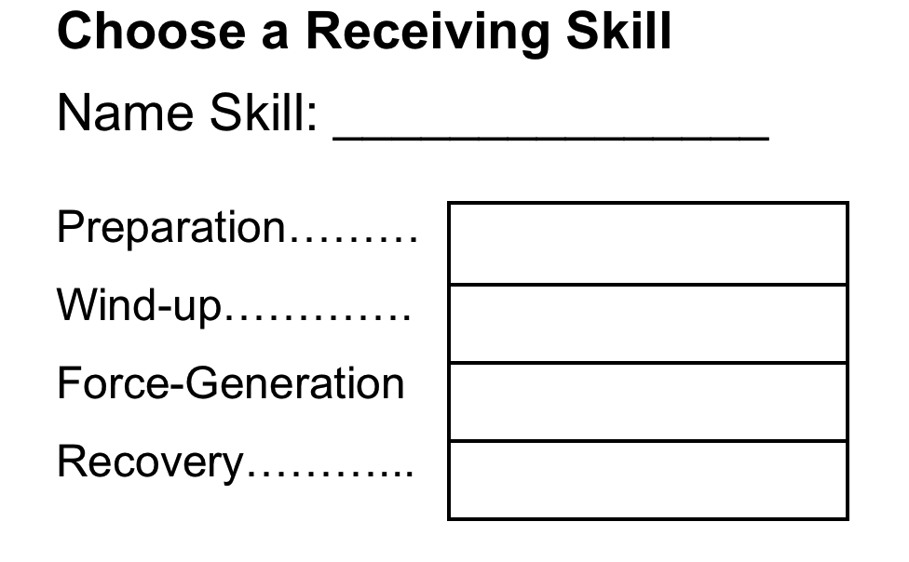

What are possible retaining skills you could add to your games?

_________________________________________________________________

What would be two tasks you could do to practice that would help your peers play your game?

Consider (1) Skill cues (2) Tactical prompts

Task | Word Suitable Tasks
1
2

