**Volleyball Day 1: Forearm Pass and Serve Receive**

**Technical cues**:

* Used to get low balls (below head/neck)
* Forearms create a nice flat platform
* Hands together, thumbs folded over
* Arms straight
* Body square to target
* Power comes from bending the knees, not swinging the arms

**Drills:**

**Partner Passing:** Player 1 passes to player 2 who returns the ball with a forearm pass and then backpedals to the endline (10x) and then switch passers.

Force the passer to get square to the target. To make it more difficult, toss the ball to the left and right and force the passer to move.

**Attack Line Pass:** Player 3 tosses the ball over the net to the attack line area. Player 1 runs to the attack line, forearm passes the ball to player 2 and then back pedals to the next lateral position to repeat the same process until he/she has passed 3 times.

**Technical cues of serve receive**:

* 6 positions
* Must stick to your position
* Knees bent, ready position, on toes ready to move one way or another
* First pass off a service should normally be a forearm pass

**Formations**

Warm up serving by having two teams on the end lines and serve back and forth.  
  
**Serving and Receiving Drill:** Players are divided into 2 teams, a serving team and a receiving team. The goal of the receivers is to forearm pass the ball to their setter, and by doing so they score a point. The servers goal is to either ace the serve or cause the receiving team to lose control of the ball. Either one of these counts as a point to the serving team.

Ended day 1 by playing some full games.

**Volleyball Day 2: Setting and Overhead Passing**

Today was the first day of micro-teaching. The topic was setting and overhead passing.  
  
**Technical cues of setting**:

* Index fingers and thumbs should form a triangular window
* Get body behind the ball and square to target
* Low base
* Hands above head
* Power comes from elbow extension
* Knee extension can help add distance

**Rules of setting**:

* Setter usually takes 2nd pass
* Opponents may not block a set
* Positions 2/3 are generally where a setter will pass from

**Drill 1 Individual Passing:** Practice setting stationary, by doing 10 light sets making sure the ball stays in your control. If you are successful, begin setting higher (3 feet), and even higher (10 feet) if you are successful with that. Now you can incorporate walking, and spinning just to add a degree of difficulty.

**Drill 2 Man in the middle:** 3 players pass the ball using overhead passes. Player 1 sets a short overhead pass to player 2, who returns a short pass back. Now player 1 digs deep and sends a long set to player 3, meanwhile player 2 turns to face player 3. Repeat the cycle

**Drill 3 Setting Only**: Two teams play out a point. Each player on the team must set the ball once before the ball can be passed over the net.

**Setting Rotation:**  
2 types of setting rotations were discussed. The 4-2 and the 5-1.   
  
**4-2 Setting Rotation:**

* Team has two setters.
* Always opposite of each other in rotation
* Setter in front row sets.
* Advantage: Easier to learn for younger students/players, less confusion.
* Disadvantage: Only have 2 hitters in the front row.

**5-1 Setting Rotation:**

* Team has one setter that sets everything.
* On service, players must align so the setter has the easiest route to setters spot
* Advantage: 3 front row attackers, opens more options for attack.
* Disadvantage: Higher degree of difficulty, easier to make rotational faults
* Meant more for higher level play and advanced players.

**Rules covered**:

* Cannot overlap with another player until serve has been made
* Once handed in, official changes to the lineup card cannot be made unless it’s a substitution

**Scoring:**

* Backline player jumps after attack line
* Foot Fault Serving
* Carry
* Coach gets a yellow card
* Lift
* Ball touches down
* Double touch

**Volleyball Day 3: Attacking & Strategic Offense**

**Technical cues**:

* 3 step approach
* As you approach arms draw up behind your back
* Arms swing forward on jump to create momentum
* Hitting arm cocks back like a bow and arrow (Batman, Superman, Robin Hood)
* Open palm
* Shoulders should point direction you want to hit the ball
* Contact ball with arm fully extended
* Hit top of ball

**Rules**:

* Not allowed to touch the net
* Back row must jump from behind attack line

**Drills:**

**Self Practice:** To begin getting the feel for the timing of the jump, players should practice tossing the ball up for themselves and hitting it over the net or into a wall.

**Hitting drill:** The coach sets the ball to the power position and players go up for a hit. While setting, the coach calls out 1 or 2, signalling for a line shot or a cross court shot. This drill forces the player to react to verbal cues and begin thinking about the placement of their attacks.

**Three hitters:**

Have three attacking player and one setter at the net. The hitters should be set up in the power, middle, and off side or right side. A ball is tossed to the setter who makes the decision of where to set the ball. All players should approach even if they are not the ones attacking. Players in a good position to hit should be encouraged to call for the set.

**Volleyball Day 4: Blocking & Strategic Defense**

**Technical cues of blocking**:

* Forearm distance from the net
* Both arms together at the elbows
* Body forms a C-shape to reach over the net
* Strong hands
* Use core muscles to increase height

**Rules**:

* Cannot touch net tape
* Cannot block a set or a serve
* No limb can completely cross the half court line
* A block does not count as a touch

**Drills:**

**Stationary Block:** Three players along one side of the net should stand holding balls up above the net (benches and chairs may be used). Players on the opposite side of the net should approach and block as if the ball was coming over, then move laterally down the net and repeat. Put emphasis on reaching over the net and pushing the ball back.

**Battle Block:** Two players stand on opposing sides of the net. A coach tosses a ball as fairly as possible so it is right in-between the players and they have to jump and attempt to push the ball onto their opponents court.

3. **Defensive formation Drill:** Coaches stand along the net in either the power, middle, or right side position. When the coaches claps their hand on the ball, players move into the defensive formation that best defends against the position being hit from. Below

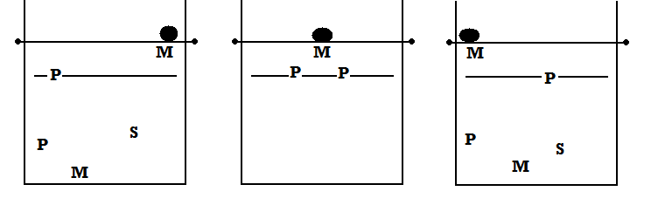

**P Attack M attack R Attack**

**Referee signals:**

Three things: Team to serve, nature of fault, player or fault.

Things to know:  
1. Ball in bounds  
2. Ball out of bounds  
3. Ball out after contact  
4. Held/carried  
5. Contacted more than once  
6. End of game  
7. Time out  
8. Substitution  
9. Service  
10. Delay of service (8 seconds)  
11. Player illegal touches net/serve not over  
12. Double fault (both teams fault)  
13. Illegal screen  
14. Positional/Rotational fault  
15. Illegal reach over net  
16. Ball contacted more than three times  
17. Enter court  
18. Change court

**Volleyball Day 5: Strength & Conditioning**

**Teaching cues:**

* Focus on dynamic workouts with emphasis on vertical jumps, as well as static, and weight lifting
* Important muscle groups can be prone to injury, focus on strengthening shoulder, back, thigh, calf, and core muscles.
* Volleyball is a power sport, not endurance

**Drills:**

**Vertical Jump drills:** One leg line jumps; jumping back and forth over a line on one leg. Net jumps; repetitive jumping as if blocking. Jump rope.

**Arms:** Pushups, wall throws, tricep dips, and ball toss.

**Legs:** Side lunges, mountain climbers, jump squats, suicides.

**Core:** Walking lunge and twist, plank, dead bugs, situps.

**Individual & Team Defense**(October 17, 2012)

**Warm up:**

* Laps around the court
* High knees
* Butt kicks
* Karaoke step

Warm up activity: Mirror your partner, when your partner moves lateral follow them lateral, when they stop to do a spike or a block copy the same thing or if they get in the ready position, after a couple minutes switch partners.   
  
Following this play a game of pepper with a partner, practice forearm pass, setting, and spiking.

**Defensive Strategy:**

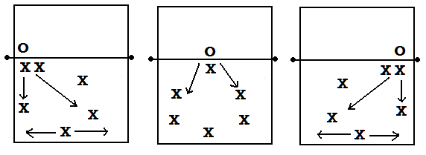

**Right Side Attack Middle Attack Power Attack  
  
Drills:**1. Group teaching the class had us do three passes P1 would forearm pass laterally to P2 who would then forearm pass to the setter. This drill made absolutely no sense and is *highly impractical*. ***Never in a game would a player try and laterally pass to another passer.***

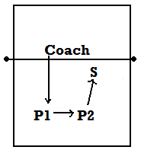

2. The next drill was more practical there are two back rower passers and a setter, someone from the other side of the net throws a ball to either P1 or P2 and they forearm pass to the setter, whoever does not forearm passes goes to the net for the attack, the setter sets them and they hit the ball.

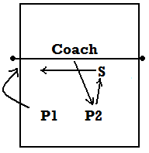

3. Diving: Players are in a line and are doing fast feet, every time the whistle blows they dive out as if they are diving for a short ball or a tip.

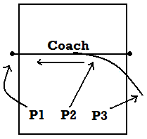

4. For this drill players are in positions 1, 5, and 6 and a coach is standing off to the side of the net. It is the 3 player’s objective to get the ball and play three hits and return it to the other side of the net. The coach makes the drill more challenging by throwing the ball further than just the court boundaries, communication and quick movements are key in this drill.

5. Progression of the previous drill, there are two teams on opposite sides of the court, this is a 3 on 3 defensive game. Both teams T1 and T2 start laying down on the end line of their side. The coach is off to the side and smacks the ball and both teams get up and run to position on their side of the court. The coach then throws or bounces a ball in to one side. Both teams play out the point, whichever team is successful gains a point, you can play this until whatever limit.  
  
We finished the day with game play and practicing refereeing for the practical exam.

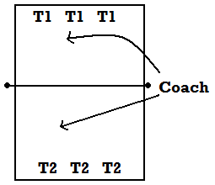

**Beach Volleyball**(October 31, 2012)

**Rules:**

* One side of the court is only 8m long, shorter distance because only 2 people
* Still three touches per team
* No forehand pass over the net
* Block counts as a team touch

**Technical Cues:**

* Only two players on a team/court
* The front player uses signals for who has block and where
* Index finger means player will take line shots
* Index and middle finger means player will take cross shots
* Both players need to be able to set
* Setting needs to always be straight up at the net because of wind

**Drills:**

1. Class was divided into teams (pairs of 2) One pair on each side of the court, one pair is the tosser, the other pair has to communicate and react to the toss, one has to receive, the other set, and the next grab the ball as if they are hitting.

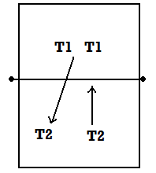

Players should focus on communication. Whoever goes for the first hit the other player has to peel off to the net.

2. In partners students stand parallel to the net and practice setting straight up back and forth between each other. This is important in beach volleyball because wind is a huge factor so you cannot push the ball to a power set for example because you would never be able to know where it would end up. Have players stand not too far apart, focus on control and consistency. In beach volleyball the hitter comes to the setter.

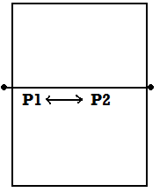

3. The final activity of the day was two games of king of the court, teams constantly rotated off but gained points if they won a point. At the end of these games the top 4 teams that had the most points played a mini beach volleyball tournament simulated indoors.

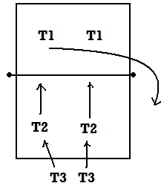

**Coaching**(October 31, 2012)

**Jobs/Positions:**

* Referee
* Second Referee
* Lines persons
* Scorekeeper
* Coach
* Assistant Coach
* Player:
* Setter
* Power Attacker, Middle Attacker, Right side Attacker
* Libero
* Substitutes

Referee:

* In charge of officiating the game
* Keeping players safe
* Enforcing rules
* Awards points

Second Referee:

* Watches net plus line
* Deals with subs
* Informed of time outs

Lines person:

* Points if the ball is out or in
* Does not make the call, the referee still makes the call

Coach:

* Responsible for their team
* Gives advice and feedback
* Substitutes players
* Teaches players

Assistant Coach:

* Helps the coach during training in whatever way possible

Setter:

* Should always be the player getting second touch
* Sets the attackers for a hit
* You can have one or two depending on rotation 5-1, 4-2 you’re using
* Beginners set from position 3
* Advanced players set from position 2

Attackers (Power, Middle, Right side):

* Generally have the third touch, hit or tip.
* Aim is to put the ball down on the opposing teams side

Libero

* Defensive specialist
* Plays back row only (exceptional passer)
* Libero can go in freely for any player in the back row

Substitutes

* Prepare the same way for a game as starters
* Need to be ready to go in at all times
* Support the team

In this class the micro teachers used a mock game and simulated a game experience by having players fill each of the above mentioned roles. Each person got an opportunity to shift through each roll so they could see what each role is responsible for.

**Activity Task Card**

**6 v 6 Volleyball**

Jobs:

1 Ref -main official, makes deciding calls

1 Second Ref -second official, makes some preliminary calls, signals for substitutions

3 coaches -make team decisions (who to put in where and when), provide feedback to players, plan a practice for players who are not involved in game

14+ players -play volleyball

2 Liberos

**Rules**

1. Every point **BOTH** teams rotate.
2. Every **six points** coaches rotate, and players out switch in
3. Coaches switch out after running a **practice**
4. If you are asked a question by a facilitator, respond **loudly** so others can hear as well.
5. Play by the regular volleyball rules we have learned in this class with exception to **rule 1**.

**Coaches Task Card**

**Libero - “Defensive Specialist”**

Can only play back row - Cannot serve - Cannot be captain

*Who should be the Libero? When should they be rotated in/out?*

**Rotation**

5-1 (one setter) vs 6-2 (2 setters on opposite corners) vs basic/advanced setups

*How many strong attackers do we have? How skilled are my players? How well do the players understand volleyball?*

**Serve Receive**

M (2 up 3 back), W (3 up 2 back), Advanced rotations

*Are they serving short or long? Where are my strong receivers?*

**Substitutions**

Entry (b/w attack-center line, libero b/w attack-end line)

Must sub back in for player that took you out

*What opposition players do I need to watch for? What players should I keep apart from eachother? Who plays well in the front/back row?*

**Defensive Strategy**

Libero -

Blocking – 1 or 2 blockers, tips, line coverage or cross court

Subbing strategy – marking certain players, attacking weaknesses

*What are the strengths of my team? How many tall players do I have? How many players are good at digging? Are we strong cross court?*

**Practice**

Look at areas needing improvement (cues), progressions of difficulty/specificity of practice

*What skills do my players need to practice? How can I break that skill down? What cues/guides can I use? How can I progress the skill from simple to complex?*