**DON’T SWEAT THE di-STRESS**

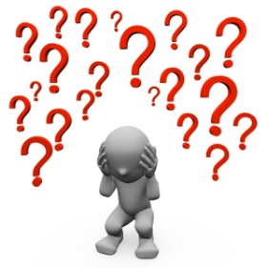

* **Stress** is a state of mental or emotional strain resulting from adverse or demanding circumstances
  + **Eustress** – “good stress” is what gives us motivation to get something done and accomplish a challenge.
  + **Distress** – is when good stress becomes too much to handle and the challenge is overwhelming. This is the one we are most familiar with.
* A **stressor** is the stimulus or “thing” that causes us stress

We need the “good” stress in order to be successful

**Stressors** can include:

* Not getting enough sleep
* Poor body image
* Exams/Deadlines
* Relationships
* Sports games
* *List 3 more here…*

When you are stressed, your body reacts:

* You lose sleep
* Your immune system weakens
* Your muscles tense up
* Your blood pressure rises
* You digest food slower
* You get emotional (angry/sad)

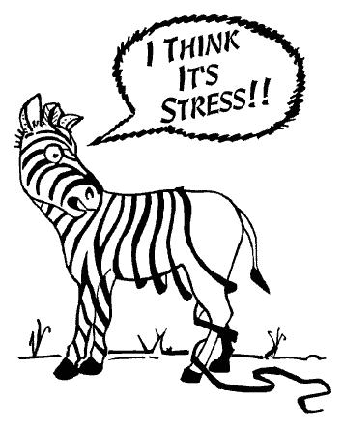

To identify stress:

**Take a few breaths**; are they deep? Or shallow? Do you skip a breath?

**Think about your muscles**; are they tense? Are they sore? Are your hands clenched? How about your teeth?

|  |  |  |  |  |
| --- | --- | --- | --- | --- |
| *Activity 1*  **Write or draw** an account of the last time you remember feeling unhealthy stress.  Was it due to an event? A day? A week? | *Activity 2*  **Identify and list** the causes of stress in your example. Were they due to your environment or your schedule? | *Activity 3*  In groups of 3 or 4, **discuss** your list. Are any of them the same or similar? Compile a list of all of the *stressors*. | *Activity 4*  With your group **discuss** ways you manage or reduce this stress?  *i.e. Physical activity*  *Video games*  *Movies* | *Activity 5*  **Create or** **produce** something that demonstrates how to promote good stress and reduce bad stress (radio broadcast, poster, skit etc.) |

**Charlotte Dickinson**

**Grade 11 PLO:**

1. Describe strategies for stress management and relaxation

2. Design and implement plans for balanced, healthy living, including (1) nutrition, (2) exercise, (3) rest, (4) work.

**Grade 12 PLO:**

1. Analyse and design plans for stress management and relaxation

I believe that the activities will lead the students to an appreciation of what stress feels like in their lives, to identify the stressors and to implement a plan whereby they are able to determine what helps them to relax and refer to this in times of need. The activities are easy to do at short notice, in any environment and with a bare minimum of equipment. The activities also allow the students to work individually and in small groups; furthermore, they allow a certain freedom of choice to the student in terms of how they express their ideas and present their work.

It is expected that the students will use the time for activity one and two to reflect on themselves and to connect with an experience, and then for activities 3 and 4 the expectation is that the students will be working on task, sharing information, actively listening and consciously drawing similarities and differences between their experiences. I would imagine that the stressful experience that one student has experienced could be completely unlike that of another student; therefore, taking the time to listen and understand the situation will mean that the students increase their repertoire of knowledge and strategies for identifying and reducing stress. The final activity is designed to both have the students think of common strategies for relaxation but also determine what they LIKE to do when they are feeling stressed. It is probable that at least one student will not have thought about this before and the ideas generated may lead them to make personal health decisions that positively affect their lives.

The solutions that I would expect the students to come up with would be the key features of a healthy and balanced lifestyle, and the group collaboration should increase the number of responses and help develop work strategies for group activities. It should be the kind of activity where teachers can mingle with students, listen to their ideas, and pose possible solutions. However, they may also need to keep students on task and focused on the discussion at hand.

References

Brock University. (2010). “Eustress vs distress.” *Brock University.* Retrieved from http://www.brocku.ca/health-services/health-education/stress/eustress-distress

Nordqvist, C. (2013, August 27). "What is stress? How to deal with stress." *Medical News Today*. Retrieved from http://www.medicalnewstoday.com/articles/145855

Segal, J., Smith, M., & Robinson, L. (2013, July). “Stress relief in the moment.” *Helpguide.* Retrieved from http://www.helpguide.org/mental/quick_stress_relief.htm