Lesson: Yoga  Topic: Review of last days poses and introduction to a new sequence  Equipment: Yoga mats for each student, stereo system | Learning Outcomes  - Apply a range of movement concepts associated with body awareness, postures and spatial awareness  - Analyze their partners and understand what a proper pose should look like through peer assessment
Parts of the Lesson (50 minutes) | Organization/Safety Concern | Teaching Points
Introductions and Discussions (2 mins)  -what today’s lesson will be, expectations  -why we do yoga | -know your own body (injuries and limits) | -breathe deep, remain calm, and relaxed
Introductory Activity (5-10 mins)  Warm-up  Stork, elephant, snake  -count to three, make pose, hold pose  -Stork drops baby on elephants head, elephant squishes snake, snake wraps stork!  -Play with partners - switch.  Tag  -One player is “it”  -When tagged must make bear/downward dog position  -To be free another player must slide under your pose | -teacher demo 3 poses | -demonstrate 3 poses for game  -show example game  -know bounderies  -compare to toilet tag  -bear
Lesson Focus (5-10 minutes)  Sun salutations:  1) Mountain (dandasana)  -legs together  -hands in prayer position  2) Forward Bend  Look up followed by another forward bend  3) Plank Position  -step back with right foot then left  4) Cobra  -lower body onto stomach and onto top of feet  5) Downward facing dog  - push through palms, shouders away from ears, push hips to the sky, relax head  6) Warrior  -step right leg through arms, rotate back foot slightly and look at front arm  Repeat cobra sequence, then go to other side  Repeat sequence | -remember the importance of breath  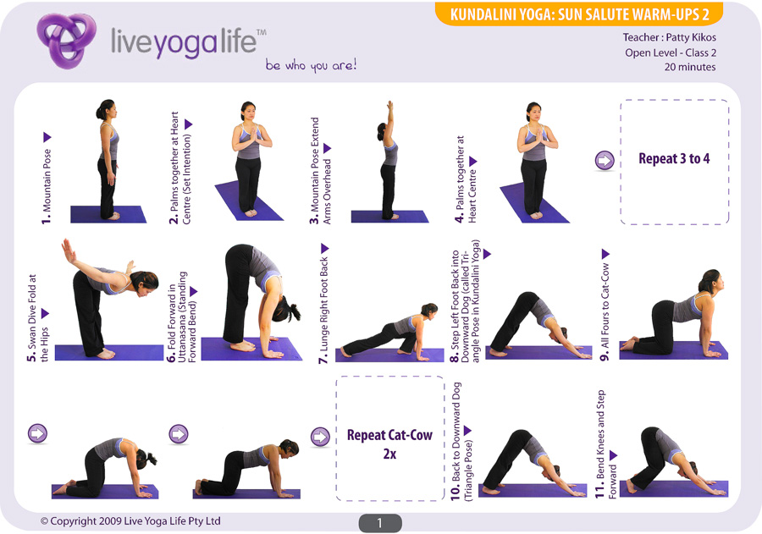  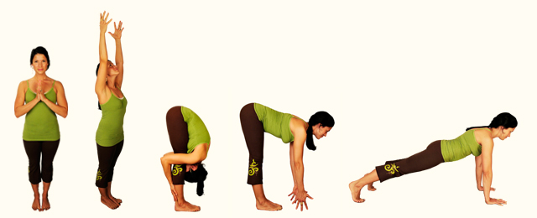  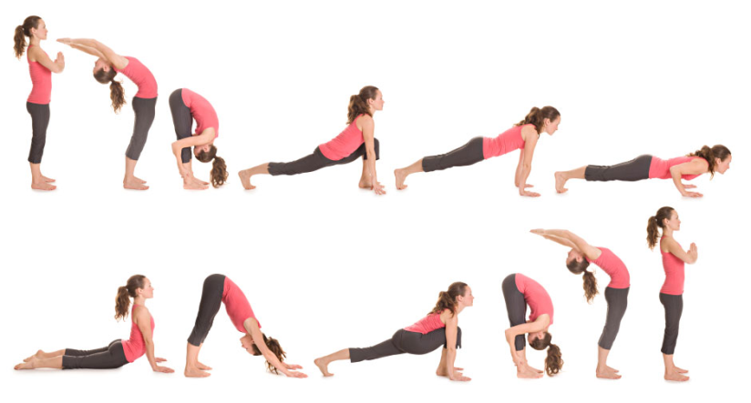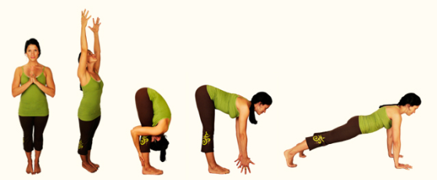  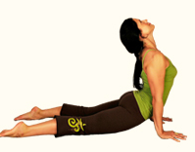  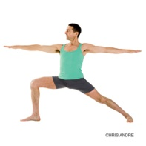  -come up slowly to decrease dizziness | -stand tall  -shoulders back, heart out  -reach arms and stretch high (inhale)  -(exhale) hinge at the hip, arms out at side, head is the last thing to go, place hands on ground  -(inhale) look above eyebrows, back straight, hands at shins or ground  -three breaths and hinge again (exhale)  -keep back straight and long, look forwards, stand on toes  -walk your feet if needed, neck relaxed & in line with arms  -breathe, stare at one spot, keep back leg firm  - Come back to dandasana same way, slowly rolling up, one vertebrae at a time.
Review of Poses (5mins)  1) Tree Pose  -Ensure leg is not over knee  2) Triangle pose  -rotate torso and chest so that is faces the sky  4) Eagle Pose  6) Bow Pose  -very good for digestive/stomach discomfort | 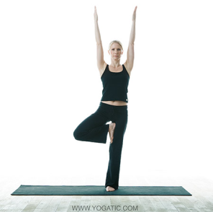  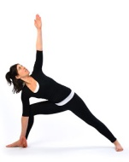  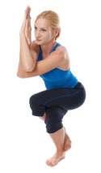  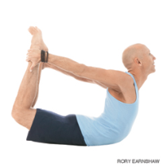 | -stare at one place on the wall  -push standing leg into foot and foot into leg  Maintain balance, stare at one spot, breathe  -look at the ceiling  -keep the back leg strong  -focus on your legs and breathing first  -opposite arm-to-leg  -push out with your legs and up with your abs and chest  -look at the ceiling & breathe
Peer Assessment (5-10 min) Becky  -(Look below for form) | -scattered amongst the room while teacher walks about | -make sure parnters exchange comments before switching  -make sure students can hold position for 10 seconds  -don’t push past your limit/do whats comfortable  -Advanced pose can be attempted but isnt required
Culminating Activity (5 mins) Lora  Make your own Yoga Pose  -Develop a sequence of three poses, incorporating 2 poses used in class and creating 1 pose  -students should name their pose. | -in a circle, asked groups to share | -what are the three components of yoga: balance, strength, flexibility
Closure (5mins) Lora  Relaxation Activity (3min)  -corpse pose  - Read script  Closure (2min)  -Thank everyone, encourage them to continue to use yoga in their daily life, and ask if anyone has questions. | 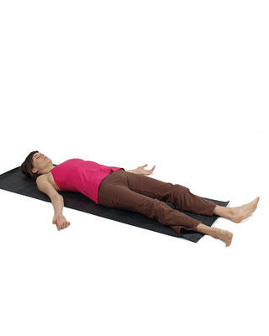  -find a comfortable place in the gym with their mats | -turn off lights  -Legs extended, palms facing up, eyes closed, whole body relaxed

