EPHE 461G – Soccer Lesson Plan

Shooting (60 minutes)

Warm-up (10 minutes)

Moving goal game: (Equipment: 2 sets of pinnies, rope or extra pinnie, cones for area)

* Space : 10ft x 10ft – 12ft x 12ft
* 2 equal teams of 3 or 4 people + 2 extra
* 2 extra people carry pinnie or rope taut between the two of them to create “goal”
* Goal: To pass between team mates minimum 3 times and shoot into “goal”
* Key points:
  + - 1) strike the ball with the instep of the foot
    - 2) hips face the goal
    - 3) look at the ball, target then ball again before shooting

Technique (15 minutes)

Air and ground control

* In partners, facing each other 6 – 10ft apart (based on skill level)
* One throws the ball to the other, choosing ground level, knee level or chest level
* Upon receiving the ball, the person must control the ball at the appropriate level and return the ball to the thrower
* Goal: To enhance control of the ball when it is aimed at the body, and be able to hit the ball with power afterwards.
* Key points:
  + - 1) absorb the ball in to the area of the body it hits
    - 2) let it bounce if it helps control
    - 3) contact the ball below for height, instep for flat, laces for power

Drill (15 minutes)

Pass and Shoot

* 2 lines, either side of the net (3 – 4 people max), everyone has a ball except the first in one line
* Person without the ball runs out towards the penalty spot, other line passes them a ball as they round the spot and face
* Hit the ball at the net
* Goal: to make a run at the ball and shoot accurately on target

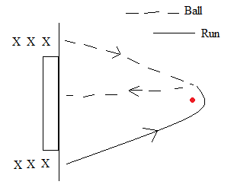

* Key points:

1) keep the head up

2) place body over the ball

3) place non striking foot just behind and beside ball for power

Related game (15 minutes)

Modified game (equipment: 2 goals, pinnies)

* 2 teams 6+ people, 4 on the pitch, 1 on either side of the goal being attacked (2)
* Pass the ball between team mates towards goal, must make 4 passes and, also pass the ball to the player on the end line who passes it back in for a shot to be taken
* There may or may not be a goalie, depending on numbers and players
* Goal: to effectively make passes between team members in space, to pass and receive from the end line and take a shot from this final pass
* Key points:
  + - 1) play to space for successful passes
    - 2) play to end line and continue moving in towards the goal
    - 3) choose the placement of the ball (upper, lower, left or right) in the net before striking

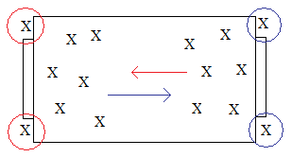

Cool down (5 minutes)