Danie Proby & Kyle Long

EPHE 106- Feb 21/2012

Lesson Plan: Discus

**Introduction:**

The discus throw dates back to at least 8th century B.C. in the ancient track and field events using a heavy metal disc. In modern times the discus is 2.5 in diameter and 2.0 kgs (men)/ 1.0 kgs (women) in weight. In the discus throw, the individual will complete a one-and-a-half or one-and-three-quarter rotations in the designated ring, while moving in a straight line from the back of the ring to the front. Beginners should start with the basic fundamentals and slowly work in the harder, more technical aspects of the throw. Muscle memory is vital for learning proper form for the discus throw.

Today’s class will be focused on the release point and basic body torque/pivoting. We will run a series of activities and drills to ensure the participants are actively learning with a hands-on approach. The objective is to build basic muscle memory, using fun and specific drills, without complicating or confusing the participants.

***Equipment:*** If indoors, Frisbees can be used in place of discuses.

***Safety Points:*** Since no longer throws are being made, safety is only really a prevalent issue if the warm-up is not adequate. To ensure the wellbeing of the participants, make sure the whole lesson is active and engaging from start to finish.

**Warm Up:**

We will take the students through a warm-up activity that is fun for all ages. It progresses from slow to fast pace using the Frisbees that will be used in class.

***Builders and Bulldozers:*** The class will be split up into builders and bulldozers. When the top of the Frisbee is pointing towards the sky, it is a building. If the top of the Frisbee is facing towards the ground, it has been bulldozed. The point of the game is to turn as many Frisbees over to your team’s position as possible in the allotted time with the specific method of movement. The games will be first speed-walking, then running, then polar bearing on all four limbs for a minute per method. The polar bear method is to begin focusing on warming up the upper body for the rest of the class.

***Arm Swings:*** The class will now arm swing back and forth, trying to achieve the feeling of a whip like action with their arms. Leading with the body is important here.

***Misc. Stretches***: focusing on arms and core

**Lesson:**

The actual lesson for the class is focused on how pivoting should feel and how the disc should feel as it leaves the hand. Keeping the drills fairly basic but high repetition should allow the students to start gaining muscle memory and eventually gain the confidence to proceed onto more complex movements and stages of the throw.

***Pivoting Drills:***

The pivot, or turn, in the discus throw is vital because it is one of the fundamental ways you generate power during the throw. When done properly, it can increase your distance and give you the basic feel for your throw. Rotate clockwise, bringing your arms back as far as you can, holding it in your throwing hand with your non-throwing arm in the opposite direction, keeping your throwing arm as far away from your body as is comfortable. You weight should be distributed mostly on your right foot, while you pivot on your left toe (right-handed).

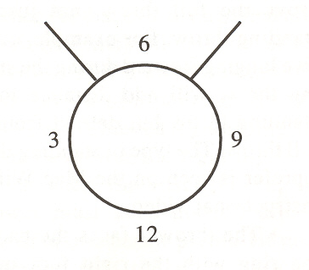

1. **Clock-Work:** First, you will pivot on your right foot (for right-handed) and on your left (for left-handed) to 9 o’clock, 6 o’clock, 3 o’clock, then back to 12 o ‘clock around the circle. Now repeat but only pivot to 6 o’clock, and then back to 12 o’clock. Finally pivot all the way around from 12 o’clock back to 12 o’clock. Your arms should be out as if you were going to throw the discus. Really focus on whipping your arms and being in an athletic stance.
2. **Hand Clap:** Find a partner. The first person stands with their arm at about should height, just over an arm length away from the other partner. The second person does their 360* pivot and tries to strike the first persons hand. Repeat ten times and then switch.
3. **Basic Turns:** Pivot 360* with a jump, then reverse back into the starting position. Repeat ten times. Then pivot 360* again but continue only in one direction across the gym ten times.

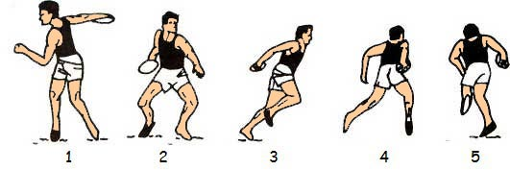

***Release Point Drills:***

Finding the proper release point on your hand is one of the basic parts of learning the throw the discus. From your pivot, continue shifting your weight forward as your hips pivot around. The disc should smoothly exit your grip at around shoulder height. You want to spin the disc off your index finger, clockwise, while making sure to release it, not throw it. These drills will help the students feel comfortable with releasing the disc with the proper technique.

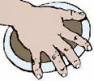

1. **Frisbee Bowling:** The disc should be held in the most distal joints of your fingers and the disc should be delivered against and from the index finger with the disc spinning clockwise for a right handed thrower. With a partner stand approximately three meters apart and do a basic bowl with the Frisbee to your partner on the other side. The disc should release off of your index finger and should at least start rolling straight. Take a step forward with your left foot (right-handed), bend at the waist, thighs and knees.
2. **Push Pass:** With a partner standing approximately two meters apart, begin push-passing the Frisbee back and forth. A push pass is where your fingers are curled underneath the Frisbee, except your index finger which is on the edge of the disc and the thumb rests on the top of the disc. Try to put a lot of spin on the disc and keep it flat. Next throw is up to your partner at approximately a 35 degree angle. Finally, use your pivot that you learned in the pivot section of the class, and add the push pass at the end. Start close to your partner, and after each successful push pass made by each person, take a step back until you reach your potential. (Variation= two lines facing each other, passing back and forth, following pass to the opposite line.)
3. **Passing (if time):** With a partner pass back and forth using the pushing motion on the disc, adding in a full pivot or spin.

**Cool down:**

1. Find a partner and jog slowly around the gym approximately 2 meters apart. Push pass back and forth to each other. Exaggerate each movement as to stretch out the muscles you have utilized during class.
2. Misc. Stretching in a circle

**Conclusion:**

Learning to properly perform each step of the discus throw will provide the student with all the necessary tools to use their body’s potential energy most efficiently. Breaking the throw down into smaller steps and focuses on just a few at a time will give them the building blocks to be able to reinforce the moves into muscle memory.