**Table of Contents**

Session I: Forearm Passing and Rules

Session 2: Setting and Overhead Passing

Session 3: All Passing and Defense

Session 4: Pass Testing

Session 5: Attacking and Blocking

Session 6: Serving, Receiving, Team Play, and Wash Drills

Session 7: Attack and Block Testing

Session 8: Tournament and Systems of Play

Further Information

Session 1

**Volleyball Warm-up**

**Area used:** half a volleyball court

**Equipment:** 1 ball per court

**Number of players:** 4-6/half of a court

**Drill 1:** volleyball tag

**Usefulness:** incorporates volleyball style passes and spatial awareness

**Location of players:** scattered about the half court

**Location of ball:** starts in the hand of one the players who is not it

**How drill starts:** one player is ‘it’ who runs around the half court trying to tag someone

**Ball circulation:**  the ball is the passed around the players who are not it as if you have the ball you are

**Method:**  the players run around passing the ball and when they are tagged they could

**A:** wait for the next round and rejoin

**B:** becomes it and who tagged them is now it

**Skill performed:** setting and passing, or tossing

**Variation:** for beginners the ball can be tossed and for the more advanced the can set/ bump the ball to themselves and eventually to another player

**Success criteria:** communication, fast, accurate, and strategic ball movement

**Drill 2:** dynamic stretching

**Stretches:** high knees, butt kicks, low shuffles, grapevine, leg swings, arm circles, dynamic calf stretch

**Volleyball Communication**

**General guidelines**

* One syllable
* Early
* Loud
* Back row precedence

**Good examples**

* Mine
* Me
* In
* Out
* Down
* Free *(easy ball to play likely a high arching pass from the other team)*
* Help
* Up

**Bad examples**

* I got it
* My ball
* Go
* I go
* I’ll set
* Yours *(do not call the ball for someone else)*

**Volleyball Skill: Passing (bump)**

**How to:**

* Move to ball
* Medium stance position
  + On toes
  + Knees somewhat bent
  + Torso straight
  + Feet shoulder width apart
  + Good balance position
* Flat platform
  + Hands clasped with thumbs on top
  + Arms away from the body *(as if beach ball in between arms and thighs)*
  + Angled to target *(push ball towards target not like swinging a racket)*

**Starter Drills**

1. Individual passing
   1. Bumping to self
      1. Use legs
      2. Let the ball only go about a meter up
      3. Move around while passing
      4. Keep arms straight in front *(do not bring to chest)*
   2. Change in height
      1. Alternate between high and low
      2. Still focus on straight arms and bent legs
   3. Bump against the wall
      1. Try to keep the ball below head height

*Depending on the goal of the practice can have the players strive for quality, reps, or time

1. Passing with a partner
   1. One player on knees (toes on the ground), facing the net and weight forward
      1. Standing player passes the ball in front of the kneeling player
      2. Kneeling player bumps the ball back aiming for the passers forehead
   2. Kneeling partner now standing
      1. Player tosses the ball just in front of the standing player who bumps it back
      2. Start with completions and then work on toward and height

**Volleyball: Coaching Tips**

**Practice expectations**

* Keep the plan simple and keep the focus on the important things
* Be clear and consistent on your expectations
  + Gear, rituals, warm-ups, what to do when your talking

**Practice Values**

* You start it by how you act and what you do and who you associate with
* How you structure training
* But it must be accepted and realized by the players

**Practice Planning**

* Practice planning with vary depending what point and type of season you are in
* Start of with block training (focus on one skill all practice)
* Take notes on the practice and adjust with necessary
* Have regular drills of all kinds
  + Ends up with less time spent learning the drill and more practicing the skill
* Create a mix of structured and unstructured practices
* Consider the importance of an increased number of touches on the ball
  + Hit -> block -> shag vs. hit/ hit/ block/ block/ shag
* All positions require good ball handling skills
  + Middles must be able to set cleanly
  + Liberos should be able to jump and hit a ball into play
  + Don’t have players stuck on one position
* Vary intensities
  + Fast paced drills and more realistic game like pace
* Use water breaks effectively
* Try and work on scouting opponents
  + Especially the higher the level

Session 2

**Volleyball Warm-up**

**Area used:** 1-2 courts

**Equipment:** court and net

**Number of players:** doesn’t matter

**Drill 1:** Dynamic yoga

**Stretching:** dynamic stretches in the form of yoga poses holding each poses for at least 15 and make sure to do both sides of tree, warrior I/II, and triangle

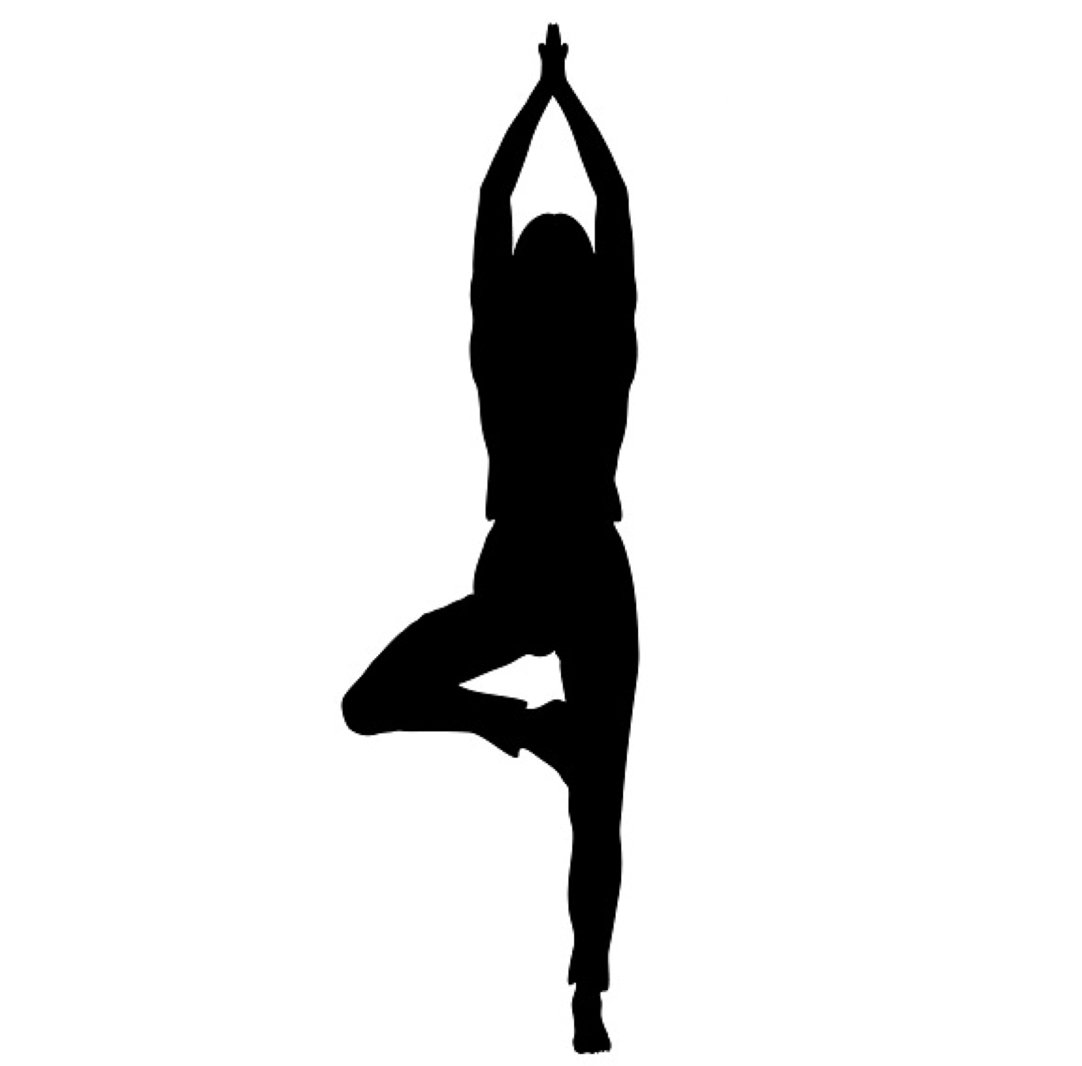 [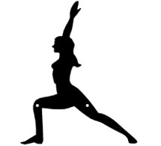](http://www.artisanmetalshop.com/sport-yoga-warrior-i-pose-wall-art-studio-decor-755.html) [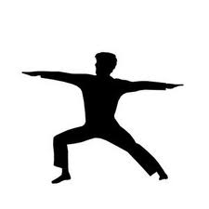](http://www.ehow.com/about_6593340_sport-yoga-certification.html)

Tree Warrior I Warrior II

[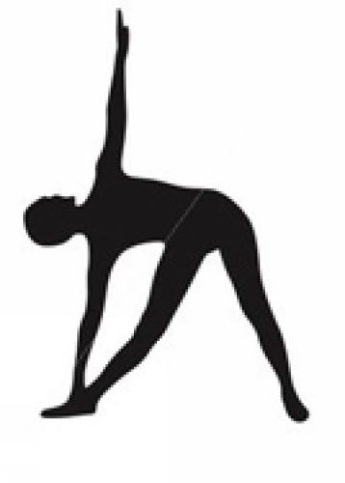](http://pilatesyfitness.com/category/yoga/) 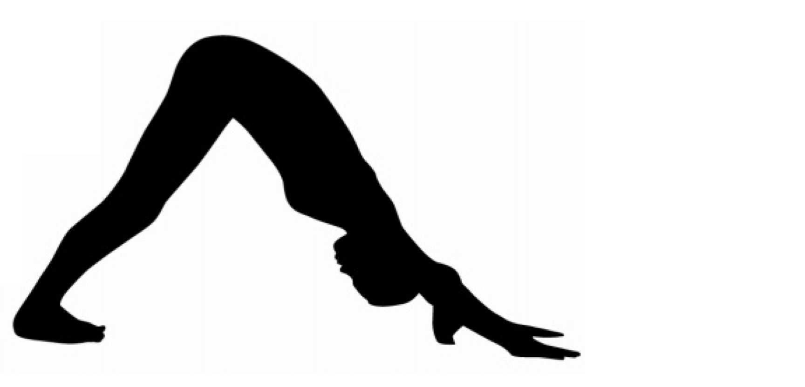 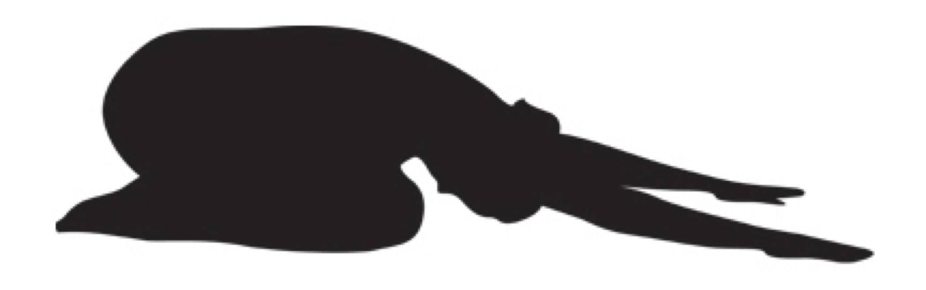

Triangle Downward Dog Child’s Pose

**Volleyball Skill: Setting**

**How to:**

* Beginners
  + Feet to ball
  + Balanced
  + Hands above forehead making a diamond with fore fingers and thumbs (thumbs back)
  + Extending arms in a parallel motion upwards
* Advanced
  + Feet to ball square to outside set
  + Consistent hand and body position
    - Keep a high contact point
  + Jump setting
  + Avoid
    - Squatting or dropping hands when setting in position 2
    - Bending backwards when setting behind
  + Setting tactic
    - Keep everyone involved
    - Setting long and against flow of game
    - Knowing when to set the middle and not to

**Starter Drills:**

1. Individual Setting
   1. Setting to self
      1. Use finger tips
      2. Extend arms
      3. Move around while setting
      4. Do not let arms ‘swim’ down to your side while ball in air
   2. Passing with partner along ground
      1. Lay flat on ground pushing ball to partner
      2. Maintain straight arms until the ball comes back
      3. Watch your own hand positioning
   3. Setting against a wall
      1. Aim for a spot above your head
      2. Try to have the ball land back on your forehead
      3. Keep arms straight while ball in air
      4. Step towards wall
2. Passing (2-4/ group) 3-5m apart
   1. Front set
      1. Catch ball/set low above forehead with correct hand positioning
      2. Then set high to partner
         1. Use legs and arms
   2. Side set to partner
      1. Catch ball, low set to self, and then high side set to partner (alternate sides)
         1. Drop leading shoulder, follow through with hands
   3. Set, clap, set
      1. Set to self
      2. Clap three times
      3. Set to partner
   4. Set, spin, set
      1. Set to self
      2. Spin
      3. Set to partner
   5. Back set to partner
      1. Catch ball, low set to self, and then high side set to partner
         1. Look at the ball, do not bend back just pushback with arms

* As skill level increases reduce the number of touches the player does on the ball during their turn

* Adding another person to the group and having the players following their pass

**Definitions:**

* Double contact: ends in the ball spinning (each hand pushing separately)
* Carry: (indoor) when ball stays too long in hands
* 51: quick ball in front of setter
  + Position 5 and one foot above the net

|  |  |  |  |  |  |  |  |  |
| --- | --- | --- | --- | --- | --- | --- | --- | --- |
|  |  |  |  |  |  |  |  |  |
|  |  |  |  |  |  |  |  |  |

* + 1 2 3 4 **5**  6 7 8 9 - positions that you could be in
  + See following page for more information

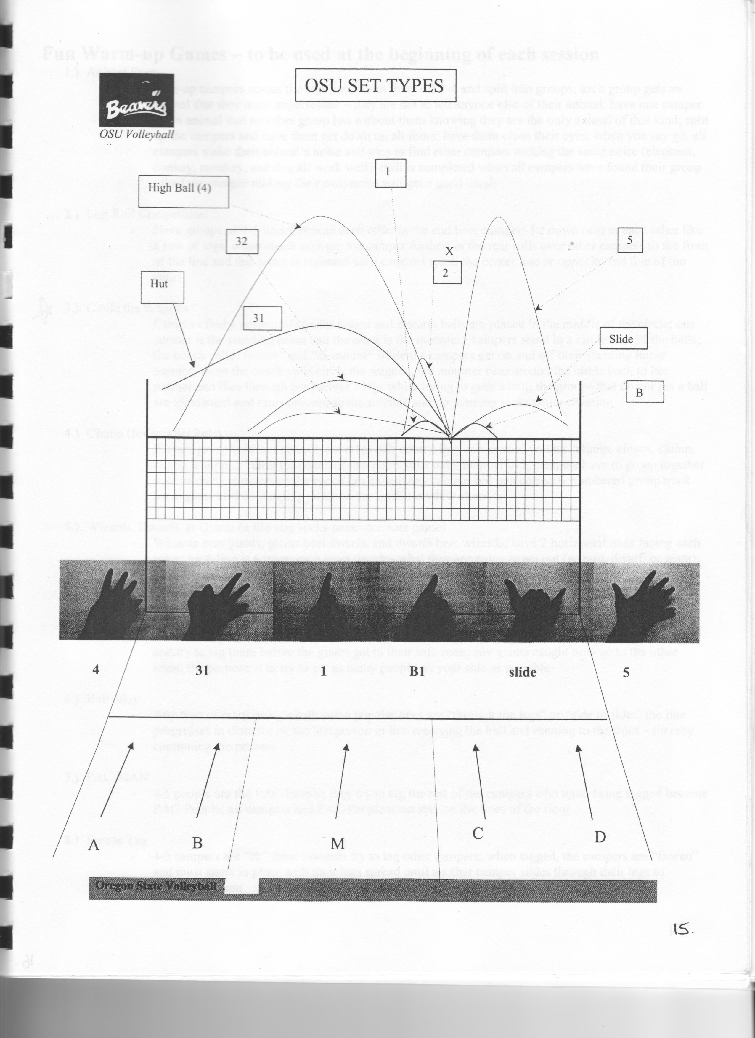

**Volleyball Coaching Tips**

Environment

* Players must do the behavior you want in order to have success in the drill
* Do not explain too much, do what you are saying
* Try and incorporate ball handling into the warm-up
* Involve players as much as possible in drills
  + If you are doing anything more than entering the ball into play you should get a player to complete the task
* Working towards a number, consecutive, or time completing skill
  + Make sure that the goal is reasonable for them
  + Decide whether you will go until they complete the task how you want or have a time limit so you can move on to the next drill
* Keeps statistics (score, correct skills, incorrect skills)
  + Will help you settle line-up questions along with other considerations
  + Make the players more accountable for their own performance
* Encourage positivity (celebration, sayings) even over small successes
  + Do not do if they aren’t doing well as it won’t help them
* Reinforcement that is instant and clear for desired or undesired behavior is important
  + Particularly when learning of changing a skill
  + At times they may know what they have don wrong but praise is rarely too much

Session 3

**Volleyball Warm-up**

**Area used:** gym

**Equipment:** none

**Number of players:** whole team

**Drill 1:** Follow the leader

**Usefulness:** gets the athletes warm as well as

**Location of players:** in pairs in a line

**How drill starts:** everyone follows the leaders, who also call the directions,

around the gym in a random pattern

**Method:**

**Skills performed:** jumping (like blocking), touching down left/right (getting

low), turn (movement), and switch (used in volleyball)

**Variation:** adding different movements such as running backwards,

shuffling, or touching down with two hands

**Success criteria:** loud person calling the directions

**Volleyball Skill: Defense**

**How to:**

* One arm bump
  + Inside of arm or wrist
  + Contact ball above knees
  + Maintain a straight arm
* Diving
  + Lower you start the less it will hurt
  + Stride (girls do more)
    - Fall on hip not knee
    - Play the ball on or as going to ground in J swing or pancake
    - Try to roll out of it into a upright position
  + Chest (guys)
    - Needs upper body strength
    - Plays ball in air and then lands
    - Dives forward, catches self, then hits the ground
  + If of balance from jump slide backwards
    - If landing off balance wrong could injury knees
    - Guys do this naturally so important for girls to do this

**Starter Drills:**

* Shuttles (groups of 3-5) following your pass
  + Bumping keeping the ball below net height
    - Aiming for the ball to land in front of partner
  + Setting high and getting feet under ball
  + Left side bumping and right side setting
  + Bump to self and then set to partner

*can add competition to any of the above

* Partners with one ball between two
  + Tosser has back to net
  + Bumper stands at mid court
    - Completes short and long
    - Short: diving/ lunging or diving pass to tosser
    - Long: side/back bump (platform toward partner) or tomahawk

**Definitions:**

* Tomahawk: two hands together like bump except overhead
  + High enough for setter to get under it but not over the net
* J swing: arms swings in a J shape in a one handed bump
* Pancake: flat hand palm down on the ground and lifting fingers up to play the ball

Session 4

**Volleyball Warm-up**

**Area used:** court

**Equipment:** net and 1 volleyball/ 2 players

**Number of players:** whole team

**Drill 1:** shuttles

**Usefulness:** gets the athletes warm as well as preforming volleyball skills

**Location of players:** in pairs spread out along the sideline

**How drill starts:** each partner passes back and forth between each other from side

line to side line

**Method:** passes include bumping and setting back and forth while either running or

shuffling, forward or backward

**Skills performed:** bumping and setting

**Variation:** adding different movements such as being stationary and touching the

ground before bumping to encourage getting low

**Success criteria:** movement and accurate passes

**Grading Rubric**

|  |  |  |  |
| --- | --- | --- | --- |
|  | Student A | Student B | Student C |
| **Passing (/15)** |  |  |  |
| Platform |  |  |  |
| Thumbs |  |  |  |
| Straight arms |  |  |  |
| Arms away from body |  |  |  |
| Step towards target |  |  |  |
| Midline to target |  |  |  |
| Dropped shoulder if ball is out of midline |  |  |  |
| Feet to the ball |  |  |  |
| Use of legs |  |  |  |
| Medium body position |  |  |  |
| Balanced |  |  |  |
| Good ball height |  |  |  |
| # of good passes /15 (1-5=1, 5-10=2, 10-15=3) |  |  |  |
|  |  |  |  |
| Setting (/15) |  |  |  |
| Medium body position |  |  |  |
| Steps towards target |  |  |  |
| Midline to target |  |  |  |
| Hands at crown of head |  |  |  |
| Hands finish high |  |  |  |
| Arms finish equally |  |  |  |
| Quick release of ball from hands |  |  |  |
| Feet to the ball |  |  |  |
| Thumbs back |  |  |  |
| Balanced |  |  |  |
| Good ball height |  |  |  |
| # of good passes (1-5=1. 5-10=2, 10-15=3) |  |  |  |

**Test**

* Teacher tosses ball over the net to the player who has to bump/set to target at center of net
  + Target counts the number of good passes
  + Good pass: balls will land above head and within two steps of the target
* Teacher will toss five balls to the center of court, five to the left and five to the right
  + Player always returns to the center

Session 5

**Volleyball Warm-up**

**Area used:** 1 court or more

**Equipment:** none

**Number of players:** whole team

**Drill 1:** Coach’s Call

**Usefulness:** gets the athletes warm as well as preforming volleyball like actions

**Location of players:** spread out about the court

**How drill starts:** everyone is spread out and the coach will call out directions for

the players to do

**Skills performed:** block (jump with hands up), spike (jump with arm swing), left

(touch down with left), right (touch with right), lunge left, lunge right, shuffle left,

shuffle right, grapevine left and grapevine right

**Variation:** adding different movements such as running backwards, diving and

sliding backward

**Success criteria:** loud person calling the directions

**Volleyball Skill: Attack and Block**

**How to:**

* Attack
  + Approach (if right handed) left, right, left
    - Left handed: right, left, right
  + Swing
    - Superman: both arms raised above head
    - Robin Hood: non-hitting arm raised above head and hitting arm bent back by head
    - Ninja Turtle: swing hitting arm forward while slightly lowering non-hitting arm
    - Like throwing a ball and pointing with non-throwing to target
  + Show different shots
    - Swing: full swing and powerful hit
    - Roll: topspin contact which rolls the ball between the blockers and net
    - Tip: just uses fingers to tip the ball just behind the block
* Block
  + Face the net
  + Keep hands up when moving across the net always ready
  + Watch for attackers midline and line of approach to anticipate where the hit will go
  + Jump and reach hands over the net without touching it
  + Block the hitting arm

**Starter Drills:**

* Attack: using a Tennis ball

1. Throwing the ball back and forth with a partner
   * + High hand and elbow
     + Point with non-throwing hand at your partner
2. Throw a bounce pass ½ way between you and your partner
3. Hold tennis ball in non- throwing hand

* Mimic arm swing action
* When hand are above head next to each other transfer ball to throw arm
* Throw a bounce pass to your partner

1. Add approach

* Complete the same action as #3

1. Move to the net completing the approach and throwing action

* Do 5 approaches at each position (power, middle, right/left)

1. Add volleyball

* Practice topspin hits over the net getting progressively further back
* Have partner toss a 53 for them
  + Progress to setting a 53 with 2 lines per net
  + Progress to completing forward and back sets for the attacker
* Blocking

1. Practice closing with a partner
   * + Shuffle towards each other and jump to block
2. On one side of the net have 3 students on benches holding up ball above net

* Split class into groups based on height
* Have half block and the other hold the ball then switch
* Progression have the players on benches hit the ball for the blockers

1. Jousting Competition

* Still in their height group have one blocker on either side of the net
* Another person will toss the ball up and the blockers have to try and block the ball down on their opponents side

Session 6

**Volleyball Warm-up**

**Area used:** 1 court

**Equipment:** none

**Number of players:** entire team

**Drill 1:** Stretching

**Usefulness:** gets the athletes warm

**Location of players:** spread out about the sideline

**How drill starts:** coach explains the stretches they will do

**Skills performed:** jogging while completing arm rotations (forward and backward),

arm pull across body, arms above head with fingers intertwined, elbow pull, with

straight legs touch the ground, legs apart lean hand to each foot, knee to chest (left

and right), and torso rotations

**Variation:** adding different movements and stretches

**Volleyball Skill: Serving**

**How to:**

* Underhand
  + Face the net
  + Contact ball with fist (beginners) or palm of open hand (as soon as possible)
  + Do not toss ball in the air hit out of your hand
* Sidearm
  + Ball is held to the side and your not facing the net
  + Step towards the net as swinging to contact the ball
* Overhand
  + At first minimize movement
    - Small toss and weight shift (no steps)
  + Contact ball in it’s center above and in front of hitting shoulder
    - To change target hit ball in different areas
  + Jump topspin serve
    - Can toss with 1 hand
    - Same approach as an attack
    - Hit the ball with a lot of power
  + Jump float serve
    - Controlled toss
    - Contact the ball at a height of toss

**Starter Drills:**

1. Start by serving to a partner from the attack line progress to end line

* Complete 5 of every serve and at each line

1. Have players serve into hula hoops scattered about the court

* Could give out points for hitting or not hitting hula hoops
* Receiving drill

1. One side serves and the other side must get their feet to the ball and low enough for the ball to bounce between their legs

**6 Up**

* When receiving a serve the players should not be standing in 2 lines of three
* 6 should be in the center of the court with 1 and 5 tucked towards the middle and behind 6
  + Making the center of the court look covered from the view of the server
* This is to try and force the serving team to aim for the sidelines making it harder for them

Session 7

**Volleyball Warm-up**

**Area used:** 1 court

**Equipment:** none

**Number of players:** entire team

**Drill 1:** Active Warm-up

**Usefulness:** gets the athletes warm while performing volleyball like movements

**Location of players:** lined up single file in position 1

**How drill starts:** run/shuffle towards the net

**Skills performed:** blocking, attack approach, running (forward and backward), and

shuffling

**Method:**

**-** First two laps: run towards shuffle across the net, run backward to service

line and shuffle across back to position 1

- Second two laps: run towards shuffle across the net blocking at positions 2,

3,4, run backward to service line and shuffle across

- Third two laps: run towards the net, across the net completing 3

approaches, run backward to service line and shuffle across

**Competitive Drills**

1. **19 vs. 11**

Team A starts on 19 points and must win the 2 wash points in a row to score a point.

Team B starts on 11 points and wins a point for every rally they win. Play to 25

points. Play as a 2 ball wash with alternating serves.

1. **+7**

Play as positional drill with LvL. Only left side hitter can score a plus when they terminate any other player kills the ball it is a wash (0). If any player (including designated player) makes an error then hitter is credited with a minus (-). The winner is the first player to get to +7 points.

1. **21 vs. 23**

Team starting on 21 points is receiving. Play a rally score game to 25 points.

1. **Clockwork**

6v6 with the idea being that a team needs to go through all 6 rotations in a positive direction to win. If you serve and win a point you rotate to you next positions, if you don’t win the point you receive. You get 1 chance to win that point, if you do then you serve in the last rotation you were in If not then you rotate back 1 spot and the other team keeps serving. If you go backwards 6 rotations you lose.

1. **2 minute frenzy**

Keep putting free balls into Team A for 2/3 minutes and keep track of points they score. After allotted time switch to Team B and keep track of their points.

1. **LvL or RvR or MvM**

Can put any player against any player and the first ball must go to them, play out the rally and then put the ball into the opposition and they must set the first ball to the designated player.

1. **Hitters vs. 6**

Two hitters on the same side of the net attacking against the team of 6, alternate balls going to each hitter and keep score.

Session 8

**Volleyball Warm Up**

**Area used:** 1 court

**Equipment:** none

**Number of players:** entire team

**Drill 1:** Active Warm-up

**Usefulness:** gets the athletes warm while performing volleyball like movements

**Location of players:** lined up single file in position 1

**How drill starts:** coach calls out the stretch they will do

**Skills performed:** high knees, butt kicks, shuffles, grapevine, arm circles

**Drill 2:** Mr. Wolf

**Method:** who ever is the ‘wolf’ faces away form the players lined up on end line. Mr.

Wolf if asked what time it is and call out their answer. The players take that amount

of steps that the wolf called. When the players get close to Mr. Wolf he yells

dinnertime and chases them. If they catch anyone they sit on the side and either do

20 jumping jacks, 1 burpees, or 15 sit-ups.

**Drill 3:** Pepper

**Method:** use bump, set, spike format

**Possible Systems to Use**

**5-1:** Setter is always moving to position 6

Strengths (why everyone uses it)

* + You only need on setter to use it
  + Only one setter must be trained
  + Half the time transition is great
  + Half the time there are three hitters
  + Half the time the defense is single minded
  + Half the time the setter can play close passes
  + A single player is placed in a natural leadership positions
  + Variance

Weaknesses (why it may not be used as much)

* + Catastrophes can happen
  + Half the time (see 3-6 above)
  + System is becoming predictable

**6-2:** Setter are opposite of each other (position 3 and 6 for example)

Strengths (used a lot)

* + System allows at least 3 hitters at all times
  + Trains and gives 2 setters experience
  + Gives a team the best possible alternate setter
  + Setters don’t have to be big hitters or blockers because they can be replaced in the front row
  + If you setters are also you best hitters then they may be used in both areas

Weaknesses (why it is now rarely used)

* + A team must have 2 good setters
  + Transition is the hardest in this system
  + The system had become predictable offensively
  + The offensive setter is eliminated
  + The tight pass becomes your enemy
  + One player cannot focus on defense
  + System add difficulty to serve receptions
  + Some on court leadership is lost (particularly when a setter(s) leave the court in the front row)

**4-2:** One setter move to position 6

Strengths

* + Usually run with a lower level of complexity
  + Easy and fast transition
  + It lets all defenders worry about defense
  + Allows setters (is capable) to always play passes which are close to the net
  + Trains and gives experiences to 2 setters (good for emergencies and transition for year to year)
  + Setters and passers can be trained to always be offensive

Weaknesses

* + Limits offense to 2 attackers
  + Limits the number of offensive option or combinations
  + Must use to different setters to train hitters
  + Setters must be bug enough to block or a blocking system and defensive system must be used to minimize the effect of this problem
  + The new developments are not yet being applied to this system

Strategies used against the 4-2

* + Cheat blocking
  + Serve to one or both of the hitters
  + Attack areas which will force the hitters to dig
  + Make the front row setter dig
  + Set the defense up to stop the offensive setter thus forcing the set to one of the only two hitters

Changes that might make the 4-2 more effective

* + Use of more deceptive serve reception patterns
  + Use of 2 and 3 player passing systems
  + New attack options (1 foot takeoff, slides)
  + Back row attack

**Man Up Defense**

Strengths

* + Disguised personal liabilities
  + Defends the middle attack better than other systems
  + Hits down the line and tips are defended well
  + Not much movement required for defender
  + Setter can create “instant offense” by setting the ball to the attacker right away

Weaknesses

* + The player in the man up position must move really well
  + Man up is usually the right back player (setter if they’re back row)
  + Must have disciplined and consistent blocking

Strategies used against Man Up Defense

* + Not give up too many free balls

Changes that might make the Man Up Defense more effective

* + “Over on two” attack if the team is having trouble getting a good attack off

**Red Base Defense**

Strengths

* + Does not require much post set movement
  + Keeps the defenders deep and attackers in front
  + Doesn’t require the wing player to back up, only forward

Weaknesses

* + Requires two defenders in the back row that can cover a large area and are quick and serve receive well
  + Defenders need to be up for the challenge

Fun Games

1. **Animal Farm**

Line-up players across the end line and number them 1-4. Each group gets an animal that they must impersonate. They are not to tell anyone else of their animal. Have one player be an animal that no other group has without them knowing they are the only animal of that kind. Split up the players and have them get down on all fours and close their eyes. When you say go all players make their animal’s noise and try to find other players making the same noise (elephant, donkey, monkey, and dog work well). The drill is completed when all campers have found their group.

1. **Log Roll Competition**

Have groups of 4-5 line up behind each other on the end line. Players lie down next to each other like a row of logs. When the coach says go, the player furthest in the rear rolls over other players to the front of the line and this move is repeated until campers reach the center line or opposite end line of the court.

1. **Circle the Wagons**

Players find a partner of similar height and stature. Balls are placed in the middle of the circle. One partner is the standing horse and the other is the mounter. Players stand in a circle around the balls. The coach yells ‘mount’ and ‘dismount’ while the players get on and off their standing horse partner. When the coach yells circle the wagons, the mounter runs around the circle back to their partner and flies through their partner’s legs while trying to grab the ball. The groups that do not get the ball are eliminated and proceed to the sideline and do jumping jacks while cheering.

1. **Clump** (for smaller kids)

Players grouped together on each court (of half). They run around yelling and repeating the word ‘clump’ until the coach of their court yells out a number 0-5. Players have to group together with as many players as the coach has called. Any camper not in a correct group number eaves the game and do jumping jacks on the sidelines while cheering.

1. **Wizards, Dwarfs, and Giants**

Wizard beats giants, giants beat dwarfs, and dwarfs beat wizards. Have 2 horizontal lines facing each other. Each line is a team. Each team decides what they are going to act out (wizard, giant, or dwarf). Each team also picks a 2nd choice in case both teams pick the same. One count of three, each line acts out their character. The team that beats the other chases and tries to tag them before the team reaches their ‘safe zone’. Is the chasing team tags any of the other players they join the winning team.

1. **Ball Relay**

Any type of relay using a ball. Some popular ones are: through the legs, side to side. The line progressed in distance by the last person in the line running to the front of the line.

1. **PAC-MAN**

4-5 players are the PAC- people. They try to tag the rest of the players who upon being tagged become PAC- people. All players and PAC- people must stay on the lines of the floor.

1. **Freeze Tag** (go through legs or under arms)