**Tennis Log Book**

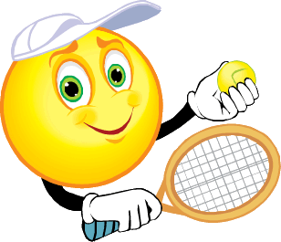

Presented to: Dennis

Matthew Collins

V00698046

TABLE OF CONTENTS

Day 1 …………………………………………Introduction, Warm up, Grips Pg.1

Day 2 ……………………………… Warm up, Forehand Ground Stroke Pg. 2-3

Day 3 …………….……………… Warm up, Stretching, Games ….. Pg. 3-4

Day 4 …………………………………… Warm up and Drills……………….…..Pg. 4-5

Day 5 …………………………………………Warm up/ Serving/Backhand…....Pg. 5-6

Day 6 ……………………………….Review Stokes, Monarch Game……………….. Pg. 6-7

Day 7 ………………………………………..Test and Volleying……..….. Pg.7-8

Day 8 ……………………………………..Filming and 2 vs. 2……….……. Pg. 8-9

**Day 1**

**I**ntroduction of the course materials and Denis went over his expectations of the class. There was then a sneaky surprise test from our instructor to see the classes overall knowledge. The test triggered the games history and the terms and rules of tennis.

**L**earned: Various hand grips, when we need to use them.

**W**atched: Video on how to hit a forehand shot.

**T**ested: On our serving, volleying and ground stokes. (this was done off of the wall).

Player in black, had 10 chances to hit the red star target box.

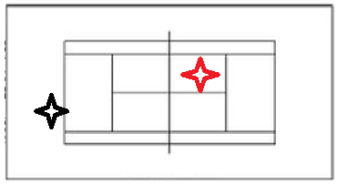

Player had to stay in the black box and hit it consecutively against wall to get their possible maximum score

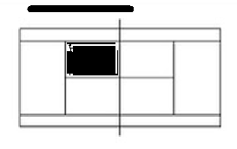

**O**rganization: We split into 5 groups, 1 group was tested at a time, and the rest rallied.

**P**ersonal Reflection: The first day of class sent me away with the overall impression that I was going to enjoy the instructor and his styles of teaching. The video shown in class really helped with my forehand and the test helped me prepare for the final.

**Day 2**

**W**e were taught firsthand how to apply the forehand ground stoke and were shown the different grips that are used.

**W**e reviewed the lines and zones on the tennis court. We then did progression on how to hit a ball with our forehand:

* Used our hands to put top spin on the balls and hit the balls over the net
* We then progressed to using our racquet but could only hold the throat
* The third and final step was to hold the racquet using the proper grip
* We used sponge balls then progressed to the 50% compression balls.

We also played castle where we had to hit the top of a tennis ball case alternating turn with our opponent.

**D**iagram:

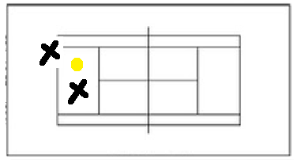

**P**ersonal Reflection: The game of castle was something new I learnt and I kept stored in my memory bank for when I teach tennis. I also found the sponge balls and 50% compression balls fun to experiment with.

**Day 3**

**T**eaching points:

* Warmed up by stretching, doing horizontal and vertical repeaters and playing castle
* We continued with the forehand topspin drill we did the previous day.
* We then progressed into using the 50% compression balls doing the same drill
* We then played doubles
* Finally we ended the day by using our backhand with the foam balls, again stressing backspin

**P**ersonal reflection: As it was the second day of doing forehand drills with various balls I became more confident in the drills we were asked to do. Using the foam and 50 % compression balls help make the learning curve more manageable.

**Day 4**

**W**arm up: Our warm-ups included bouncing a tennis ball along the lines of the tennis court as well as vertical and horizontal repeaters.

**S**erving: Stressed back scratch with racquet, We did half serves against the drapes and stood on ladders to see the angles of the service box for various spots on the court.

Learned 3 serves:

* Top spin serve- hit it high
* Flat serve- hard and flat
* Slice serve- hit on side of hitting arm and brush the outside

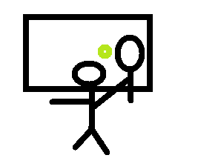**H**itting ball against drapes

**P**ersonal reflection: Hitting the ball against the drapes was very useful for helping get my serve higher. I struggled with proper serve technique during this class but felt as if I somewhat improved

**Day 5**

**S**erve

We review out serving, we watched a demonstration and then proceeded to hit from the service line and progressed back to the baseline

**B**ackhand

We reviewed our back hand hits by starting close to the net with a partner and 50% compression balls as we rallied back and forth Denis spotted errors in individual strokes and corrected them.

**M**onarch (King) of the court

1 monarch of the court was chosen by Denis for each court, (I was lucky enough to be one of them). The main idea behind this game was for the opponent to work on serve and rallying skills as they tried to win 3 points in a row advancing through the 5 monarchs. If they succeeded in winning 3 points they then switch position with the last monarch who gave up the point. 2 chances per challenger.

**P**ersonal Reflection

This day was particularly fun because of the game Monarch of the court, this game will be very useful when I go on to teach the game of tennis. I felt as if my backhand improved dramatically as well.

**Day 6**

**Midterm Vocabulary Test**

Started the class with this (aced it!)

**F**ree warm-up with partner

Got a game of 2 vs. 2 going with Kaid, Megan and Evgeeni

**L**earn to volley

* Started out doing footwork and catching the ball, then we hit volleys with our grip on the throat of the racquet and finally we moved into holding the handle with a continental grip
* We learned the different volley zones best, (BVZ), ideal volley zone (IVZ), and defensive volley zone (DVZ)

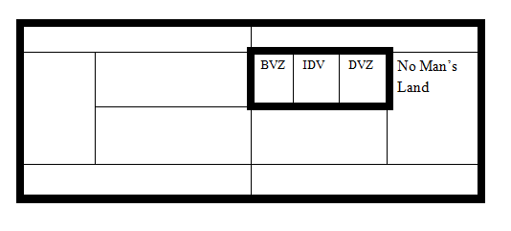

**P**ersonal Reflection

I found volleying to be a very crucial key element to an individual’s game of tennis so I was pleased we learnt it but disappointed it was so late in the semester. Found the zones very interesting.

**Day 7**

**F**ilming Analysis Project

We spent the day mostly playing real games of doubles while Derrick and Dennis got videos going of people’s serves, forehands and backhands. There were 6 groups and it was organized with 1 group at a time.

**Day 8**

**F**inal Testing

The last day of class we were tested on serving and volleying abilities against the wall, we also were tested on our use of ground stokes by how many we could consecutively hit. We ended the day playing doubles incorporating all of our valuable skills into one final match!