**LEAGUE INFORMATION**

This season, the Oak Bay Jr. Boys Soccer team participated in a league run by the Lower Vancouver Island Secondary School Athletics Association (LVISSAA). LVISSA organizes 20 member schools between grades 9-12 with both a Recreational “B” Division, and a Competitive Division. Our team competed in the competitive division along with 9 other schools which allowed us to compete for the Island Zone, and the BC Championships. The association is run by volunteers in the Greater Victoria Area serving school districts 61, 62, 63, & independent schools. All games consisted of 35 minute halves, with a 3:45pm kick off unless otherwise indicated by league Commissioner Ryan Braun (Stellys). All game scores must be reported by both coaches to [rbraun@sd63.bc.ca](mailto:rbraun@sd63.bc.ca) within 24 hours of the games completion. Home teams are responsible for field preparations including nets, corner posts, offside flags and game sheets. The following is a list of regular season game dates and practices including home field sites, kick off times, and exhibition games (Oak Bays times are in **bold)**.

|  |  |
| --- | --- |
| Pool A Teams and Home field sites | Pool B Teams and Home field sites |
| Stellys -Centennial – 3:30 kick off | **Oak Bay- School 3:45 kick off** |
| Claremont- Lochside – 3:30 kick off | GNS  – School 3:45 kick off |
| Lambrick- Lambrick 1 or 2- 3:30 kick off | St Andrews- Reynolds park- 3:30 kick off |
| Spectrum-School 3:45 kick off | St Michaels -School 3:45 kick off |
| Reynolds – Braefoot – 3:30 kick off | Mt Douglas School- 3:45 kick off |

***Practice Schedule***

**Oak Bay Jr. Boys Soccer Tryouts: Thursday September 13th, and Friday September 14th at 3:30pm on the school field.**

|  |  |  |
| --- | --- | --- |
| **Date** | **Location** | **Time** |
| **Tuesday Sept. 18th** | Oak Bay School Field | 3:30pm |
| **Thursday, Sept. 20th** | Oak Bay School Field | 3:30pm |
| **Thursday, Sept. 27th** | Oak Bay School Field | 3:30pm |
| **Thursday, Oct. 4th** | Oak Bay School Field | 3:30pm |
| **Thursday, Oct. 11th** | Oak Bay School Field | 3:30pm |
| **Thursday, Oct. 18th** | Oak Bay School Field | 3:30pm |

***Game Schedule***

|  |  |
| --- | --- |
| Monday, September 24 | |
| Pool A | Pool B |
| Reynolds at Stellys | **Oak Bay at St Andrews** |
| Claremont – bye | Mt Douglas at SMU |
| Cross over Exhibition GNS at Spectrum | |

|  |  |
| --- | --- |
| Wednesday, September 26 | |
| Pool A | Pool B |
| Spectrum at Claremont | **SMU at Oak Bay** |
| Stellys bye | St Andrews at GNS |
| Cross over Exhibition Mt Doug at Reynolds | |

|  |  |
| --- | --- |
| Monday October 1, | |
| Pool A | Pool B |
| Spectrum at Stellys | **Oak Bay at Mt Douglas** |
| Lambrick bye | SMU at GNS |
| Cross over Exhibition St Andrews at Claremont | |

|  |  |
| --- | --- |
| Wednesday, October 3 | |
| Pool A | Pool B |
| Stellys at Claremont | **Oak Bay at GNS** |
| Reynolds at Spectrum | Mt Douglas at St Andrews |
|  | SMU –bye |

|  |  |
| --- | --- |
| Wednesday, October 10 | |
| Pool A | Pool B |
| Spectrum bye | GNS at Mt Douglas |
| Claremont at Reynolds | St Andrews at SMU |
| **Cross over Exhibition Stellys at Oak Bay** | |

***Playoff Schedule***

|  |
| --- |
| Monday, October 22 |
| Quarter finals: game 1:   4th A  at  1st B 3:45 game 2:   3rd A at 2nd B 3:45 game 3:   3rd B at  2nd A 3:30 game 4:   4th at  1st A 3:30 |

|  |
| --- |
| Wednesday, October 24  Semi finals: |
| game 5:   winner of game 3 vs winner of game 1 at 3:45 game 6:   winner of game 2 vs winner of game 4 3pm |

|  |
| --- |
| Monday, October 29 – FINALS |
| 1st/2nd:   winner of game 5 vs winner of game 6 at 3:45 pm 3rd/4th:   loser of game 5 vs loser of game 6  at 3:15 pm  These teams have advanced to the ISLANDS Nov 1/2 at SMUS |

**SPECIFIC RESPONSIBILITIES**

This year’s league commissioner was Ryan Braun of Stellys. His duties included scheduling of all games and referees, official scoring, website management and league updates. Email: [rbraun@sd63.bc.ca](mailto:rbraun@sd63.bc.ca) Ph: 250-514-0319.

This years head referee and referee coordinator was Keith Thompson. His duties included working along side Ryan Braun to coordinate referees for every match. Email: [k.sthompson@shaw.ca](mailto:k.sthompson@shaw.ca) Ph: 250-812-0854.

**LVISSAA Executive List**

|  |  |  |  |  |  |
| --- | --- | --- | --- | --- | --- |
| **Executive** | **Name** | **School** | **Phone(250)** | **Fax (250)** | **Email** |
| President | Rocky Vitale | Lambrick Park | 477-0181 | 477-0143 | rvitale@sd61.bc.ca |
| Past-President | Ken Lowe | Belmont | 478-5501 | 478-2879 | klowe@sd62.bc.ca |
| Vice-President | Darren Reisig | Claremont | 658-5221 | 658-5387 | dreisig@sd63.bc.ca |
| Treasurer | Yeta DiLalla | Oak Bay | 598-3361 | 598-0710 | [ydilalla@sd61.bc.ca](mailto:ydilalla@sd61.bc.ca) |
| Board of Governors | Kevin Luchies | Lambrick Park | 477-0181 | 477-0143 | kluchies@sd61.bc.ca |

Although the official league website promised an updated coaching list of all head coaches and assistant coaches with names, emails and phone numbers, none was ever issued. The following is a list of coaching staff information from our pool (B) I acquired personally throughout the season.

|  |  |  |  |
| --- | --- | --- | --- |
| COACH/ DIRECTOR | SCHOOL | EMAIL | PHONE # |
| Lucho Davidov  Sandy Drever | GNS | [ldavidov@mygns.ca](mailto:ldavidov@mygns.ca)  sdrever@mygns.ca | 250-370-6800  250-370-6823 |
| Ted Meldrum | Mt. Doug | tmeldrum@sd61.bc.ca | 250-477-6977 |
| Lindsay Brooke | SMUS | lindsay.brooke@smus.ca |  |
| Dave Ravenhill  J.J. Atterbury | Reynolds | [dravenhill@sd61.bc.ca](mailto:dravenhill@sd61.bc.ca)  jatterbury@sd61.bc.ca | 250-479-1696 |
| Leanne Barcelos | St. Andrews | [leannabarcelos@gmail.com](mailto:leannabarcelos@gmail.com) | 250-479-1414 |

**PLAYER INFORMATION**

This season, I selected 20 grade 9-10 boys to play on the Jr. Boys soccer team. At the first practice I gave them forms for their parents, and for them to sign. The forms outlined: Athlete Code of Conduct (player), Spectator Code of Conduct (parents), Player Expectations, Activity/program participation agreement, Medical History, and Driver Agreement Forms. Players were told that until the forms were returned they would not be given a jersey, and no jersey means no game play (most forms were returned promptly). No players indicated that they had medical conditions, though previous injuries were a concern for some players. Emergency contacts, and family doctors were listed in the forms, and a photocopy of each player’s medical history was given to Athletic Director, Richard Fast. Parents who wished to volunteer to give rides to and from away games were asked to provide insurance information, as well as a photocopy of their drivers license. For an example of forms sent home see *Appendix.* The players were also asked to give a preferred contact method (ie personal email, parents email, cell phone, home phone), so I was able to remind them of all upcoming games, practices, or changes in the schedule. The following is a list of players and their contact information. Players marked with a * indicated previous injury concerns that were taken into consideration throughout the season.

|  |  |  |  |
| --- | --- | --- | --- |
| **NAME** | **DATE OF BIRTH** | **PHONE #** | **EMAIL** |
| Andrew Abuleal | Sept. 19, 1997 | 250-888-2586 | [ayman@telus.net](mailto:ayman@telus.net) |
| Evan Carr | Dec. 16, 1997 |  | [fiedac@telus.net](mailto:fiedac@telus.net) |
| Taylor Chan | Dec. 13, 1996 | 250-884-9295 | [taylorchan96@gmail.com](mailto:taylorchan96@gmail.com) |
| Ydrisa DaSilva | Dec. 4, 1998 |  | [ydrisadasilva@gmail.com](mailto:ydrisadasilva@gmail.com) |
| *Adam Eardley* | Sept. 30, 1997 |  | [teardley@shaw.ca](mailto:teardley@shaw.ca) |
| Keaton Eccelston | Dec. 12, 1998 |  | [keats@universe.ca](mailto:keats@universe.ca) |
| Bryn Evans | May 21, 1997 | 250-415-3328 | [gailevans@telus.net](mailto:gailevans@telus.net) |
| *Mattie Grant* | March 14, 1998 | 250-514-6822 | [kbik@shaw.ca](mailto:kbik@shaw.ca) |
| Jack Hill | June 9, 1998 | 250-634-1880 | [hill@shaw.ca](mailto:hill@shaw.ca) |
| Liam Hodge | Sept. 26, 1997 | 250-598-5961 | [k.hodge@shaw.ca](mailto:k.hodge@shaw.ca) |
| Reed Jones | March 5, 1998 | 250-818-8107 | [reed.jones17@gmail.com](mailto:reed.jones17@gmail.com) |
| Peter Kachan | May 23, 1998 |  | [chrissygaucher@shaw.ca](mailto:chrissygaucher@shaw.ca) |
| Connor King | March 09, 1998 |  | [theking22@hotmail.com](mailto:theking22@hotmail.com) |
| *Charlie Miller* | July 14, 1998 |  | [cmnmiller@telus.net](mailto:cmnmiller@telus.net) |
| Brandon Molitwenik | Oct. 22, 1998 |  | [jurushidani@hotmail.com](mailto:jurushidani@hotmail.com) |
| Peter Pawlowski | Oct. 26 1996 | 250-882-8418 | [peter_pawlowski@live.ca](mailto:peter_pawlowski@live.ca) |
| Alex Perlstrom | Aug. 19, 1998 | 250-818-1723 | [erinvincent@shaw.ca](mailto:erinvincent@shaw.ca) |
| Jasper Smith-Davies | May 23, 1998 |  | [jsmith-davies@hotmail.com](mailto:jsmith-davies@hotmail.com) |
| Mika Tang-Blumschein | Jan. 14, 1998 | 778-977-7410 | [tngbc2000@yahoo.com](mailto:tngbc2000@yahoo.com) |
| Hayden White | Apr. 1, 1997 |  | [hakaw@shaw.ca](mailto:hakaw@shaw.ca) |

**EMERGENCY INFORMATION**

After receiving all of the player’s medical information, I reviewed each one to make sure I was aware of any serious allergies, injuries, or other medical conditions that could potentially be dangerous to the player. I then created a binder which contained their medical information (including emergency contacts, and family doctor information), which I carried with me to all games and practices. One of the forms sent home with players outlined a brief Emergency Protocol Procedure that was developed by the school (see *Appendix)*. On top of that, I created a more detailed Emergency Action Plan (EAP) for home games/practices in the event of a more serious injury.

**(E)mergency (A)ction (P)lan**

**Date:** **Opposition:**

**Location**: Oak Bay High School **Sport:** Jr. Boys Soccer

**Emergency Numbers**: EMS: 9-1-1

Alex Howes (Head Coach) 250-896-0244

Richard Fast (Athletic Director) 250-589-8851

**Supplies:**

First Aid kit – Sideline

Ice, Spine Board, Crutches – Main Office

**Location:**   
Games/ Practices Royal Jubilee Hospital

2151 Cranmore Road 1952 Bay St.

Victoria, B.C. Victoria, B.C.

V8R 1Z2 V8R 1J8

250-598-3361 9-1-1

**Directions From Oak Bay High School to the Royal Jubliee Hospital**

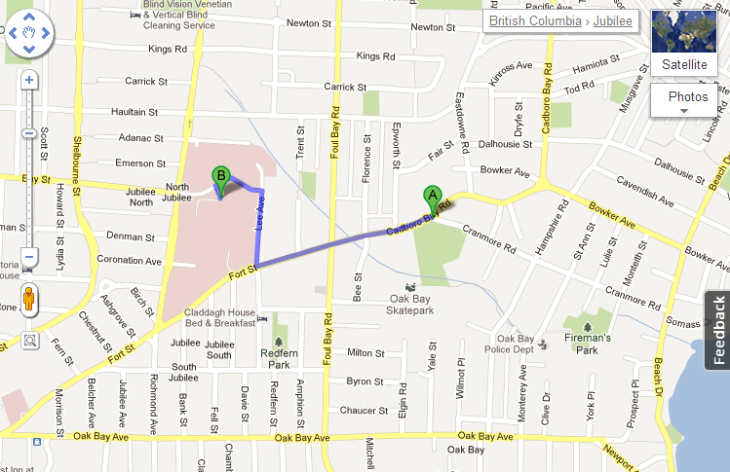

**Emergency phone**: Front office, or coach will always carry cell phone (practices & games)

* 1. Emergency phone: 911
  2. Information for dispatcher:
     1. Identify yourself
     2. Type of emergency
     3. Type of suspected injury
     4. Present condition of athlete
     5. Current assistance being given
     6. Exact location of emergency
     7. Estimated time of arrival

For emergencies during the game the following signals will be used

**Ambulance required** – arms extended out to side

**Life threatening injury** – wrists crossed over chest

**Assistance needed** – hand wave

**OBJECTIVES FOR THE SEASON**

At the beginning of the season, I sent an email to all players asking them to tell me a little bit about themselves. I wanted to know: What positions they liked to play? What were their strengths? What were their weaknesses? How much experience did they have? What were their goals for the season? What did they want to take from this season? I was surprised with the detail many of them replied with. For the most part, they were an experienced team, and wanted to play competitively. They identified their strengths and weaknesses, and from that we collaborated as a team to decide what the season would look like.

*Physical Objectives:*

Many players identified that they were track runners, and it became evident early that our team was built with a lot of speed. We decided to capitalize on this, and make speed and endurance a strong component of our game. This meant that along with the skills that we practiced, we would also be doing a fitness component every week. The players embraced this idea, and seemed excited to be “the fastest team in the league”. For some of the track runners on the team, the fitness component was just another day of practice. On the other hand, some players began to show excellent improvement in their speed and endurance. A mother of one of the players thanked me personally, and said that her son had begun bragging about how fast he was getting. By the end of the season, it was evident that the majority of our players could play in both halves, and still have more stamina than players on the opposing team.

*Technical Objectives:*

From what I had seen in tryouts and the first practice, most of the players had good knowledge of the game, and decent skills to go with it. There were two issues that I noticed though, and some of the players mentioned that these were things they would like to try and improve on throughout the season. The first was ball control. Not passing and maintaining possession, but controlling the ball on the run, and while shooting. Many of the players were very eager to move up the field with the ball, and often wouldn’t take the time to control it before sprinting up field. This often led to them kicking the ball out of control, and causing a turnover. Throughout the season we worked hard on taking a touch before attempting to move up field. As the players got better at this, so did their game. Another major issue was that most players were only confident, striking and passing with their dominant foot. After the first game (a 1-1 tie), it was painfully obvious how many opportunities were squandered because players were not confident enough to shoot with their non-dominant foot. This became a focal point in all of our drills for the remainder of the season. I would insist players use both feet interchangeably. Although this seemed to work well in practice, the improvement in the game was minimal. I guess it takes more than one season to break old habits.

*Tactical Objectives:*

There were two tactics I emphasized throughout the entire season: support, and pressure. A common mistake in young soccer players is to relax after they have passed the ball to a teammate. In my opinion, this is where the real task begins. During the season we worked on continuously supporting the player with the ball. If players always have an outlet to pass to, we should never lose possession (in theory). This played a major role in our offence, as I began teaching the players some set plays that involved midfielders jumping up in support of the strikers. By supporting the ball carrier in the offensive end, we cause teams to collapse defensively and opened the field up for cross-field passes.

I also stressed the importance of pressuring the ball carrier. When teams successfully maintain pressure on the ball, it forces the opponents to make mistakes, and can be incredibly beneficial. Since we focused on endurance our midfielders were able to play a strong two way game, and pressure just as well defensively as they did offensively. In the end, pressure caused a ton of turnovers that led to offensive pressure and goals. We even recorded a goal when one of our strikers pressured a goalkeeper and caused him to mishandle the ball into his own goal.

*Personal Objectives:*

After speaking to each player individually, I knew this was a team of players with good attitudes. The team voted anonymously, and still unanimously that playing time should be based on a mixture of effort and skill. It was obvious that this team was competitive, and that all players were ready to play their role to help the team succeed. The following is an excerpt from an email I received from a first year player:

“Hey Alex,

First of all thanks for stepping up and taking on coaching the team. Life

gets busy and we appreciate you taking the time out of your day for us.

For playing time I'd definitely support the better players playing more.

That being said, I'll always give 100% and hope to be rewarded for that,

but if I'm more helpful on the bench then the field, I'm all for it. I like to

win whatever the costs. As for my game I have solid athleticism and a

decent understanding of the game, but I lack the experience and ball

control the other, more seasoned players may have. So those are a

few things I'd love to work on.”

I received many similar emails from the other players on the team, and I was glad to know we were going to be a cohesive team, not a bunch of individual players. The team set their goal to be making it to the provincial championships this season. This meant placing either 1st or 2nd in the league. Every player worked extremely hard throughout the season, and were all rewarded with the recognition and playing time they deserved.

**COACHING PLANS FOR THE SEASON**

**Practice #1**

Oak Bay Jr. Boys Soccer

Tuesday September 18th

No. of Players: 16

Equipment: Balls, Nets, Cones, Pinnies

**Objectives**

*Physical*

* Promote speed and endurance with a fitness portion

*Technical*

* Ball Control

*Tactical*

* Work hard
* Develop Team Bond

*Personal*

* Have Fun
* Introduce new players to returning players

**Session Plan**

1. **Intro Activity**

Today I will begin the practice by introducing myself, as the players have never formally met me yet. I will take attendance today, and continue to do so until I am able to name every player on the field. We will have a short discussion about this years goals as a team, and how I will be conducting my practices. I will introduce them to my rules about whistles, mutual respect for each other, and work ethic. We will then move into a dynamic warm up (jog/ dynamic stretching), followed by a static stretch.

1. **Teaching Activities**

The main goal of today’s practice will be to begin to build team chemistry (tactical). Since this is the beginning of a brand new season, I’m aware that many players will not know each other, and will never have played together. We will not focus on any individual skills today (ie shooting), instead everything will be done in groups or partners.

Begin with simple control drills (technical). Find a partner, and pass back and forth 10 times. Then have one partner toss the ball and have the other trap it with their thigh (10x then switch tossers). Progress to chest and head.

Keep away drill. Players set up in a grid. Begin with 3vs1 passing around the grid. Work on moving into space, and supporting the ball carrier. Progress to 3vs2.

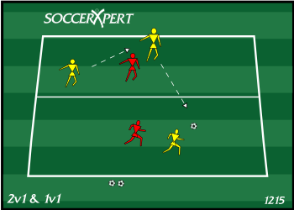

Chippy: 2 grids 10 meters away from each other. 2 players in each grid. Score 1 point by using a loft pass to land the ball in the opponents grid. Move grids farther apart if this is too easy. Eventually, add defenders who can pressure after first touch, but can’t enter the grid.

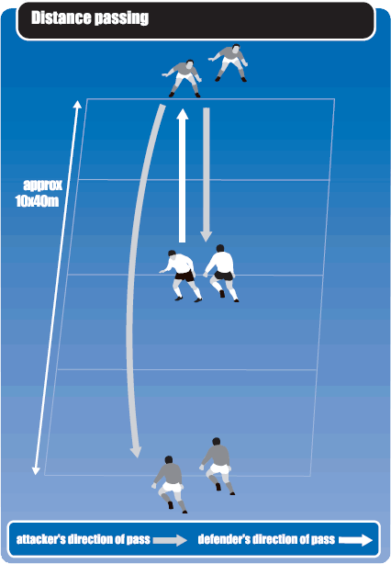

Fitness Component: A mixture of cardio and calisthenic exercises that will be performed every practice.

Scrimmage!

1. **Culminating Activity**

I ended today’s practice as I plan on ending every practice. After letting the boys scrimmage, I blew my whistle and had the team gather in a circle around me. This time will always get used for a cool down stretch, a recap of the goals of the days practice, and a note on where/ when the next practice and game will be. I did not address any players individually, although I did address them as a whole. I gave them consent sheets that both they and their parents needed to sign (mentioned earlier), and told them they would not get game time until the forms were returned. I also passed around a sign up sheet so players could add their preferred mode of contact. Some left emails, some left phone numbers, some left both. I alerted them that I would be contacting them soon with the season schedule.

**Evaluation**

Today was the first practice. Before beginning practice, I released the balls to the players and told them to partner up and pass around. This gave them an opportunity to get a feel for the ball, and me an opportunity to prepare myself and count how many players had come. After introductions and attendance, a grade 10 student, Adam Eardley, who was still wearing a cast after breaking his foot, volunteered to lead a dynamic warm-up before I even instructed them to. It soon became apparent to me that he would assume the captain role, as both older and younger players seemed to respect him. It was nice to see that we had a solid leader in our group, and his attendance even with a broken foot showed good commitment. Adam said he was getting the cast removed this week, and would likely only have to miss our first game. I instructed him that he needed to provide me with a doctors note clearing him for contact before he was able to participate. The practice was neither good nor bad. Although everything ran smoothly, I believe the players are more advanced then I had anticipated. The drills I used today were fairly simple, so next practice I will increase the difficulty. On the plus side, I think the team began to build some chemistry.

**Practice #2**

Oak Bay Jr. Boys Soccer

Thursday September 20th

No. of Players: 18

Equipment: Balls, Nets, Cones, Pinnies

**Objectives**

*Physical*

* Promote speed and endurance with a fitness portion

*Technical*

* Shooting
* Using both feet

*Tactical*

* Corner kick tactics
* Defensive positioning

*Personal*

* Have fun
* Determine positions for individual players
* Prepare for next week’s games

**Session Plan**

1. **Intro Activity**

Today’s practice will start with some simple partner passing, followed by a light jog, some dynamic and some static stretching. While stretching I will give the players an overview of some of the tactics we will try and implement in our season opening game. We will discuss the positioning that we will implement for the start of the season (2-4-4-1) and alert the players that today’s practice will be a strong determinant of where I believe they should play. I will also use this time to collect any of the waiver forms that were sent home on Tuesday.

1. **Teaching Activities**

Since next week is our first pair of games, I will use today’s practice to focus on some of the offensive and defensive strategies that will be crucial to our success.

Instep Shooting Drill: Divide the team into two lines and place two players at the top of the 18 yard box. Players in line pass to players at the top of the box, and in 2 touches the player must turn and perform an instep drive. Must shoot to the opposite side of the goal and use both feet. Passer then becomes the shooter, shooter collects the ball, line 2 goes.

Wide and In game: Create boundaries and divide into 2 even team. Have a few of the players from each team stand on the sidelines. Play a regular game but emphasize using the players on the sidelines as outlet passes. Players must support their teammates on the sideline after passing. This will transfer for quick outlet passes in a game situation.

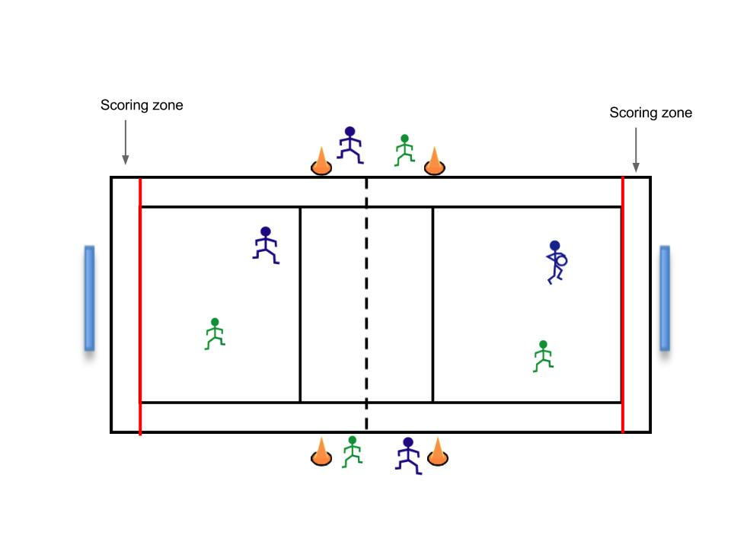

Corner Kicks: Today’s practice will focus mostly on both offensive and defensive strategies for corner kicks. Defensively focus on keeping your body between your opponents and the goal. This way they will have no angle to shoot if the ball comes to them. Emphasize clearing the ball in any direction, rather than attempting dangerous passes out of the box. Offensively we will have hand signals from the kicker that will alert teammates where they are attempting to send the ball (short, middle, far). Always have players charging into the box towards both posts and at least one near the top of the box. This way we maximize the areas where we can receive the ball. We will spend a large portion of the practice working on this.

Fitness Component: Training drills which I will pull from my lacrosse days. Great workout!

Scrimmage!

1. **Culminating Activity**

Today’s practice once again concluded with a scrimmage. A game situation is a fun way to end practice that all the players seem to enjoy. After a light cool down jog and stretch, I took the opportunity to discuss team roles in detail with all the players. Since Adam Eardley was still injured (out of his cast but still not able to play), I had to select a captain for next week’s games. After careful consideration I announced to the team that both Adam Eardley, and Hayden White would be co-captains throughout the season. I also took the opportunity to announce to all players the positions I would be trying them in for our first game. Unfortunately when I asked for all the players preferred positions, I found out that we had very few defensive players. This meant that some players who usually played midfield or forward would have to play defence for at least a game this season. Before leaving I reminded all players that they needed to bring me their medical forms before the game or else they would not be allowed to play.

**Evaluation**

Practice was considerably more successful today. The emphasis on corner kick tactical play seemed to really engage and interest the players. I think they really enjoyed being given “secret hand signals” that other teams would not be aware of. It was also a good opportunity for me to teach defensive tactics to all the players who normally play offence but will have to play back this season. Having Adam attend practice even though he was injured was very helpful. He was able to offer insight and personal experiences as he is a natural center back (the backbone of soccer defence). The shooting and wide and in games seemed to be a hit with the players as well. It is apparent to me that we have a mix of strong and weak shooter, but also that the majority of them are very weak with their non dominant foot. From now on we will focus strongly on working with both feet.

**Practice #3**

Oak Bay Jr. Boys Soccer

Thursday September 27th

No. of Players: 15

Equipment: Balls, Nets, Cones, Pinnies

**Objectives**

*Physical*

* Promote speed and endurance with a fitness portion

*Technical*

* Shooting
* Using both feet
* Winning loose balls

*Tactical*

* Recovering
* Ball support

*Personal*

* Have fun
* Prepare for next week’s games

**Session Plan**

1. **Intro Activity**

Today I want to go over quite a few skills that need to be developed on our team. This week’s games were a great opportunity to see the guys in action, and determine where we need to focus our attention. Because there are so many things I’d like to cover, I will combine today’s warm up with our fitness portion. Before beginning practice, the boys will run “The Loop”. The loop is a 4km run around the school grounds that P.E. teachers often get their students to do. To encourage the guys, and to make sure it is done at a good pace I will run it with them. When we return we will stretch, and then move directly into our drills.

1. **Teaching Activities**

Today will begin with a variety of shooting drills. This will be good to start with since they will be tired from the run and it takes very little physical effort. Make sure all players are coming from both sides so that they get an opportunity to shoot with both feet. If a player misses the goal they must do 5 push ups.

Instep Shooting Drill

One timer drill

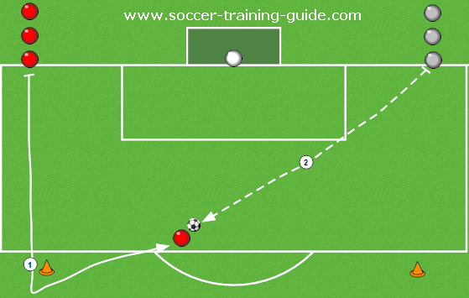

Shooting on the volley

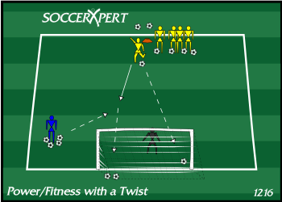

We will then move on to drill that involve winning lose balls, and recovering from losing a ball. These were both things that we needed to work on in our games versus SMUS, and St. Andrews.

Drill 1: Lose Ball Race

Players will separate into 2 lines along the goal line on either side of the goal. Cones will be set out by the top of the 18 yard box. On my whistle the two players at the front of each line will sprint out to the cones and turn back towards the goal. While the players are running the goalkeeper will roll a ball down the middle (as evenly as possible) and the players must compete to be first to the ball. I will emphasize shooting as quickly as possible, rather than trying to be fancy.

Drill 2: Ball recovery

Players will separate into 2 lines. The first 2 players in line will lie down on their stomachs facing away from the goal. I will stand behind them with all of the balls, and when I blow my whistle I will toss a ball in whichever direction I choose. The players will spring up and race to the ball, and attempt to get a shot on goal. Many times the toss will favour one player or the other. The aim of this drill is to emphasize winning balls back from opponents who have control. In this weeks games our 1 on 1 defence seemed a little lazy.

Scrimmage!

1. **Culminating Activity**

After the scrimmage, I called the boys in for a talk and a stretch. I addressed that although their play was nothing to be ashamed of, we did not get the results we wanted to start the season. If we were going to rely on our speed as a team, we needed to use it both offensively and defensively. This means fighting hard to win back balls that had been lost, and making sure we were always first to the loose balls. I also asked if anybody knew where Charlie Miller had been. He was yet to attend a game or a practice, and I was beginning to wonder if he was committed to the team or not.The players said that he had a previous lower back injury and did not want to re-injure it in practice. Other players mentioned that he had been playing for his other (non school) teams, and I began to get the sense that Charlie was not the most well liked player on the team. After we ended our talk, Adam approached me with a doctor’s note clearing him for contact. He had participated in this practice, and although he seemed cautious, I could tell he was a very skilled player.

**Evaluation**

I really liked how today’s practice went. I was not sure how the loose ball drills would go since they are not well known soccer drills. In fact, I designed them to model drills I had undergone while playing hockey and lacrosse. To my pleasant surprise the team really seemed to enjoy them. Not only did they get a chance to practice their 1 on 1 capability, loose ball skills, and speed, but I began to see a real sense of camaraderie building between many of the players. The competitive nature of the drills seemed to encourage them to play hard against each other. Hopefully this is something we can channel into next week’s games.

**Practice #4**

Oak Bay Jr. Boys Soccer

Thursday October 4th

No. of Players: 17

Equipment: Balls, Nets, Cones, Pinnies

*Physical*

* Promote speed and endurance with a fitness portion

*Technical*

* Dribbling
* Using both feet
* Winning loose balls

*Tactical*

* Controlling the ball
* Supporting the ball carrier

*Personal*

* Have fun
* Prepare for the upcoming playoffs
* 1 on 1 training with Evan
* Talk to Charlie

1. **Introductory Activities**

Before beginning today’s practice I will introduce Evan to my cousin Nick, who is an excellent goalkeeper in a Men’s league. Earlier this week we reviewed some of the activities he would do with Evan, and I believe this is a good opportunity for Evan to receive some one on one training that I cannot provide for him. After this we will proceed with warm up as usual, and discuss the goals of today’s practice.

1. **Teaching Activities (see *Appendix 3 for diagrams of drills).***

Dribbling Drills for ball control

Nascar: Mark out an area with cones, give every player a ball a put them inside that area. When I yell “first gear” players must dribble their soccer ball around slowly, avoiding other players. “Second gear” means they jog. “Third Gear” means ¾ speed. And “fourth gear” is an all out sprint. If two players or their balls collide they must each do 5 push ups outside the area.

Slalom: Divide players into 3 equal teams, and line them up. On the whistle, have them zig zag through the cones in front of them, tuen around and come back. Once the first player gets through all the cones he must pass the ball to the next player who carries on etc…Losing two teams must run extra sprints during today’s fitness component. Progressively make this more challenging by moving the cones closer together.

Loose Ball drills used in last weeks practice

Attempt to teach the team a set play used by the Vikes: This play involves initially skipping the midfielders when our defenders are in possession of the ball. Have the defender send a long pass over the heads of the midfielders to the strikers. As the ball is moving through the air, the midfielders nearest the ball should begin moving up field quickly. When the striker receives the ball they should immediately lay it back towards the midfield. If executed properly the midfielder receiving the ball should be at full speed and will now make a run for the goal. The strikers must now support the ball and attempt to get open for a cross or to recover a stolen ball.

Fitness component- Keep today’s fitness component short. The drills done today we fairly rigorous and the players have earned themselves a break.

Scrimmage!

1. **Culminating Activities**

During our after scrimmage cool down, I announced to the team that we had finished 2nd in our pool, behind only SMUS. This meant that in 2 weeks time we would be playing Reynolds in the quarter finals. I showed them all a break down of the season’s results, here’s how it looked.

|  |  |  |  |  |  |  |  |  |  |
| --- | --- | --- | --- | --- | --- | --- | --- | --- | --- |
| Teams | GP | W | L | T | GF | GA | Pts | Placing | GD |
| Pool A |  |  |  |  |  |  |  |  |  |
| Stelly’s | 3 | 0 | 3 | 0 | 3 | 14 | 0 | 4th | -11 |
| Claremont | 3 | 2 | 1 | 0 | 7 | 2 | 3 | 1st | +5 |
| Reynolds | 3 | 2 | 1 | 0 | 7 | 6 | 6 | 3rd | +1 |
| Spectrum | 3 | 2 | 1 | 0 | 9 | 4 | 6 | 2nd | +5 |
| Pool B |  |  |  |  |  |  |  |  |  |
| GNS | 4 | 2 | 2 | 0 | 5 | 9 | 6 | 3rd | -4 |
| SMUS | 4 | 4 | 0 | 0 | 18 | 1 | 12 | 1st | +17 |
| Oak Bay | 4 | 2 | 1 | 1 | 7 | 5 | 7 | 2nd | +2 |
| St. Andrew’s | 4 | 1 | 2 | 1 | 9 | 13 | 4 | 4th | +1 |
| Mt. Doug | 4 | 0 | 4 | 0 | 4 | 16 | 0 | 5th | -12 |

It looked like we would have an evenly matched game against Reynolds and the guys would have to play hard to advance. I told them to be prepared for next weeks exhibition match against Stellys, because even though it was exhibition we wanted to continue our win streak into the playoffs. I also had a chance to catch up with Evan who was grateful that he got some personal training time.

**Evaluation**

I was really glad that Evan got some extra training today. If it doesn’t improve his game I know it definitely improved his confidence. I was also happy that we tried out a set play that had been passed along to me earlier this week. It took the players some time to get it right, and although they still aren’t amazing at it, I will be interested to see if they can execute it in this weeks exhibition match. Dribbling drills were not a hit with the team, but because of last game I believed they were necessary. I also needed to find some drills that didn’t involve shooting so that Evan could work with Nick.

On a gloomy note, Charlie came to practice today to announce that he was quitting the team. Although he would have been an asset to the team in the playoffs, his attitude was not sitting well with me or the rest of the team. I wished him luck, and told him that his spot would remain available should he choose to practice with the team.

Adam also mentioned that he would not be attending next practice, or our first playoff game. His family was taking him to Hawaii for a holiday. This meant that we would be without our strongest defensive player, arguably our best all round player, for the first round of playoffs.

**Practice #5**

Oak Bay Jr. Boys Soccer

Thursday October 11th

No. of Players: 14

Equipment: Balls, Nets, Cones, Pinnies

*Physical*

* Promote speed and endurance with a fitness portion

*Technical*

* Shooting
* Using both feet
* Passing into Space

*Tactical*

* Controlling the ball
* Supporting the ball carrier
* Moving to where the ball will be

*Personal*

* Have fun
* Prepare for the upcoming playoffs

1. **Introductory Activities**

Once again I will begin today’s practice by combining our fitness unit with our warm up. Rather than running the loop, I will lead the team in a jog down to Willows beach. While stretching we will discuss our goals for the playoffs. SMUS finished with a +17 goal differential, the best in the league by far, but I want our troops to be confident that we could go all the way. Last week’s exhibition game was cancelled due to rain so we did not have an opportunity to attempt our play. For fear that it will not work, I have adapted a more simple version that should prove just as effective.

1. **Teaching Activities**

We will begin with all of our standard shooting drills:

Instep Drive

One timer

Volley Shot

We will then work on passing into space with a 4 corners game: Create 4 grids on the field. Divide the players into 2 teams. Have them play soccer, but rather than shooting on goal, the aim of the game is to pass to a player in one of the grids. Cannot pass into the same grid twice in a row. Eventually, adapt the game so that players cannot stand in the gird to receive the pass, they must be running into it. This will help players develop their through pass, and hopefully get us a few breakaways.

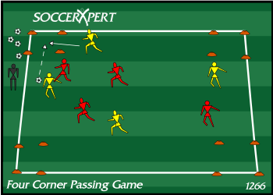

Adapted support drill: In the previous attempt, we had our defenders sending the ball over the midfields head. Unfortunately we only had a few players with strong enough kicks to do this, and one will not be with us for our first playoff game. Instead we are going to attempt to bring it up field like we usually would, but have the midfielder who relays the ball to the striker join the attack. This way the ball carrier has more options, and we are more of an offensive threat.

Scrimmage!

1. **Culminating Activities**

During our cool down and stretch I announced to the players that I would not be attending the next practice due to prior obligations. Instead, the practice would be run by last years head coach who had been monitoring the team’s progress this season. Practice was still mandatory as they needed to get prepared for the playoffs.

**Evaluation**

Today’s practice was altogether successful. The players have really begun to bond as a team, and have built good chemistry in these last few weeks. Our shooting is improving and players are finally starting to use both feet in practice scenarios. Let’s just hope that transfers into the game. The passing game was good, but I should have been clearer with some of the rules. Players began to get frustrated with each other because not everybody understood the game. Right now all the players seem to be in a good frame of mind and are excited for a big playoff run.

**Practice #6**

Oak Bay Jr. Boys

Thursday October 18th

No. of Players: ?

Equipment: Balls, Nets, Cones, Pinnies

**I was not able to attend practice, it was run by last seasons head coach.**

**INFORMATION ON GAMES**

**Game #1: Oak Bay @ St. Andrews**

Result: 1-1 Tie

Our first game was neither a disappointment nor a success. We were fortunate to not be playing an overly strong team because it was obvious we were lacking team chemistry. We showed promise offensively, though we missed the net with the majority of our shots. Shooting will be a focus in our next practice. I was especially impressed with our defensive play. Since we do not have enough natural backs, some offensive players were asked to play defence. They stepped up and challenged their opposition very well. The goal scored against us was an impressive offence assault that cannot be pinned on poor defence. Hayden was our goal scorer today. It was a nice hard drive from the top of the 18 yard box that supported my choice to make him a captain. One area of our game that needs improvement is our transitional game. Too many balls were lost in the midfield, or sent up field into empty space. I attribute this to inexperienced defenders, and lack of midfield support. Next practice I will emphasize supporting the ball on both offence and defence. I think today’s game was a good lesson for the players too. Although I always encourage confidence, many of the players seemed overly cocky about being able to win. Hopefully tying a team we believed we had the upper hand on will be a good wake up call for the team. Our next game is Wednesday against SMUS, who are the obvious favourites to win this season’s league championships. The boys know that they will have to play much harder than they did today if they have any chance at success.

**Things that went well**: Shutdown defence

**Things to work on**: Shooting, Ball support, Composure (cockiness)

**Game #2 SMU @ Oak Bay**

Result: 0-2 Loss

Although we lost today’s game, I was proud to see a significant improvement in every player’s game. Rather than exerting the cockiness I had seen from them in the previous game, there was a sense of determination in all of them. Offensively we played well, despite scoring any legitimate goals. We did score once but the referee deemed the play offside. I told my players I thought the goal should have counted, and we should be proud to score on a team of this calibre. More importantly, we played a solid defensive game. SMUS was clearly a very experienced and well coached team who expected to be successful. Our players did a great job shutting some of their more offensively gifted players down for most of the game. I was especially impressed with Taylor Chan today. Despite this being his first year playing soccer, he was our illegitimate goal scorer, and a defensive machine. SMUS had a center midfielder who was a step above any player in the league, and was making great plays on the field. I instructed Taylor to mark him, and never to leave his side, even if it put him out of position. Taylor did exactly what I asked, and before long the opposing coach subbed the player out when he noticed we were targeting him defensively. I was also proud of Evan Carr, our goalkeeper. He made the saves when we needed him to, and cannot be blamed for the goals scored against him. A down side to today’s game was despite being an athletic team, the players never followed up on lost balls, or chased down loose ones. If they were stripped of the ball they looked dejected, rather than fighting for it back. Next practice I will emphasize the importance of never giving up. All in all, I was happy with the team’s performance despite the loss. The spectators were also very impressed. One of the mothers from SMUS approached me after the game and told me that it had been a long time since a team was able to challenge them the way that we had today. Some of our players heard this as well, and I think it helped boost morale all around. We are now 0-1-1.

**Things that went well**: Shutdown Defence, Taylor and Evan

**Things to work on**: Loose balls, recovering

**Game #3 Oak Bay @ Mt. Doug**

Result: 3-2 Win

Today’s game was an excellent showing from every player. It looks like loose ball drills we had been practicing are beginning to pay off, because the team played a very hard 2-way game. In fact, the score did not indicate the tale of the game, as it was mainly dominated by us.

Charlie Miller arrived for his first game, and seemed put off that he was not started. When he did play it became evident that he was a very talented player, but that he was not a team player. After awhile, I subbed him out for a player who was less talented, but had arrived to every game and practice, and given great effort. Once again Charlie was upset and claimed it was stupid to sub him. There were many parents and players who were listening when he confronted me, and I made it very clear to him that he would get the playing time he felt he deserved when he equalled the amount of effort the other players had given. I explained to him that practice was not optional, and that if he wanted playing time he would have to work for it like everybody else.

The weakest point of our game today was our goalkeeping. I am generally the last person to ever blame things on a keeper, but today was not Evan’s best performance. I realized that although I have focused on offensive and defensive strategies, I have not given any attention to goalkeeping. This is mostly because I could not stop a ball to save my life, and do not feel like Evan could benefit from me. Before next week’s practice I will do my best to find somebody who can come to practice and work individually with Evan to improve his skills.

The highlight of today’s performance was our offence. Previously we had struggled with our transitional game, and were not maintaining a lot of pressure. That was not the case today. We used our speed to send balls through defenders to our streaking strikers who had countless opportunities. Although they managed quite a few shots, many of them were taken at awkward angles. Instead of using their non dominant foot to strike a cross goal shot, they had the tendency to stop and switch feet. This made it easy for the goalkeeper to predict where the ball was going. We will continue to work with both feet in practice.

**Things that went well**: Offence, loose ball recovery, effort

**Things to work on**: Goal Keeping, switching feet, Charlie

**Game #4 Oak Bay @ GNS**

Result 3-0 Win

Today we played like the team I had hoped we could be. We carried the momentum we had from Monday into today and proved we have the potential to beat any team. Our offence was clicking, and we had many opportunities. On the other end, our defence did a great job of making sure very few balls were put on goal, and Evan made sure the ones that were stayed out. The strongest point of our game today was our communication. All players were very vocal, and it led to some fantastic passing plays. Although we continued to miss the net with a large percentage of shots, I was pleased with the team for getting themselves into positions to take so many shots.

The only thing that did not look incredible was our ball handling skills. Often players were pushing the ball to far ahead of themselves and losing control. Although this lost us the ball many times, our players were relentless and winning the ball back again. I was also very pleased with our corner kicks. Although we hadn’t practiced these for a bit, the players continued to work on them in scrimmages and it was paying off.

Charlie was a no show for the game today. I don’t know why he wasn’t there, but I hope he attends practice next week. He would be a very valuable asset going into playoffs.

**Things that went well:** Passing, defence, taking shots, pressure

**Things to work on:** Ball control

**Game #5 Exhibition Match, Stellys @ Oak Bay**

Result: Cancelled due to weather

**Playoff Game #1 Reynolds @ Oak Bay**

Result 1-2 Loss

Our first and only playoff game of this season was nothing short of disappointing. Since before the match even began things were not looking good. At 3:45pm when the opening kickoff was supposed to happen, we still had not seen our referee. Thankfully, I had the contact information for the leagues referee coordinator Keith Thompson. After speaking with him we determined that there was a referee scheduled to be there, but he was not answering his phone. Keith alerted me that if the scheduled match does not get played, the visiting team is awarded the victory. I took this opportunity to speak with the head coach from Reynolds, and alert him of the situation. He was very accommodating, though unfortunately he did not want to reschedule the match. We compromised by agreeing to let one of the parents referee the game. Needless to say, the game didn’t run as smoothly as we had anticipated. The parent ref was not biased or unfair to either team in particular, although the quality of the game decreased significantly. Our team played well, but nothing like the calibre of play I had seen in previous weeks. The game was tied 1-1 until the final minute when a wet ball slipped through Evan’s hands while he was attempting to pick it up. Unfortunately that was the game winning goal. Evan was devastated as he felt it was his fault, although the entire team reassured him that nobody had put forward their best effort today. I gathered the team up and thanked them for all the effort they had put into this season. Although we didn’t achieve our goals, we never stopped trying and I was proud of us as a team. I announced that I would be hosting a wrap up party, and would be in contact shortly. In the following weeks the playoffs ended with SMUS coming out on top, and Reynolds placing 2nd.

**EVALUATION OF THE SEASON’S PROGRESS**

On the hole, I believe we put together a fairly successful season. Personally, I was happy to have coached a team successfully into the playoffs on my first ever attempt. As a team I believe we accomplished many of our objectives, but unfortunately not all of them. Physically I believe there was no other team that had the stamina and speed that our squad did. When I began the season I wasn’t sure how well a fitness component would fit into the season, being that it was not overly long. As it turned out, the players enjoyed the fitness because it gave them a sense of accomplishment. They believed they were the fastest and most fit team in the entire league, and I wouldn’t doubt if they were right. Unfortunately not all of our technical goals were met. I would have liked to see more improvement in some of the areas I felt they were lacking, like using both feet! It was a point that I stressed all season long, but it was really difficult to break their bad habits. I was especially impressed with the way the teams tactical play evolved. When the season began, they were reluctant to chase after loose balls, or battle for possession. Near the end of the season, teams were getting visibly frustrated at their inability to win a ball against our team. Lastly, and unfortunately most importantly to the players, we did not meet our personal goals. We had our sights set on going to the provincial championships, and sadly we fell short. I believe the key to our success was our work ethic and team bond. No players ever complained about the workouts we did in practice, they just did it. The players also built relationships among each other, and began communicating incredibly well on the field. I think our major downfall was our inability to execute (technical) when we needed too. The amount of missed shots or shots that were not taken because they would be left footed were astronomical. There was also some attitude problems when it came to Charlie, although that didn’t seem to affect the team to much. If I were to coach again, I would use the knowledge I have gained this season to hopefully become more successful. I would build off our tactical success, and continue to use some unorthodox hockey and lacrosse drills that the players seemed to love. I would also put more emphasis on some of the technical skills that were continuously a downfall for us. I was not aware at the time how costly it could be to miss so many opportunities. All in all, I am happy with the season. I was happy with the great group of players I was fortunate to work with, and I wish them all the best of luck in the future!

Appendix