Roll and run
2 spots, 4 yellow corners to make square and 1 ball of choice.
2 fielders v 1 batter/roller
A fence or a wall.
Equipment
Monitor

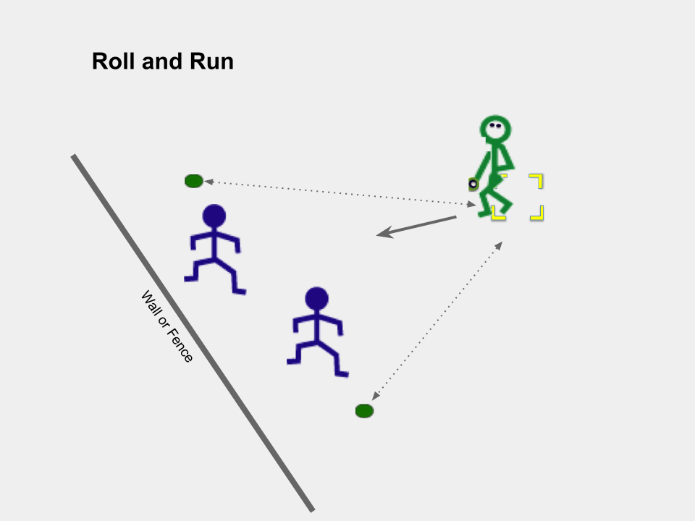
Aim of game: Send the ball away from fielders, between spots, in order to score runs

- With ball staying on the ground and one foot in the square, roll the ball between two spots
- Then try to run to spot and back to square before fielders get ball back to square
- Run as many times as you can to spot and back to square before ball sent back
Official
- Get roller out by returning ball to hoop before runner gets back to the hoop.

- Change ball as needed.
- Rotate after 5 goes if not out.

Extensions to the game
- Strike ball with hand
- Strike ball rolled to you
Coach
- Increase space from fence.

How could a modification by adaptation rule be added to your game? (Outcome of a game encounter changes the game for winner to make the game more challenging)

Combine with other group and decide how to develop your game with teams.
Will your game play area be an Oval or a Fan shaped batting field game?
Strategies: Principles of Play
Batting | Fielding
Send the ball to elude fielders  Run to safe areas to score  Avoid getting out | Cover space where ball can be sent  Return ball to target before runner  Get batter out

Content Analysis of Game

What are the key strategies (ways of playing and movement off-the ball) to use to be successful at these games?

_________________________________________________________________

What body management (movement skills) do you need to play your game?

_________________________________________________________________

What are the manipulative skills you need to play these games?
Skill Phase | Receiving = | Sending =
Preparation
Wind-up
Force-Generation
Recovery

What would be two tasks you could do to practice that would help your peers play your game?

Consider (1) Skill cues (2) Tactical prompts

Task | Word Suitable Tasks
1
2

