**Introduction:**  
 Serving in tennis is one of the most important aspects of the game. Those who can master the serve will gain a significant advantage over their opponents. Serving is always used to start and restart play at the beginning of each game and after each point. Other racquet sports like badminton require players to switch servers between points, but tennis is unique because it requires that only one player serves for the duration of a whole game. After each game control of the serve is given to the team who did not just serve. It is important to note that when playing doubles, both players on a team must serve full games in rotation, there cannot be a designated server. There is no time constraint when performing a serve, so establishing a routine is key to executing the skill properly. There are no external pressures, so it is strictly up to the server to perform well and gain control. Serving allows the player to make the first decision on the way the rally will begin and can be an effective way to force their opponent into hitting weak shots. An effective server should always use a variety of serves to keep their opponent guessing and force them to use defensive returns. There are a variety of factors that influence the serve, such as power and force applied, as well as spin that can be added to the ball. There are 3 types of serves players are able to perform The flat serve which has the highest velocity, and can easily catch an opponent off guard or force a weak return. The top spin serve which causes the ball to dive on the opponents side and then bounce up. And the slice serve which is used to spin the ball away from the opponent often fooling them. Examining the biomechanics of a serve can be very beneficial to us because it allows us to break the skill into key phases and in the case of this analysis we are able to compare and contrast our amateur performance to that of a professional tennis player. The camera angle used is a sagittal/arbitrary viewing plane. The four phases I examined and compared of the serve were the preparatory phase, windup phase, force generation phase and finally the recovery/ follow up phase.

**Preparatory Phase (1):** The preparatory phase is the first and initial stage of the serve. At this time the player should begin a routine that they intend to perform before every serve. For example, many players like to bounce the ball several times before beginning. The server then needs to make a decision of what type of serve to use based on their opponent’s ability and positioning. It is important to vary service types fairly often in an attempt to catch your opponent off guard. A player’s strategy may be different between the first and second serve though. To avoid a double fault players tend to be less daring on their second serve. I compared my preparatory serve (fig. 1, 2) to that of Peter Sampras (fig. 3, 4). In the preparatory phase we look slightly different while starting off. Sampras’ front lead foot is in dorsi-flexion and his body weight is loaded to his rear leg. Initially I have my weight shifted forwards onto my lead foot. In the second frame I begin shifting my weight backwards although if I had begun like Sampras I would not need this extra movement. It is important to have weight on the back leg because it will allow for a great force exerted forward with a greater transition from rear to front leg in later phases. A nice similarity between our movements is the position of our racquets. We both begin with our racquets in front of our bodies and then drop them below our knees before the wind up phase. Sampras maintains a relaxed body position which is key to an accurate serve. My back is bent indicating that I am slightly more tense and I should loosen up a bit. .

**Fig. 1 Fig. 2**

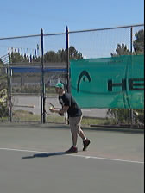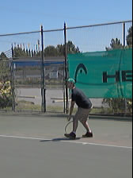

**Fig. 3 Fig. 4**

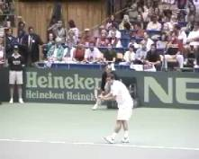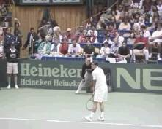

**Wind-up Phase (2):**  The wind up phase is important because it prepares the body for the force generation phase where all the power comes from therefore if you do not wind up properly it will throw off the dynamics of the later stages of the serve and compromise accuracy and power. The wind up phase is very similar to a spring, the body should load in flexion and then during this phase it explodes to full extension generating force that will go into the force generation phase. The purpose of flexion to full extension is to build up and release potential energy for the next phase. During this phase the performer does several things. The ball is tossed out of the non racquet hand in a line straight up into the air. This should be in front of the performer so that when they make contact they force their body to carry through and increase velocity. In this phase the performer also transfers their weight from their front lead foot to their rear leg and loads it. In the force generation phase when they contact the ball this will transfer forward again and create further velocity on contact. There are many similarities in both mine and Sampras’ wind up phase, and only a few small details I could change. We both have our bodies rotated nicely, but while Pete’s feet are almost parallel to the base line, my toe is pointed slightly inwards. Turning your feet can tip off a skilled opponent as to where you plan to serve the ball, I should try and stay rotated like Sampras. In figure 6 and figure 8 we see many similarities in our performance. Sampras has begun to shift his momentum from his back leg forwards to create momentum for his serve. I have also done this, although it seems like I may have shifted the full extent of my weight already. I need to spend more time loading my weight onto my back foot before shifting. My toss is also too far in front of my body, while Pete’s is almost directly vertical. I do a good job of using my free hand to track the ball through its flight though, preparing my racquet for the power phase. I also do a decent job with my racquet arm, drawing it backwards and keeping it up, although bending my elbow slightly more would add to the mechanical lever action that is key for this stage.

**Fig. 5 Fig. 6**

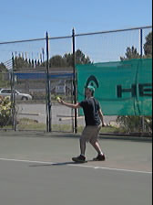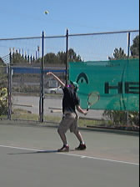

**Fig. 7 Fig. 8**

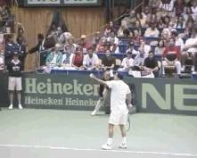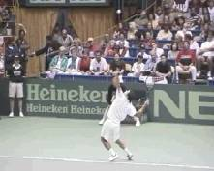

**Force Generation Phase (3):** While the preparatory and wind up phase were used to build up all kinds of potential energy, the force generation stage is the time to convert all that potential energy into kinetic energy. The majority of this energy comes from pushing, exploding and thrusting upward and forward by shifting your weight. As the performer explodes they also bring their rotation back to square to the net. When you push against the ground the ground pushes back and this is known as ground reaction force (Carr, 1997). This is also known as Newton`s third law which states that every action has an equal and opposite reaction. The force exerts against the ground and creates an equal force propelling the performer forward which increases velocity. Along with this is Angular momentum which can be described as swinging around an axis (Carr 1997 pg 25). Your internal shoulder rotation during a serve has an angular velocity of 1000-25000 degrees per second, elbow extension of 1700 degrees per second and wrist flexion of 315 degrees per second (Roetert 2001). When comparing fig. 11 of Sampras to my fig. 9 of the force generation phase my shoulders are beginning to become square to the net, whereas Sampras still remains in a closed position, which means I begin my rotation to early. He has also fully extended both his knees and is using both legs to generate force. I am only using one, meaning I’m lacking a large amount of possible force. Our racquet positioning is similar though, we are both in the “scratch the back” position meaning we are generating force with our arm and positioning ourselves for a nice high contact. Fig. 10 and 12 show that I have made contact at exactly the right point. I cannot spot any large differences between myself and Sampras. We have both contacted the ball at maximum extension, have open body position, and are carrying our momentum forwards.

**Fig. 9 Fig. 10**

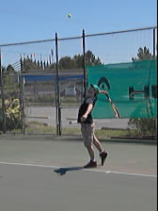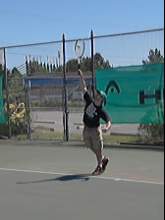

**Fig. 11 Fig. 12**

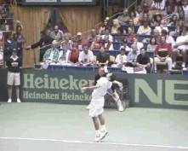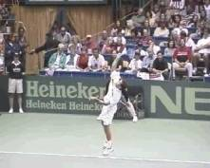

**Recovery Phase (4):** The recovery phase is the point that you have hit the serve and now need to prepare for what your opponents reaction is going to be and prepare for playing the ball if they return the serve. The typical movement is bringing the racquet across the body finishing the full momentum of the swing and then bringing the feet to a stable base that you are agile enough to move either left or right. In my recovery phase I bring my racquet across my entire body, meaning I swung to my full potential, accelerating as long as possible just like Sampras. In the final images Sampras and I both recover onto two feet, meaning we are perfectly balanced and ready for the return in either direction. The difference is that I have raised my racquet back into the ready position, meaning my return swing will take less time. Maybe Sampras can take a tip or two from me as well....

**Fig. 13 Fig. 14**

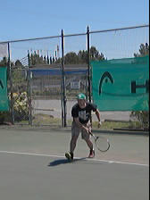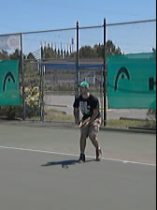

**Fig. 15 Fig. 16**

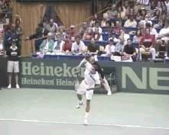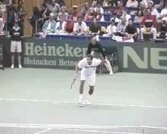

**Conclusion:**

There is a lot to be learned from analysing ones own swing and comparing it against a tennis legends. All in all I believe my technique is effective but it has details that if corrected could bring my serve from being good to being great. My racquet position and timing seem to be fairly consistent with that of Pete Sampras, but I’ve learned a great deal about my body position. Breaking down the serve clip by clip has shown me that I am losing a trenmendous amount of momentum and energy from my body. In the future these will be areas of focus when I continue to practice my serve.

**References**

Carr, Gerry. (1997). Mechanics of Sport: A Practitioner’s Guide. *Windsor: Human Kinetics*.

P, Roetert. ( 2001). World class tennis technique. *Human kinetics*. Chapter 4.