Throwing Events Safety Quiz

Name: ____________________________ Block: _______________

1. Jimmy and his class are learning how to throw the javelin in PE today. The class listen to the teacher give them rules to follow when throwing and retrieving the javelin.

Identify 3 rules that Jimmy’s teacher would set for her class:

**a.**_________________________________________________________________

**b.**_________________________________________________________________

**c.**_________________________________________________________________

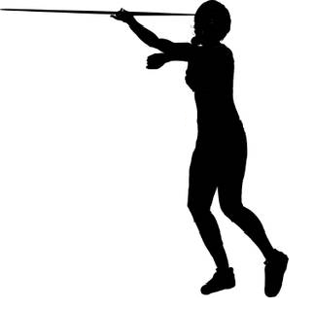2. Jimmy carries one of the javelins to the field. The person next to him is carrying the javelin like the person pictured.

What is she doing wrong? How should she be carrying the javelin?

__________________________________________

__________________________________________

__________________________________________

__________________________________________

__________________________________________

__________________________________________

3. The shot put throwing area is marked by pylons. Jimmy’s friend George is next up to throw but he is worried he won’t have enough time. He wants to stand out by the pylons so he can measure and retrieve the shot faster. Jimmy tells him it is a bad idea and against the rules.

**Where does Jimmy insist George stand to watch?** ______________________________________________________________________________

**How could George ensure that he gets a chance to throw the shot?**

**______________________________________________________________________________**

4. The school has 2 different sized discus. Jimmy throws a discus that weighs 1.5kg. Jimmy’s twin sister, Jane, throws a discus that is smaller and only weighs 1kg. Jane wants to know why she can’t throw the bigger discus like her brother.

**Explain to Jane why she must throw the smaller, lighter discus?**

____________________________________________________________________________________________________________________________________________________________________________________________________________________________________________________________________________________________________________________________________________________________________________________________________________