***Principles of Play***

*Score – stop score*

*Keep possession – get possession*

*Invade territory – prevent invasion*

4 Phase Ultimate Frisbee Lesson Plan

The purpose of this resource is to allow physical education teachers with little to no Ultimate Frisbee background to teach Ultimate in a way where students learn the tactics of the sport through games. There are 4 phases with breakdowns for each phase. In each phase there is a game which focuses on a specific tactic and then activities embedded to teach the skills throughout the lesson. The phases focus on cooperative games, then practicing the key skills for that game, then eventually moving towards a competitive game. Each game will have a video demonstration of what the game will look like if the students are reaching success as well as a tactical question for each game. Then the students will be able to move onto the next phase of the lessons if they are able to play the game and understand the tactic.

Phase 1:

Tag Game [video 1.1]

Partner Throwing

Box Game Cooperative Phases [video 1.2]

Phase 2:

Box Game Phases [video 2.1]

Target Game [video 2.2]

Pendulum Throwing

Box/Target Game

Phase 3:

3 v 3 Mini Game

Outlet Game [video 3.1]

Mini Game

Pepsi [video 3.2]

5 v 5 Mini Game

Phase 4:

Tournament

Phase 1:

Before beginning the unit it will be important to talk to the students about the heart and soul of Ultimate which is “spirit of the game.” Being spirited and respectful is the most important part of Ultimate and can serve as a great lesson for the social domain. Phase 1 of this unit is focused on getting comfortable moving to spaces and throwing an object in front of a player. It is a basic overview of all the tactics in Ultimate (defense, making a move to deke defender, moving into open space, throwing into a space) as well as basic rules.

1. Tag Game [video 1.1]
2. Partner Throwing
3. Box Game Cooperative Phases [video 1.2]
4. Tag Game/ 2 zone box game

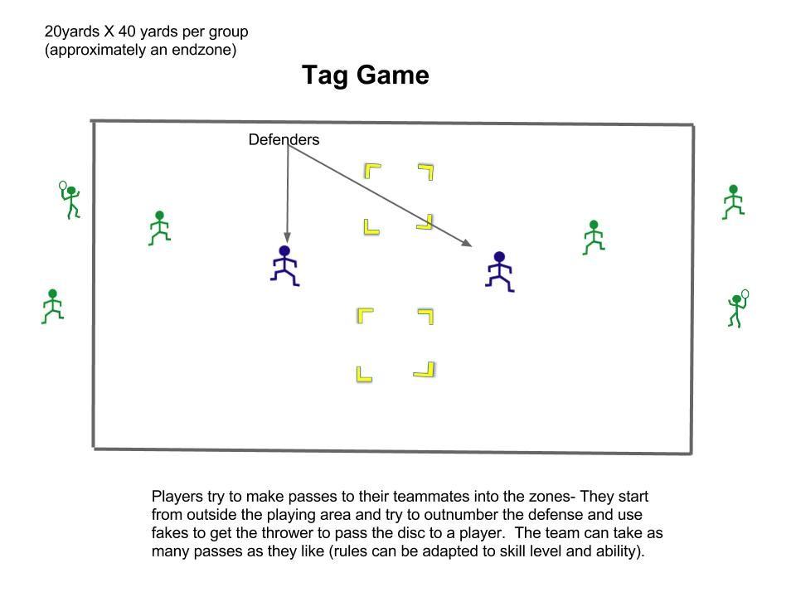

**Aim**: Score by having your teammate pass the object to another teammate into one of two zones.

1. Score by passing the object to player within the zones
2. Cannot run with the object
3. After there is a goal switch the defender out

**Ways of conditioning rules:**

* Can make the zones further apart, closer, smaller, or bigger
* Must score with a particular throw
* Can start with walking then move to full speed
* Have everyone touch the object

**Equipment**

|  |  |
| --- | --- |
| Tag Game | Cones to mark where to cut to and to mark bigger playing area (20)  Bean bags X # of groups. Frisbees X # of groups |

**Analysis**

What are the key strategies (ways of playing) to use to be successful at this game? What are the tactical awareness movements you need in this game to increase your chances of being skilful?

This game focuses on being able to recognize what the defense is giving you and what they are trying to take away. Since the offence is outnumbering the defence, the goal is to work together to get the defense moving to be able to attack the zone.

1. Partner Throwing

Now that the demand for throwing has been acknowledged by the students and they have been running around, it is time to get them into partners to work on the basic throws.

**Aim**: Complete both forehand and backhand throws at various distances to a partner.

**Ways of conditioning rules:**

* After the partnership completes 4 passes in a row, they can take one step backwards- if they do not complete one, they go back to the beginning

**Equipment**

|  |  |
| --- | --- |
| Throwing | 15 Frisbees (1 per partnership of 2) |

Throwing Cues-

Forehand:

* Face target
* Have disc be almost parallel to the leg before the throw
* Snap the wrist
* Avoid too much arm swing

Backhand:

* Face target
* Step out to the side
* Have arm lead the action
* End with a snap at the very end of the arm action
* Point to target on follow through

VIDEOS FROM RISE UP ON HOW TO THROW

1. Box Game- Cooperative

This is the culminating game for phase one. It focuses less on person-on-person game play than on finding spaces to move into.

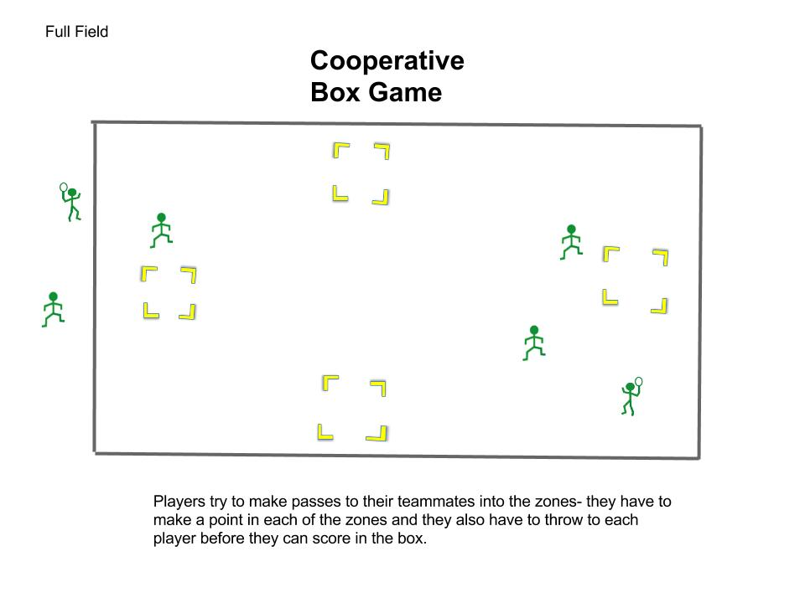

Part 1 of this game could be without defense. Have the class split up into groups of three and just have them try to make passes to each other and try to the passes in each of the zones.

**Aim**: Have the teams move around the field by passing the object to a player in the zones around the space.

Rules

1. Score by passing the object to player boxes
2. Every player must touch the object before each goal
3. If there is a turnover, the players must start at the place where they made their last goal and start the new box over again.
4. Keep track of how many successful passes you make around the space

**Ways of conditioning rules:**

* Can only score if the runner is at or close to top speed
* Make more spaces/less/bigger/smaller
* Must score with a particular throw

**Equipment**

|  |  |
| --- | --- |
| Target | Cones to mark the four boxes (16)  10 red playground ball or beanbags. 10 frisbees. |

**Analysis**

What are the key strategies (ways of playing) to use to be successful at this game? What are the tactical awareness movements you need in this game to increase your chances of being skilful?

This game focuses on throwing to two other teammates in a space into 4 zones. This concept can be challenging at first because there is a lot of space but also many other people in that space. This will force them to have to think before they throw and be aware of the people around them.

Phase 2:

Phase 2 of this unit starts to add more competitive aspects to the games through defense as well as throwing to a moving target into space.

1. Box Game Competitive [video 2.1]
2. Target Game [video 2.2]
3. Pendulum [video 2.3]
4. Box Game

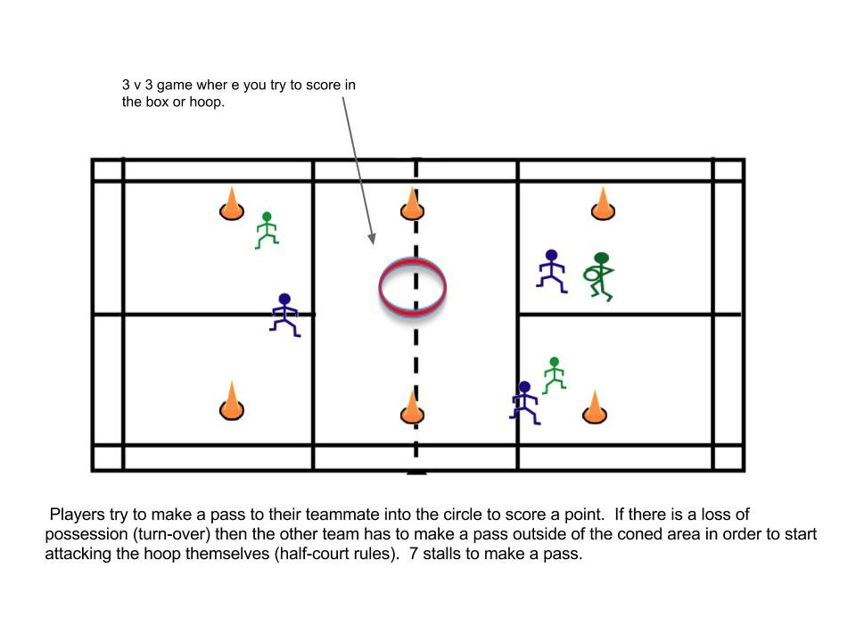

This game should start off being 3 v 1 so that the defence has to work hard and try to choose to take away the biggest threat. The offense should work to move the disc away from the defender to throw to the open players and then attack the box. Then slowly add in extra defenders (will have to make two groups join together).

**Aim**: 3v3 game where you score by invading opponents’ area to by passing the object from one teammate to another

Rules

1. Score by passing the object from one player to another in the circle or box
2. Cannot move with the object
3. If there is a loss of possession, the new team on offense must make a pass outside of the coned area before they are able to attempt to score.
4. Loss of possession can be caused by: dropping the disc, having the disc be defended (caught or hitting the ground), catching out of bounds, taking more than 7 stalls to throw.
5. Game starts by a flip of the coin or Frisbee to see who starts on offence.
6. No puppy guarding – must play person defense.
7. 7 stalls until you have to make a pass

**Ways of conditioning rules:**

* Have to have every player touch the object before a score
* Make the scoring area big at first and with each score, the scoring area for the scoring team becomes smaller
* Must score with a particular throw

**Equipment**

|  |  |
| --- | --- |
| Box | 3 X 2 pinnies. (X however many groups)  Cones to mark playing field and box (16)  1 playground ball. 1 frisbee. (x however many groups) |

**Analysis**

What are the key strategies (ways of playing) to use to be successful at this game? What are the tactical awareness movements you need in this game to increase your chances of being skilful?

This game focuses on moving the disc quickly to attack the box. Throw selection is important as is being able to lose your defender. Moving with sharp angles and into open space will help offense be able to attack the zone. On defense, being able to stay close to your player and put pressure on their throw.

1. Target Game

Area of play – Approx. 1/3 of the field per group (20 yards X 25 yards)

Ideally 7 or less players.

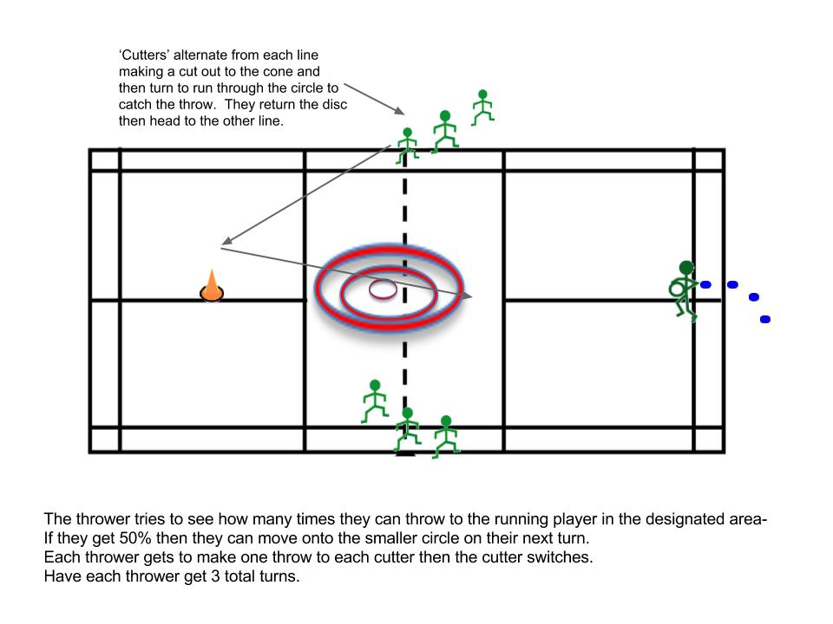

**Aim**: Keep score by completing passes into the circular zone to a moving player

Rules

1. Score by passing the object to player within the circles
2. Cutting player must be moving while they catch
3. Throw one pass to each cutter then the thrower switches
4. Keep track of how many successful passes you make
5. Can move onto the smaller circle if they complete 50% (can be adapted for different abilities)

**Ways of conditioning rules:**

* Can only score if the runner is at or close to top speed
* Have to make a different % (75% or 25%)
* Must score with a particular throw

**Equipment**

|  |  |
| --- | --- |
| Target | Cones to mark where to cut to and to mark bigger circles (20)  1-3 red playground ball. 1-3 frisbees (per group)  1 hula hoop |

**Analysis**

What are the key strategies (ways of playing) to use to be successful at this game? What are the tactical awareness movements you need in this game to increase your chances of being skilful?

This game focuses on throwing the object to a moving player. This concept can be challenging at first so creating a wide target at first will allow for successes early on. Making a leading throw is important as is accuracy to move up in the levels. This game also works on the cut that the player makes being a sharp angle out to the cone and a sharp turn back towards the thrower. It also works on catching while moving.

Now that there is a demand for the skill, split the students up into partners to isolate that key skill.

C. Pendulum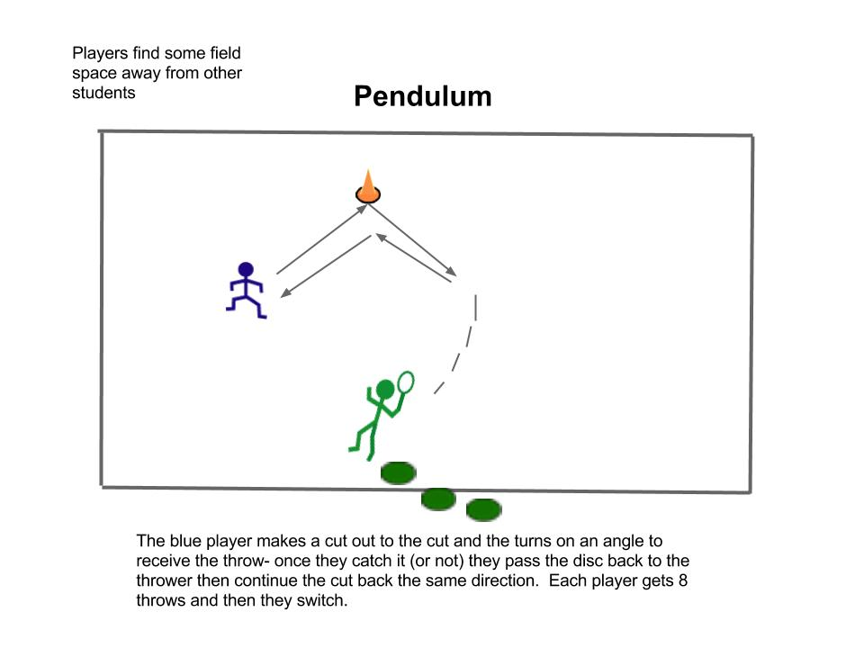

The goal of this activity is to focus on throwing again but have them throwing at a moving target. The receiving player is focused on making a sharp cut and catching the disc while moving. Once you feel that they are having more success with this skill then move onto either the Box Game [2.1] or the Target Game [2.2] again to emphasize what they have learned.

Phase 3:

Phase 3 of this unit starts to add more Ultimate-like game-play using small games to increase participation and touches.

1. 4 v 4 Mini-Game
2. Outlet Game [video 3.1]
3. Pepsi [video 3.2]
4. 5 v 5
5. 4 v 4 Mini-Game

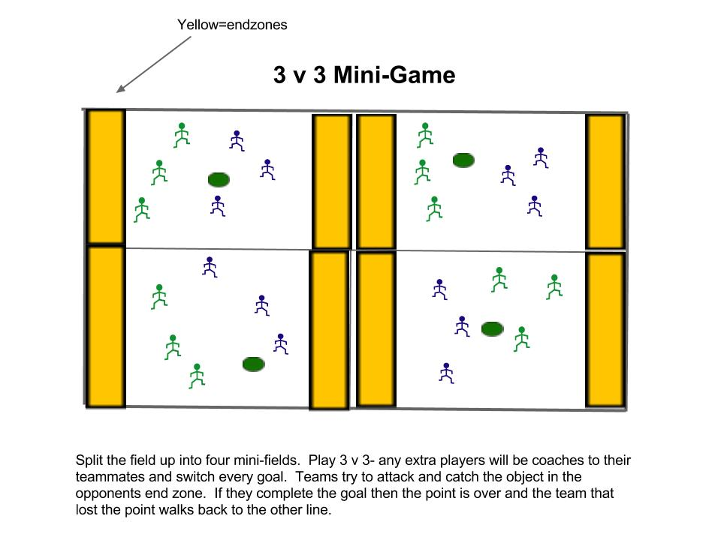

The first stage in this phase is to play this game 3 v 3. Once a key skill is practiced, more players can be slowly added in. If it is more effective to have less players on each team, then keep the numbers lower for longer.

1. Outlet Game

Area of play – 15 yards wide, 50 yards long, (end zone is 15 X 10 yards) marked by cones on corners of end zone for 3 on 3 (to 5 on 3) players



**Aim**: Score by invading opponents’ area to pass the ball or Frisbee to the end-zone

Rules

1. Score by passing the object from one player to another in the end zone
2. Cannot move with the object
3. If there is a loss of possession, the team on offense must go back to 3 players (player who was involved in the turnover is now the outlet)
4. Loss of possession can be caused by: dropping the disc, having the disc be defended (caught or hitting the ground), catching out of bounds.
5. Game starts by having the team who won the point throw to the other team.

**Ways of conditioning rules:**

* Have to have every player touch the object before a score
* 7 second rule with object
* Must score with a particular throw

**Equipment**

|  |  |
| --- | --- |
| Outlet | 5 X 2 pinnies.  Cones to mark playing field (8)  1 playground ball/beanbag. 1 frisbee. **(all x # of groups) |

**Analysis**

What are the key strategies (ways of playing) to use to be successful at this game? What are the tactical awareness movements you need in this game to increase your chances of being skilful?

This game focuses on moving the disc laterally to the sidelines in order to advance the object up the field. This helps move the defense and expose their weaknesses. They are rewarded by having an extra player be added to their team. Making and taking space and spreading out are super important. Using a ball at first will help them see this space without having to focus on throwing a Frisbee. Once they are ready, they can add the Frisbee into the game. Once the defence is outnumbered, the offence should recognize the open players and get them the object.

**very transferable

After practicing the key skill of using the width of the field, it would be ideal to play a 4 v 4 game after to let them practice that skill in a game-like context.

1. Pepsi

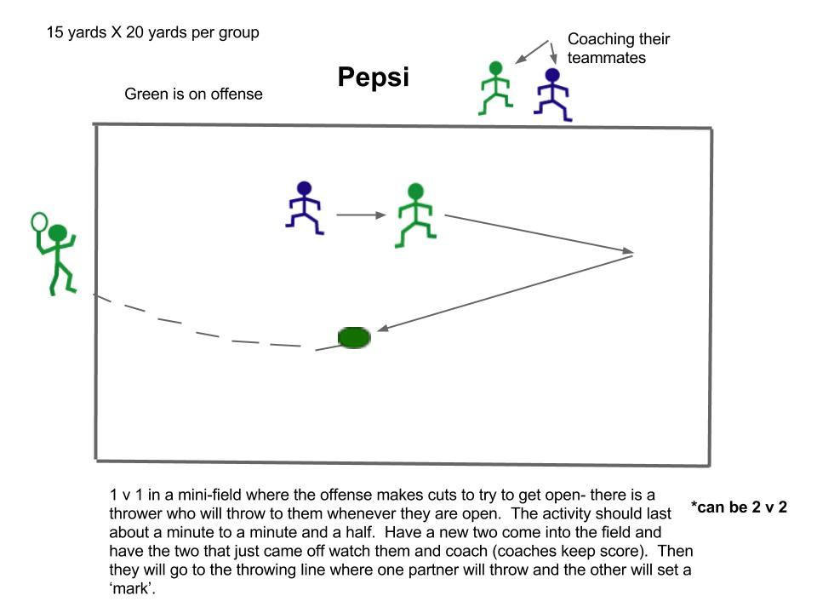

**Aim**: Make cuts in the designated area to get open from the defender for the thrower as many times as you can in the time allotted.

Rules

1. Score by receiving a pass from the thrower
2. Non-contact
3. Has to catch within the play area

**Ways of conditioning rules:**

* Make it a 2 on offense 1 on defence
* Create optimal ‘zones’ within the play area are award more points for certain areas
* Play 2 v 2 with the 2nd player making a continuation cut
* Have a coach or teacher make the throw at first to create more success

**Equipment**

|  |  |
| --- | --- |
| Outlet | 15 pinnies.  Cones to mark playing field (16)  15 frisbees. **(all x # of groups) |

**Analysis**

What are the key strategies (ways of playing) to use to be successful at this game? What are the tactical awareness movements you need in this game to increase your chances of being skilful?

This activity allows for the students to try out different methods of getting open against a defender. Making sharp cuts at angles will help the offensive player get open. The defence will have to try to triangulate (could be taught in another lesson) to be able to see the disc and their player. Adding an extra player will have them figure out timing with another person as well as spacing.

After playing Pepsi, it will be beneficial to play in another mini-game. Does not matter the size of the group, but maybe tailor it to how the tournament will be formatted in for phase 4.

Phase 4:

Tournament

Run a round-robin tournament with your class to finish off the unit and to track their progress. Switch up the groups often unless you are using a Sports Ed. model.